

SimplexusTM User's Guide

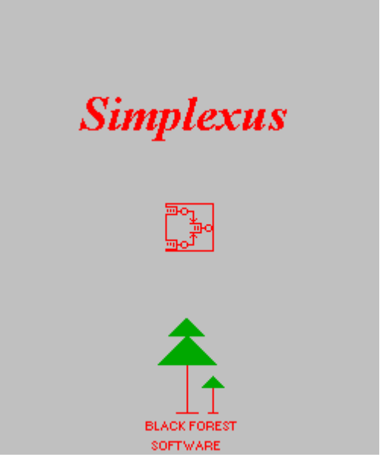

The Black Forest

Between Denver and Colorado Springs, between 5 and fifteen miles east of the Front Range there is a ridge, or rather a high plateau, of between 6000 and 7500 feet elevation, which, millions of years ago wanted to be a mountain range. But wasn't. What it did become, however, was a band of Ponderosas between 5 and 15 miles deep stretching from Parker to the northern suburbs of Colorado Springs. The area due north of Colorado Springs reaching (almost) to the El Paso County line is the Black Forest. Not a town, improvement district, or incorporation of any kind, it has become home to Utes, Cheyenne, Arapahoe, deer, antelope, black bear, porcupine, red fox,mountain lions and the occasional erstwhile software developer. I am told this forest is possible not because of the elevation, but because of a somewhat hard layer of rock just beneath the surface, which traps moisture and makes possible the growth of 300 year old Ponderosas. I myself have seen and heard mountain lions not more than 50 yards from the house; if you have never heard one of these late at night, then you are missing a real experience. The sound is somewhere between a screech and a baby’s cry, and very loud, very blood-curdling. Perhaps we can interest them (the cats) in some newcomers from California.

Just joking.

Ron

Contents

Chapter 1. Introduction, Setup and Installation
About Black Forest Software
About Simplexus
Contacting Black Forest Software
Customizing Simplexus, Support, and Consultations
Routine Support
Minor Changes and Modifications.
Major Modifications and Enhancements.
Modeling Assistance
Maintenance.
Training and Consultation.
Warranty and Disclaimer
Simplexus Installation and Equipment Requirements
Installation and Setup Problems
Chapter 2. Overview of Simulation and Simulation Models
Discrete Event Simulation and Modeling: A Definition
Limitations of Models and Modeling Tools
Chapter 3. The Art of Simulation Modeling: A Brief Overview
Step 1. Determine Your Objectives
Step 2. From the Essential to the Incarnate - Modeling Requirements
Step 3. Thinking Through the Problem
Step 4. Get a Plan, Stan
Step 5. Do It
Step 6. Analyze the Results
Step 7. Report Out Your Results
Simplexus as a CASE Tool
Chapter 4. Using Simplexus to Create Models
Introduction
Creating the Top Level Model
Timers
Time Units
Writing Setups to File
User Functions Enabled
Stopping Rule
Input Source
Verifying Model Attributes
Changing Model and Object Attributes
Creating Nodes: Sources, Processes, Resources, Meters, and Graphics
Lines
Connectors
Source Nodes
Name
Time Units
Meter
Inter arrival Rate
Entity/Attributes and Lead off Node
Successor/Target
Arrivals
Verify
Distributions for Intrinsic Delay
Seed
Upper/Lower Bound
Standard Deviations
Workstations and Host Nodes
Process Nodes
Process Dialog Box
File Outputs
Conditions Matrix
Load/Environment Conditions
Processing Conditions
Results - Old and New Successors
Results - Disk/LAN/MBX Activity
Data Transformation
Resources
Resource Scheduling
Resource Contention
Resource Blocking
CPU
Disk
LANs
Mailboxes
Memory
User Defined Process
Meters
Destroying Simulation Objects
Destroying Graphics Objects
Removing Links or Connections Between Nodes
Outputs
Highlighting
Trace
Instantaneous Raw Data
Reports
Graphics
Inputs
Execution Mode
The Simulation Clock
HELP
Chapter 5. Technical Specifications
Examples
A. A Simple MM1 Model
Setup.
Executing the MM1
Examining the MM1 Output
The MM1: Final Remarks
B. A Simple Computer Model
Sources
INDEX

Chapter 1. Introduction, Setup and Installation

About Black Forest Software

Black Forest Software has been established to develop Simplexus and make it available to the public, and is registered in the State of Colorado as a Sole Proprietorship owned by the undersigned, Ron Van Huss. The trade name “Black Forest Software”, the Simplexus trademark and logo, the Black Forest Software logo, and all other indicia and artifacts are trademarks of Black Forest Software.

Frequent reference is made in this document to Windows, Windows NT, Windows 3.1 and the like. These references are to the Windows operating system marketed by the Microsoft Corporation and are trademarks of Microsoft. All references to the term “Windows” will refer to those products unless otherwise noted. Additionally, references to simulation and modeling products marketed by other vendors refer to the trademarks of their respective companies.

It is the goal of Black Forest Software to establish a close business and technical relationship with each purchaser and user of the software, inasmuch as the availability of Simplexus is as much a public service as a business enterprise, and to provide each customer with the highest level of support, service, and insight into the sometimes arcane world of simulation modeling. Products of this type are almost never complete. Black Forest Software is committed to continuous enhancements and refinements to the product, using the latest tools and techniques available. Along these lines, users of Simplexus are invited to participate in the development and continuous refinement of the product with their suggestions and comments.

About Simplexus

The name Simplexus derives from “simulation” and “plexus”. Actually, the name belies it's roots, since the product originally started out as a simple DOS-based queuing network tool with no graphical user interface. It was decided, in 1991, to migrate the tool to the Microsoft Windows 3.1 environment, enhance it to perform full discrete event simulations involving contention for resources, and then to eventually migrate it to Windows NT. The last portion of this guide provides some limited technical details of the software. The “pure” Windows 3.1 version (which is not currently supported) was developed using the Borland C++ compiler, while the Windows NT version was developed using the Visual C++ compiler for 32 bit applications. The application is written entirely in C for portability, and is roughly divided into the user interface (or Windows) portion, and the simulation engine portion. The implication of this is that the entirety of the user interface part could be disconnected and replaced with another (XWindows perhaps) since there is almost no Windows code whatsoever in the simulation engine code units.

The major design goals are as follows: The first objective was to provide a graphical, easy to use, and self teaching (to the greatest extent possible) simulation and modeling tool. The tool was to be provided to the public at nominal cost as a public service, and to permit the rapid prototyping of large computer systems with minimal setup. The tool can be user-configured to model other systems by changing the icons representing the objects to be modeled. The tool should be of sufficient technical detail so as to provide accurate results for low to medium level of fidelity models. The tool 's interface should not only provide for the rapid characterizations of models, but also provide for the visualization of the model execution in real time; this capability is suitable for customer presentations of simulations. Finally, the tool should provide for customer generated enhancements, to the greatest degree possible. This is accomplished throught the provision of a source code Dynamic Link Library (DLL) template which can be populated by the user. Simplexus is the culmination of many years of practical experience in software development, systems engineering, and simulation modeling. Currently, it is offered in three versions -- retail, evaluation, and complimentary. The functionality of all three versions is identical; there are no restrictions, nag screens, disabled functionalities, or "time bombs" on the evaluation version; users are asked to purchase the retail version after 90 days. Minor upgrades (bug fixes,etc) are free. Major upgrades, where major new functionality is offered, will be offered to existing purchasers at nominal cost.

Finally, because Simplexus is in its infancy, there will be bugs. I have spared no expense, time, or effort to debug the product using the latest tools and techniques, even to include single step trace of each line of code with both the Microsoft and Borland debuggers. However, simulations and simulation tools are large and complex software, even in their coarse forms. See the note on Warranty and Disclaimer below and observe: Black Forest Software disclaims everything it can relating to Simplexus. Users are encouraged to avail themselves of the free, 90 - day evaluation versions offered. Simplexus is not in the public domain; it is copyrighted and its algorithms are treated as proprietary Trade Secrets. Simplexus is not shareware; it can only legally be used by purchasing a retail license or by being provided a complimentary copy. Please do not use evaluation copies to perform real simulations used in business, commerce, trade, or for any profitable enterprise; they (the evaluation copies) are to be used only to learn the look and feel of the tool, and to determine its suitability for your application. As noted, the evaluation copies are fully functional versions.

Contacting Black Forest Software

Call 719-488-1889. This line can be used for both voice and FAX. Likely as not, you will not get me; leave a message on the Voice Mail System and I'll get back to you. Usually, this will be at night or the next day; please be patient. The mailing address for Black Forest Software is: 3555 Conecrest Lane, Colorado Springs, CO 80908.

Customizing Simplexus, Support, and Consultations

Hopefully, Simplexus will fill your needs. But, perhaps you would like it customized to fit particular needs or serve special problems. Black Forest Software , as noted above, desires to involve the customer or potential customer, to the greatest degree possible, in the development and continuous refinement of the product. Here is what can be done.

Routine Support

Routine support is defined as assistance relating to the setup and operation of the tool as it it offered to the public in its baseline configuration. It includes assistance in building models using the tool’s features, but does not include tutorials or instruction in simulation and modeling, or support in building specific models or in solving customer modeling problems. Black Forest Software will solely determine the nature and extent of this support based upon the availability of time and resources, but as a rule of thumb Black Forest Software will provide its best effort to provide a level of support which will permit the operation of the tool to the satisfaction of the user.

Minor Changes and Modifications.

Those requiring a recompile or cosmetic change, are free providing that the change takes less than one hour, and are performed on a strict “as time is available” basis. Examples of this are custom bitmaps or icons which the customer wishes to use in lieu of the ones provided.

Major Modifications and Enhancements.

Otherwise, for more involved customizations, these can be negotiated. Contracts can be written for either fixed-price or time-and-materials. Examples of this are functionalities (nodes, for examples) which are not included in the tool but which can be added for particular needs.

Modeling Assistance

Modeling assistance can take the form of either particaping in a customer-dircted modeling activity as a consultant, or of building an entire model, using Simplexus, according to customer specifications. Either of these activities requires a contract.

Maintenance.

Black Forest Software does not sell “maintenance” agreements as is sometimes common with other vendors of simulation tools: as noted above, I will answer any and all questions (within reason and time permitting) relating to the setup and operation of the Simplexus tool; that is, normal and reasonable maintenance support for purchasers is free. All minor product upgrades, as noted above, are free. Major upgrades, where major functionality is offered, will be provided to registered users at a nominal cost. Details of building models, and other matters (“hand-holding”) requiring more than one hour, however, can and should be negotiated on a time-and-materials basis.

Training and Consultation.

Consultations, training and seminars relating to Simplexus or simulation modeling in general are available. Terms are as follows: $200 per diem, pre-paid plane ticket, pre-paid hotel, pre-paid car if required (usually it will be ). Course/Seminar content can be negotiated, but should use Simplexus as the core of the discussion.

Warranty and Disclaimer

These are included as a separate document. The product is warranted to perform substantially in accordance with the documentation, that is, to perform discrete event simulations. However, the software is not warranted against latent defects ("bugs"), and because this is the initial release, this disclaimer is even more critical. Loading and using this software constitutes your acceptance of these terms. If you do not accept these terms, please return the software. Also, please note that your distribution package may contain Release Notes containing last minute tidbits or known defects, problems, etc. These Release Notes constitute part of the Simplexus documentation.

This document makes reference to products offered by other vendors. These products include both simulation modeling products as well as graphical visualization products. Any such reference is intended strictly for comparison purposes or to provide examples of alternative services and methods, and no criticism or indorsement of these products is in any way intended. As noted above, all such products are trademarks of their respective companies.

Simplexus Installation and Equipment Requirements

Setup. Simplexus uses a graphical installation and setup procedure provided by the Microsoft Corporation and modified by Black Forest Software. This setup will detect the operating system (Windows NT or Windows 3.1), and load the appropriate Win32s and Simplexus files. Win32s is a group of files which allows a 32 bit Windows NT application to execute on the 16 bit Windows 3.1 system. Simplexus is a fully 32 bit application, but with the Win32s files, will execute under Windows 3.1. Setup and most setup files are located on DISK1; Simplexus executables are on DISK2.

For Windows NT. Setup will load Simplexus into a default directory or a directory of your choosing. No other support (Win32s) files are loaded. if desired, Simplexus can be executed directly from the distribution media by executing, from Program Manager, WINSIM.EXE, although this is not recommended. Windows 3.1 operation requires loading the application onto the hard disk.

For Windows 3.1. Setup will load Simplexus into a default directory or a directory of your choosing. In addition, a Win32s directory will be created in C:\windows\system, which will contain the Win32s files. Other Win32s files are loaded into the C:\Windows\System directory. If you have previously installed a Win32s product, Setup will detect this and install the Win32s files only if they are of a later version. Otherwise, only the Simplexus files are loaded.

Distribution Media. Simplexus is usually distributed on 1.4 megabyte, 3.5 inch media. However, less than 1.2 megabytess of each disk is used, so if 1.2 megabyte disks are required, do one of the following: contact Black Forest Software and enclose $5 to handle the media and postage, or find a means for copying the data from the 1.4 disks to 1.2 media. BE SURE to label the 1.2 disks DISK1, DISK2, and DISK3 (exactly). Do not overwrite any files on the media with other files: SIM.INF contains the file names and sizes; any discrepancy in file size from what is listed will cause problems.

Equipment.. Simplexus is a 32-bit application and will execute only on 386 and 486 computers. The previous 16-bit code development baseline is not currently supported but can be rebuilt , under contract, for users who absolutely must have a 286 compatible product, or for some other reason must have a 16-bit product.

As noted above, Win32s permits operation of the product on either Windows NT or Windows 3.1. Simplexus has been ported the Digital Equipment Corporation Alpha AXP platform.

Win32s does not “corrupt” your current Windows 3.1 system and will not affect the operation of Windows 3.1 applications in any way.

Minimum requirements are: system memory ( 4 megabytess for Windows 3.1, 12 for Windows NT), a mouse (NO keyboard interface is supported), a VGA monitor of any variety, and 4 megabytes of disk space. You must have a math coprocessor. Also for Win32s operation, you must have Windows 3.1 or later. Simplexus installs as a common user application under Windows NT and does not modify the Registry database. Windows NT has not been tested on a network of any kind, nor on Windows for Workgroups. Its behavior or suitability for these platforms is not known.

If you maintain the documentation in its uncompressed form, expect to have it occupy at least 4 megabytes of disk space; add another 2 megs for the Simplexus executables. If you are loading the application into Windows 3.1, you may experience “out of memory” problems. Insure that you are operating in 386 enhanced mode and that your “virtual memory” (swapfile) is enabled.

Environment. Because Simplexus uses a multitude of timers it is recommended that any applications using timers (CPU Usage meters, for example) be disabled. Additionally, it is recommended that third party memory managers such as QEMM also not be used. Simplexus has been successfully tested with HIMEM.SYS.

Files. Simplexus files are as follows:

WINSIM.EXE - the Simplexus executable;

USERCODE.DLL - Contains the user library dynamic link executable - icons, bitmaps, and user written routines;

USERCODE.C - Source code template;

USERCODE.RC - Source code template for resources (Bitmaps and Icons);

USERCODE.DEF - Definitions file for use in compiling the USERCODE;

SIM.INI - Initialization file read by Winsim. The timer intervals are user settable. Various flags are user-settable. These flags include the user-defined model logo (bitmap) enable, thevitae display enable, and text and windows trace enable. You can also adjust the upper-left hand coordinates of the user defined model bitmap or logo, so as to reposition its display. Several of these parameters, such as timer intervals and trace enable/disable can also be changed within Simplexus with the model dialog and with the “execute” pulldown menu. Do not, under any conditions, modify the serial number;

WARRANT.DOC - Warranty and Disclaimer;

USERMAN.DOC - This document, Microsoft Word format;

USERMAN.PS - This document, rendered to PostScript format;

*.BMP - One or more bitmaps which may be included as examples, tests, etc.;

*.ICO - One or more icon files which may be included as samples;

*.SIM - One or more simulation files to be used as examples or demos;

*.F1, *.F2 etc. - Output files containing raw, instantaneous simulation metric data for use in off line data reduction. Up to six metrics can be dumped to text files;

SCENARIO.DAT - Scenario script file read by Simplexus. It is created by the user and provides and alternative to generating arrival events with probability distribution functions;

MODEL.DAT - A text file containing the model setup parameters. By model setups, we mean the top-level attributes which pertain to the execution of the model in general. The model name is specified by the user; this file is written out by Simplexus;

PROCESS.DAT - The setup parameters for a process. The process name is specified by the user; this file is written out by Simplexus;

SIM.OUT - A summary output report (text file), which provides the results of a simulation run. This file is written out by Simplexus

TRACE.OUT - A text file output of trace activity. This file is written out by Simplexus.

MAKEFILE - This is used to compile USERCODE.DLL with the Microsoft 32-bit command line compiler, version 7, which is available with the the Microsoft Tools distributed with the Windows NT product. To compile with the Microsoft or Borland visual compilers, see the instructions in those compilers for creating a project file.

Many of these files, such as the output files, are generated only after a simulation has been completed. Only the *.SIM and *.DAT files can be user-named within the simulation. All other file names are hard-coded; later releases of this product will provide a means (SIM.INI, for example) to change the names of the outer output files. All other files are on the distribution media are Setup files used in the installation process, primarily Win32s installation files, or documentation.

Documentation. This User’ Guide has been rendered from Word for Windows to PostScript and to Microsoft Write for Windows. Of these, the Word “Userman.Doc”) is perhaps the most useful. All of these documents are in compressed format, inasmuch as the use of bitmap illustrations in them causes the expanded size to exceed 4 megabytes.

Vitae. The opening screen will provide you the opportunity to enter the name and the company to which the product is registered. The default behavior is for this dialog to appear each time Simplexus is executed. If you decide to disable this display, simply open SIM.INI and change the “Vitae Enable” flag from 1 (TRUE) to 0 (FALSE).

Installation and Setup Problems

The graphical setup routine is intended to be entirely automatic. Even so, problems may occasionally develop. When that occurs, you must exercise brute force methods.

Windows NT users. (1) Create a directory of your choosing and load the Simplexus executables and files as shown above into that directory. (2) Use Program Manager to bring Simplexus into a group (or better, create a separate Simplexus group and load Winsim into it). Remember, the executable image for Simplexus is WINSIM.EXE. To execute Simplexus, you must have WINSIM.EXE, USERCODE.DLL, and SIM.INI in the same directory. These are the three minimum essential files necessary for execution.

For Win32s installations, the Setup/Install application should re-boot into Windows to enable the configurations. If this does not happen, simply exit windows and restart. Simplexus should work.

Windows 3.1 users. You can check for a previous installation of Win32s by noting the existence of the C:\windows\system\win32s directory and whether it contains any files. If it exists, and contains files, then proceed as in Windows NT installation above. Try executing Simplexus or another 32-bit application directly from Program Manager if you suspect a previous installation of Win32s. It (Winsim) should execute. If the Win32s directory does not exist, or does not contain any files, then create it and load the following files into it from the distribution media:

ADVAPI32.DLL
COMDLG32.DLL
GDI32.DLL
KERNEL32.DLL
LZ32.DLL
NTDLL.DLL
CRTDLL.DLL
OLECLI32.DLL
OLESVR32.DLL
SHELL32.DLL
USER32.DLL
VERSION.DLL
W32S.386
W32SKRNL.DLL
WIN32S.EXE
WINSPOOL.DRV

Insure that C:\Windows\System contains the following files:

WIN32S16.DLL
OLECLI.DLL
W32SYS.DLL

Finally, proceed as in Windows NT above to install the Simplexus executables, keeping in mind that you must have WINSIM.EXE, its associated dynamic link library (USERCODE.DLL), and SIM.INI in the same directory to execute Simplexus. Reboot Windows. If none of this works, call me.

Chapter 2. Overview of Simulation and Simulation Models

This Chapter will introduce you to basic modeling concepts, especially as they apply to the operation of Simplexus. Then, in Chapter 4, the operation of Simplexus' menus and dialog boxes will be explained. One of the major design goals of Simplexus was to preclude the necessity for having many years of study not only in the art of simulation modeling, but also of statistics and probability as well as, more importantly, the need to learn a simulation language. Nevertheless, there are certain essential concepts which are necessary, as well as certain myths and misconceptions, which must be dealt with. This guide will contain a limited bibliography; while there are many excellent texts available on this subject, the two that I have found most helpful are The Art of Computer Systems Performance Analysis, by Dr. Raj Jain (Wiley and Sons, ISBN 0-471-50336-3), and Simulation Modeling and Analysis, by Dr. Averill M. Law and Dr. W. David Kelton (McGraw-Hill, ISBN 0-07--036698-5). If you have no other books on modeling, have these: they will give you many insights and provide you with an outline of the conceptual underpinnings of Simplexus.

Discrete Event Simulation and Modeling: A Definition

Simplexus belongs to a class of tools called discrete event simulation and modeling tools. Let us step through this phrase and elaborate our definition; this will give us some pointers into how the tool operates and what it can be used for.

First, discrete event is not something done late at night with a friend (that’s discreet event). Rather, the terms discrete event are used to define specific events which begin and end, such as: “I came, I saw, I conquered.” Caesar wanted the reader to see these as three separate, but interconnected events, and this paradigm corresponds to much human activity in life. These types of activities are typically called transaction systems (see also Jain’s discussion of Markov states and birth-death processes), such that they are characterized by inputs, processing, and outputs. Another way of describing this is events and responses. The bottle arrives on the conveyer, it is filled with soda, it departs the fill station. The customer arrives at the teller, the transaction occurs, the customer leaves. Counselors tell us that persons typically experience an event , apply an interpretation, (processing) and render an appropriate response. The art of counseling is therefore to provide the patient with an appropriate set of interpretations or filters which will permit or provide positive and beneficial responses.

Not to belabor this, but you can see that arrivals, processing, and departures are common to these examples; arrivals and departures are thus seen as discrete events. Contrast this to another, different paradigm of human activity called continuous state, or continuous time. “He was drunk all night” implies a more or less continuous state of insobriety over time , not marked by any special event. Similarly , an orbiting satellite performs the same repetitive, or continuous analog activity over time. These activities may be simulated as continuous state or continuous time simulations, but not as discrete event simulations. Simplexus does not simulate continuous state activity.

Returning to our event/response paradigm, Simplexus employs two events and three states: for events, there are arrivals and departures to processes and resources. For states, processes may be idle or busy. The term idle means both that the process is not executing nor does it have any events in its queue. The term busy means that the process is executing or otherwise not available. A process which has events in its queue can never be idle. A third, intermediate state is awaiting resource. Processes awaiting resources are neither busy nor idle, but waiting for a condition to be fulfilled before continuing processing.. Resources may also be idle (available) or busy (not available), but since resources cannot themselves seize other resources, the concept of resource wait is not applicable.

Processes and resources may exhibit either synchronous or asynchronous behavior. Process activity is inherently asynchronous: that is, each process executes as it is stimulated by an event, without waiting. Certain resources, by contrast, exhibit synchronous activity, such that they execute in parallel with the process calling them. An example of synchronous activity in everyday life is the Automatic Teller Machine, or ATM. The customer “arrives” and sends an “event” to the machine by inserting his card. The machine processes the transaction, returns the card and the customer “departs”. The customer must wait while the machine performs its transaction, and cannot leave until the machine returns both the cash and the card. In a similar way, computer processes perform a synchronous write to disk and must wait for the transaction to complete (this is sometimes referred to as “blocking”). In VMS this is equivalent to a “QIOW”, or queue IO with wait.

On the other hand, asynchronous activity means that a resource or process receives an event an executes autonomously: the sending process sends or spawns the event and continues on, which the receiving process or resource executes. Returning to our ATM example, if the customer desired only to make a deposit, then he or she may put the deposit in an envelope, seal the envelope, and insert it into the machine. He or she is then free to leave without any wait (unless, of course, the card is in the machine and has to be retrieved). This is termed an asynchronous activity since there is no synchronizing mechanism, no synchronicity, in the exchange.

Moving on to our next set of terms, let us briefly discuss the terms simulation and model. A simulation is a mimic of real behavior, but not an exact mimic: that is called an emulation. The degree to which a thing is simulated is sometimes referred as the level of detail. The level of detail is driven by the number and types of effects which we wish to observe. We will discuss the notion of effects in greater detail in a later section, but it should suffice to say that the study of effects is the central reason for building a model in the first place. This is an important concept: a simulation model is not constructed to mimic a thing or activity for the sake of replicating that thing or activity, but for studying the effects of configurations and events, or loads upon it.

In conclusion, we may define a “discrete event simulation modeling” tool as a tool which allows building an abstraction of a thing or activity, and which permits the conduct of experiments to determine the effects of differing loads or design configurations, and which performs these experiments as a sequence of discrete state and event changes.

Limitations of Models and Modeling Tools

It is commonly assumed, even by trained and experienced modelers, that a simulation model is, somehow, a copy, replica, or emulation of a system, when in fact a simulation model is a statistical experiment, an abstraction if you will, which permits only an inference of system behavior. It is sometimes assumed that models predict behaviors of systems. This is not true: model results are only estimates from which one may infer certain things about system behaviors. Typically, the inexperienced modeler will define his task as representing, to the greatest degree possible, every nuance, every artifact of the real system in the modeling code. Having thus replicated the system, in modeling code, they then attempt to determine or "predict" system and subsystem behaviors. With all that, why not just use the real system?

The November, 1993 issue of Dr. Dobb’s Journal contains an interesting essay on models by Mike Swaine, wherein he discusses the “strong” view and the “weak” view of models and modeling. Swain states, “Most people would support a weaker view: Although we can learn from models, the model is not the thing modeled. Programming is not scientific research. A computer program has no empirical content. The map is not the territory.” Then there’s the strong view, which says that “you can study the real world by writing computer programs”, and that the programs are not models [abstractions], but instances [of real phenomena]. Swaine goes on to argue the strong view, although on a more metaphysical level than most engineers consider the idea of models and modeling. Simplexus takes the weak view: simulation models are abstractions of reality which provide us an ability to conduct experiments and infer behaviors. Questions frequently asked include,”Why did you not model the LAN/pageing/swapping activity/gazornablatt?”, or, “Can this tool model a VAX/Sun/Decnet?”. Can you write books with the letters of the alphabet? Invariably you will find yourself drifting into an explanation of models as abstractions of reality and not reality itself, and you will receive some very blank (almost vacuous) stares from your audience. There is no easy way around this problem, although graphical representations do help.

First, simulation models deal with effects. Consider, if you will, theat a simulation model is a statistical experiment and not an emulation. The important thing is the experiment and the experimental results, not the elaboration of a tool. That experiment, is simply to determine the effects of a given or changing load on system and subsystem components. For computers, this usually involves experiments designed around issues of timing, sizing, throughput, and design. Timing is concerned with quantitative performance factors dealing with delays of one sort of another. These delays may be intrinsic or adaptive, constant or non-deterministic. Sizing, as might be imagined deals with capacity issues of LAN, memory, disk drives and CPU. Throughput deals with the number of events processed over time, and design deals with optimization of system and subsystem algorithms. If there is one concept which subsumes and underlies all these it is performance risk mitigation. We will return to these concepts again and again in our discussions of modeling.

Let us return to the notion of effects. When we model a CPU, for example, we are interested in certain effects of executable images or processes contending for it. The actual scheduling algorithms are almost incidental except insofar as they may alter those effects. As noted above, models deal with abstractions; the actual function of the CPU as it is scheduled and as the program counter sifts through machine code is not important, providing we can abstract its functioning to a higher level and get meaningful results from these abstractions. So the real question is not how the CPU works and how can we represent it, but what is it load and what are the effects of this load. For this reason, Simplexus does not model the CPU to some notion of "machine instructions" as a measure of delay, nor does Simplexus attempt to deal with scheduling algorithms with great fidelity. While this concept does not preclude adding this type of (scheduling) fidelity in the future, it very definitely is not of a high priority.

You may encounter texts which attempt to characterize CPU delay in terms of "executable instructions" and the like. This approach derives from a hardware modeling perspective which is not usually appropriate for modeling computer systems . First, the approach attempts to derive intrinsic CPU delay from a calculation of machine instructions divided by MIPS. This assumes that all of the machine instructions for an executable image are contained within the context of the compiled machine instructions for that application. It also assumes that the Machine Instructions per Second (MIPS) ratings for a given processor are a reasonably precise measure of a processor's performance. Neither of these assumptions are correct or supportable. MIPS, for example, is a relative measure of performance which is an aggregate of different register and memory transfer operations; it is frequently misunderstood and almost never comparable between processors. As for machine instructions, modern operating systems frequently employ dynamic link libraries, run time libraries, and callable application program interfaces (APIs) , such that the actual count of machine instructions is in effect spread amongst many operating system services and libraries, and not available as a single compiled file. There are other problems (RISC versus CISC, for example). We could go on, but permit me to suggest that to attempt to model at a level of precision that would characterize the machine-independent delay of one machine instruction is overdoing it a little, pointless, and likely to bring you to ruin. Later, I will suggest some effective methods of characterizing computer resources which will provide you reasonable results at reasonable cost.

This brings me to my second design goal: cost. The idea of a discrete event simulation, as noted above, is to build an abstraction of the real system, conduct experiments, and gain results on the effects of different loadings - quickly. If you must make a career out of it, then you will quickly exhaust your budget and patience. Simplexus is designed to be relatively easy to learn, self teaching where possible, and provide for a quick prototyping and turn-around.

Having said all of this, there are many excellent tools on the market, some of which are simulation languages, such as Simscript (CACI, Inc, LaJolla, California) and SLAM (Pritsker and Associates, Inc., LaFayette, Indiana) and others which are self contained modeling tools such as CADRE Teamwork SIM (CADRE Technologies, Providence, Rhode Island), SES Workbench (Scientific and Engineering Software, Austin, TX) , and Simplexus. Others, such as Network II.5 (CACI) and BONeS (Block Oriented Network Simulator) are targeted for certain specific applications such as LANs. Two others worthy of note include CARDTools (Sun workstations and VAXes) from CARDtools Systems, Sunnyvale, CA; and ProModel from ProModel Corporation, Orem, UT (PCs under Windows 3.1).

These are all outstanding tools - Simplexus cannot replace any of these and does not try. A tool such as Simplexus necessarily has certain limitations: whereas I have tried to represent or characterize the most common computer resources to at least a coarse level of fidelity, it would be idle to suggest that there were no shortcomings, particularly in the area of LANs and CPU algorithms.

On the other hand, if one were to invest the time in simulation language like Simscript, there is almost nothing which could not be modeled, even to a high level of fidelity. But again, the tradeoff is the learning curve, the time to develop the simulation program, etc. Finally, there is the issue of tool cost. Many simulation tools range in price from 10 to almost 50 thousand dollars for a single license, which can put them out of range for individuals and small companies. Few tools are available for PC platforms, and none (that I am aware of ) for Windows NT. The bottom line on tool selection: (1) determine the engineering problem or problems to be solved (is it primarily a LAN problem, for example), (2) determine the personnel, time, and financial resources to be applied, including schedule, (3) determine customer expectations (does the customer want graphical presentations, high level of detail in the model, etc.). Your tool trade study should balance and weigh all of these factors and arrive at a solution which is most likely to add value to your corporate enterprise. The most arcane and gossamer simulation extant, if it does not address real engineering problems and add real value to your company's operations in the form of risk mitigation which is quantifiable in terms of dollars saved is merely a pointless academic exercise.

Chapter 3. The Art of Simulation Modeling: A Brief Overview

This brings us to our next subject, which is actually constructing a model. Here we will present a suggested method for developing a system model in a stepwise manner, from the ground up. There are indeed countless methods: the references in the bibliography can be consulted, so keep in mind this is not the only nor the best method. Also, bear in mind that simulation and simulation modeling is a broad and complex field, even with respect to computer performance modeling, and this Users Guide can in no way cover the field with any semblance of depth. Rather, the intent here is to get you up and running as quickly as possible. For practice, you may want to step through the examples at the end of this guide.

Step 1. Determine Your Objectives

Determine the overall modeling objective or objectives This can (and should) be cast in terms of an engineering problem, such as: does the LAN have sufficient bandwidth for traffic during peak load periods, or, does the CPU saturate on receipt of certain types of events. Do not cast your objectives as : “to model the network”, or “to model the MARS cluster”, or “to model a Sun workstation”. These do not specify an engineering problem to be solved and are likely to lead to the type of open ended activity noted above. Frequently, if you are doing contract work, your objectives will be stated for you in the contract specification, as requirements. These are sometimes called Quantitative Performance Requirements, or simply, QPR.s.

You may also derive requirements from load sensitivity analysis. Suppose, for example, that the system or subsystem under study shows no obvious or apparent weakness under normal or even worst case loads. Under such conditions the analyst may want to increase the load until failure occurs in either the hardware or software, and in this manner determine the weakest links or components. Assuming these components are mission critical, then they define the risk areas which the modeling effort must address.

A third set of objectives derive from previous experience, assuming that there are previous experiences. By now, for example, there have been several airline reservation systems installed nationwide. What were the pitfalls and shortcomings? If your company is to build such a system, and your job is to model same, these experience may define risk areas for you to investigate.

A fourth set of objectives derive from known hardware limitations and characteristics. If, for example, you are using X-Windows, and you know the X-Windows server pipelines events synchronously into the workstation graphics engine at given rate, and you know your traffic loading is at a greater rate, you may have a problem. Other examples involve disks and DBMS activity, where the known delay of the disk or DBMS server is likely to exceed the inter arrival rate for the events they must handle. These constitute the design "hot spots" if you will, which form the core of your modeling enterprise.

The most important thing about objectives is to focus on the problem and not the hardware, and this cannot be overemphasized. Even where the initial focus is on the problem, modelers invariably drift into esoterica relating to a particular piece of hardware, so you must consciously and frequently recalibrate yourself with your initial statement of objectives.

Step 2. From the Essential to the Incarnate - Modeling Requirements

Once you have developed one or more modeling objectives, decompose these objectives into modeling requirements. The modeling requirements simply state what the model components are supposed to do so that the modeling objectives may be satisfied. Example: "the model shall represent disk I/O activity and characterize contention between process x and process y". Make those two requirements if you wish. The point is to lay out exactly what the model needs to do, and also, to exclude that which is not important. Do not model system components or elements which have no impact on performance. Usually, for example, the printer activity will fall into this category, but there are others. Sometimes, for example, LAN bandwidth will be so massive as compared with the traffic that its activity is of no consequence.

This brings us to customer expectations: the customer may feel that the LAN is a critical bottleneck (even though you know it isn't) and therefore wants and expects to see it modeled. The method for dealing with this situation is to model the LAN, show that it is not a problem, then either dispense with it or leave it where it is and not refine it further. But get customer agreement that it is not a problem, after you have dazzled him with your presentation and left no doubt in his or her mind.

Occasionally, you will want to model activities, which, singly, do not impose a load on the system, but in concert impose an aggregate overhead on the CPU or some other component. There are many examples of this: DBMS checkpointing activity, where the DBMS cache is flushed to disk at intervals , occasional user inputs, support activity such as performance monitors, all CPU support activities (swapper and the like), and any other third party COTS software which may have been installed and executes sporadically. Unless such activity is significant (and significant is subjective), such that the activity consumes more than, say 3% of the CPU utilization, then it [the activity] can be aggregated with others as a lump-sum load on the system.

Step 3. Thinking Through the Problem

Develop a paper model. There are many methods available which may be used: structured decomposition such as traditional Yourdon-DeMarco, object oriented approaches such as Shlaer-Mellor, or any system of notation that you chose. Please note that Simplexus is designed to be its own modeling tool with its own notation, but even so, it is best to think through the problem using just pencil and paper to diagram the system. The type of diagram you want to wind up with is something akin to the Shlaer-Mellor technique of requirements analysis in that you want to determine and understand hardware and software attributes, relationships, and processing (or activity). More on this later, but let us digress a bit and describe the modeling paradigm for Simplexus and how it may differ from that of other tools.

The modeling paradigm used by Simplexus is as follows: a process is an autonomous work center which co-opts or "seizes" resources as required. These processes are stimulated by one or more input events. When stimulated, a process "executes" for period of time. The execution time is called service delay. Service delay is the nominal or mean time to process one event. Unless this delay is constant, then it is the result of a pick from a given probability distribution. Other delays are adaptive: an example of this is CPU delay, which is a function of the process which called it. So there are constant (deterministic) delays, random (stochastic) delays, and computed-at-runtime as a function of one or more variables (adaptive) delays. ( A process in the Simplexus sense is similar to a process in the VMS sense. In Simscript, by contrast, a "process" is spawned for each event, and this process is analogous to a "job" which visits or "waits" for resources. In other tools, such as NetworkII.5, the hardware hosts a process which it then executes according to a certain number of machine instructions; I hope that I have explained my problem with the "machine instruction" syndrome. Many tools, such as CADRE Teamwork SIM and SES Workbench contain much intelligence in the connector or "arc" which connects processes; Simplexus does not. The pathways, or connections between the processes (or process nodes as I call them) are established via a connection matrix which is entered by the user. (An alternative method of establishing the connections is to draw line between the nodes, but the lines, other that connecting the nodes, are otherwise “dumb”). Otherwise, all the "smarts" is in the process.

Returning to the subject of paper modeling, the attributes noted above will be used to populate the hardware and software elements of the system via dialog boxes, while the relationships will be used to establish the connection matrix (again through dialog boxes), and the processing will be a combination of one of more of the following: user- written code in the supplied USERCODE link library template, stochastically generated service delays and arrival events, and conditional processing based on event attributes (again entered via dialog boxes). The Shlaer-Mellor approach relies on a combination of information modeling, modified dataflow modeling, and state modeling to drive out "objects" and their interrelationships. Constructing a Simplexus model achieves all of these objectives without the formalism of the information modeling. Even better, a Simplexus model really is executable, while most other forms of analysis are paper only.

Your paper modeling should drive out as much characterization and design as possible; this is important in an as yet unbuilt system. This brings us to a problem: how does the modeler characterize an unbuilt system? For characterization of hardware you will need a number of items, but the two most fundamental are load and delay. By load, I mean the arrival rate of the events entering a process. By delay, I mean the intrinsic delay of a process, or in the case of resources, the hardware delay (disk rotational latency, for example). Here are some sources:

(1) Benchmarking experiments with the equipment/hardware;

(2) Vendor literature;

(3) Measurements taken for similar software;

(4) Contract Specifications frequently specify loadings;

(5) Estimates.

(6) Proceedings from simulation and modeling professional societies. The Computer Measurement Group, Chicago, IL is one such organization which hosts an annual convention and publishes their proceedings. These proceeding contain a wealth of measurement information.

Once characterizations are made, measurements are taken from the real system as it is being prototyped and built (code and unit test measurements, for example), and these measurements are applied against the model characterizations, which are then adjusted. This process is called calibration.

Step 4. Get a Plan, Stan

Develop a modeling plan. The plan does not have to be formal, structured, or detailed, but it should lay out your modeling tool(s) and the selection criteria for these, the modeling objectives and requirements described above, some form of schedule which integrates program/corporate objectives and activities with modeling activities, information related to assumptions, hardware and software characterizations and characterizations methodology, threads to be modeled, and validation and verification methods. For example, software development activities generally follow a development cycle, which may be iterative (“spiral”), stepwise (“waterfall”). An airline reservation system or bank may adopt a development cycle which simply aggregates more nodes to a base system. Even building and construction has a defined development cycle (foundation, framing, roof, etc.). For whatever activity, use the appropriate development cycle as the basis for your modeling schedule. In this manner, your plan will give your modeling enterprise scope and direction. In this connection also, you should schedule your work so that it is iterative and builds on early, perhaps more course, building blocks. The worst mistake you can make, and it is a mistake which is made frequently, is to model too much too soon. Develop a course model, test it, and then perform stepwise refinements and additions to it.

Step 5. Do It

Build, Execute, and Validate your Model. Using the techniques described in the next chapter, use Simplexus to build your model. Apply experimental loads to the model and observe the results. Validate your model by comparison against the real system or other systems like it. The results should be intuitively correct, or at least not counterintuitive. Both Jain and Law provide valuable techniques for verification and validation of models. Simplexus contains built-in real time and text trace utilities to assist in this process. Additionally, although Simplexus is not compiled and does not provide sufficiency checking, it does provide a limited capability to verify model characterizations and inputs.

Step 6. Analyze the Results

Analyze Model Results. Perform worst case, nominal case, best case runs. Perform runs with different random number seeds (“independent replications”). Tabulate the results and perform statistical correlations and tests for confidence.
You may wish to use some of the third party visualization amd analysis tools cited below to add value to your analysis. Simplexus permits you to dump raw outputs of six major parameters to text files. These files may be used as input to the visualization and analysis tools.

Step 7. Report Out Your Results

Present Model Results. Provide the modeling results in a written report. Also, present the model execution, in real time, using the Simplexus. One suggested method is to vector the video outputs of the computer through a three-color projector such as Barco, onto a screen. Graphics and animation help secure customer understanding of loads and effects, particularly when the Simplexus real time performance graphs are enabled. Finally, many excellent third-party tools are available to assist in data reduction and visualization. These include PV-Wave (from Precision Visuals in Boulder, Colorado); Unifit II, Mathcad ( from Mathsoft, Cambridge, Massachusetts); and Graftool (from 3-D Visions, Torrance, California). There are many, many, others and this is not to be construed as an endorsement of any of them.

Simplexus as a CASE Tool

Simplexus was designed primarily as a simulation and modeling tool. Typically, the simulation enterprise is conducted by several individuals assigned to a systems engineering group. This group, presumably, posesses unique skills and arcane knowledge about such matters, and so provides these services on behalf of the project or program. A alternative, and perhaps more fruitful approach, is to integrate the performance engineering activities into the development cycle itself, with each engineer or developer in posession of the knowledge and tools needed to perform substantive performance studies relative to his or her portion of the project. As noted above, one of the difficulties of this approach is the large investment in tool licenses, training, and simulation code development that simulation activities have entailed. Simplexus provides a means whereby each engineer may economically integrate performance analysis into the fabric of the software or hardware design process. For example, the documentation relating to a given software code unit could have a section which specifies the performance parameters and requirements of the unit, and the results of simulation and modeling studies which exercise the unit under development. The systems engineering organization might well integrate these results into a system model. The result could be more robust systems, with the robustness designed in, rather than tested to at final delivery.

Another suggested approach is to map the organizational srtructures (system architect, systems engineering, software engineering, and test ) to the various levels of the simulation model hierarchy. In this manner the specification is “handed off” by the system architect at the model level to the software engineering organization for prototype and feasability studies; the lower (process levels) are iterated by the software development organizations, and finally, unit test occurs at the lowest USERCODE.DLL level. The individual submodels are aggregated into a system model which is then used for system verification activities by analysis. The end result of this approach is a real time validation of the system and its components and subsystems as they are being developed. This contrasts to the traditional approach of validating architectures, after they have been prototyped, by the simulation and modeling group.

Let us return to object oriented-ness. Essentially, we are referring to entities, their relationships to other entities, processes and state behavior. When we speak of object oriented analysis, we are concerned with driving out these entities, relationships, processes, and states, to determine and understand system and subsystem behaviors. Object oriented design is then concernd with optimizing system algorithms to accomplish these behaviors according to specified requirements objectives, and design goals. Object oriented pragramming is concerned with the implemention of these algorithms in a manner which incarnates the “object” paradigm, that is, the grouping of logical entities and the operations which may be performed upon them. (For a more complete discussion of this, see my paper cited below in “Sources”.) A simulation model is the ideal tool and context within which to develop, exercise and visualize these attributres, processes, and relationships. The attributes and relationships which populate the model objects could easily be folded back into the design in a recursive, spiral fashion as design constraints and interfaces. In this manner, the code objects could be mapped to the executable simulation objects, as opposed to the traditional practice of developing simulation objects as an after the fact representation of the actual code objects. Interestingly, the Shlaer-Mellor approach, utilizing as it does a complexus of models (process, state, entity-relationship, etc), virtually ingores performance attributes and performance models, while performance models are the only means of validating these activities.

The utility of the graphical simulation and the CASE environment is strong and growing daily. Simplexus brings together the best features of current software design methodologies into a seamless development environment which permits the development of strong, high performance code for systems of any size.

Chapter 4. Using Simplexus to Create Models

Introduction

This chapter will step you through the process of building, verifying, and executing a simulation model with Simplexus. But first, let us again review the Simplexus modeling paradigm with the objective of how Simplexus represents threads, relationships, processes, resources and all of the other artifacts that comprise a simulation.

As noted above, the basic entity in Simplexus is the process. A process is an executable entity or object, and for convenience we will establish the convention of referring to process nodes, resource nodes and the like. Actually, this is not far off target: the algorithm used by most simulation tools, including Simplexus, is that of a linked list or tree, with each object a node or leaf. Processes are stimulated by an event generator, or source node. The event generator is the only node which stimulates itself, or sends events to itself. All other process and resource nodes must be stimulated (“triggered”) by an event. An event is simply a time that, when it occurs, the node “executes”, or performs some action. The time is simulation time, which is a real number maintained in a list; sometimes this list is referred to as an event list or event calendar. An event notice consists of that time, plus other data. From a Windows perspective, all objects, including processes, resources, and event generators, are of a single Windows class. Other objects, such as reports, traces, or other outputs belong to another Windows class. Additionally, certain non-executable objects are merely containers, or, if you will, graphical artifacts. These include models, workstations and host nodes, which together comprise a third class. Workstations therefore do not execute; processes within them execute and "seize" or co-opt resources as necessary. Processes likewise are not "executed" by CPUs or disks, but somewhat in reverse, processes execute autonomously and resources (CPUs, disks, LANs, mailboxes, etc.) are activated or "executed" in concert with the process ( synchronously ), or autonomously ( asynchronously ). Currently, resources cannot “seize” or trigger other resources. As noted, resources are not to be thought of as "tokens" to be seized, held, and released as is sometimes typical of other simulation tools, but as work centers which are stimulated by an event. This resource paradigm is most important for understanding both the operation of Simplexus and the manner in which models are developed: an asynchronous disk, for example, "executes" in much the same manner as a process, in response to an event from that process. This is most analogous to the QIO service in VAX VMS, while the synchronous disk would be analogous to the QIOW service, in that the requesting process is stalled (or "blocked" as is it is sometimes referred to) pending completion of the IO operation. It is not, of course stalled forever, but only until the disk is "available", so that the requesting process in a state of "resource wait" pending the availability of the resource. The Simplexus resource scheduler calculates the availability of each resource attached to a process; it then reschedules the process execution for the longest resource delay waiting. At that time the process and all resources are executed together. Currently, Simplexus does not extend the process execution if the resource delay is greater than the process delay; this will be included in a future release.

Asynchronous resources never stall a process; event notices are simply placed in the resource's queue and are worked off in the same manner as are events in a process queue. Queues do not have finite length, but can be managed with conditional processing, described below.

CPU delay is completely adaptive. That is, the CPU executes for the same interval as its requesting process, so that its service delay is congruent with the process requesting it. Simplexus, as noted above, doe not support context switching or complex scheduling algorithms for the CPU, but rather schedules the CPU in the same FIFO manner as other resources. Simplexus, as noted above, also does not support single machine instruction delays as characteristic of machine-independent duty cycles. Later versions may support context switching and more complex scheduling.

Finally, consider Simplexus objects (process nodes, resources nodes) as abstractions. The process icon can be replaced with a “happy face” representing a teller, and the synchronous mailbox can represent a vault. Result: a bank simulation. Similarly, the process icons may be replaced with icons representing various industrial processes, and the resource icons replaced with icons representing heavy machinery or equipment. Thus, many of the other resources can, with different icons representing the object, double for other types of simulations equally effectively. The USERCODE. DLL and supplied source code template allows the user to integrate custom icons into Simplexus, and in this manner tailor the graphics to any type of simulation desired. Public domain icons can be found in many sources, including bulletin boards and purchased software. To the extent possible, icons are provided with this distribution.

The balance of our discussion in Chapter 4 will address the nuts-and-bolts of using the menus, dialog boxes, and other tools to develop a model. The are two things to keep in mind: first, Simplexus is characterized by a top-level container called a "model"--simply a graphical artifact, but also having certain characterizations. At the second level, there is the optional container of workstation or host node, and finally , at the lowest level, the process and resource objects (or nodes) which are threaded together into a network. As a minimum, you must have a single event generator and a single process to have any model at all: this is called, in the trade, as an "MM1" or single server, single queue model. Additionally, you must have, as a minimum certain characterizations such as stopping rule, from the "model" dialog box. This will be elaborated below, in a stepwise manner , by traversing the menu structure. It is suggested that, when building models, that the objects be menu-selected and placed across the screen from left to right, using the mouse. Then provide the object characterizations and relationships by populating the dialog boxes from right to left. Sweep right, then left. The reason for this will become clear as we go along, but has to do with the ‘linking” or connecting of the objects into a
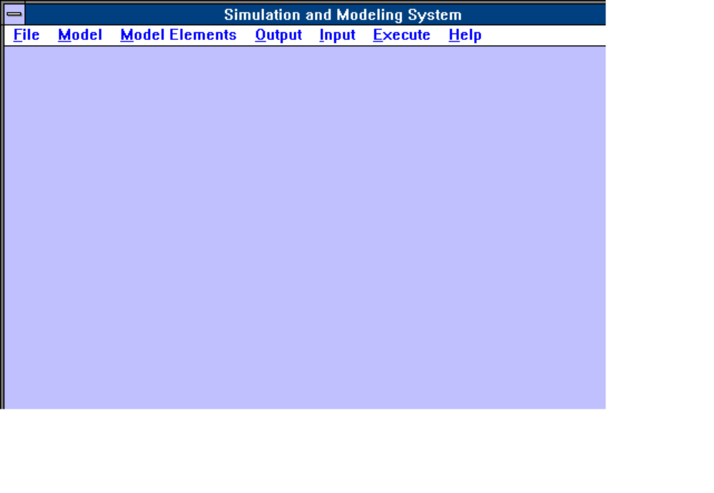
Figure 1. Main Window With Menu

connection matrix. Essentially, each object needs to know its successor, and if the attributes of that successor are fully populated and known the predecessor object, things go very much smoother.

Figure 1 shows the main window. We will start at the left-most menu item and build our model working left to right. The first item, "File" is provided courtesy of the Microsoft Corporation and is part of their common dialog box redistributable code. These components provide for a common "look and feel" across Windows(tm) applications and a high degree of uniformity among applications, and should be well-recognized by long time users of Windows. Figure 2 shows the file save and open dialog box. This box is used only to save and retrieve simulation files, identified by the suffix *.SIM. A simulation file is a binary file containing all the data necessary to store and recreate a simulation, and although these utilities permit a fully-qualified DOS path name, it is recommended that you store ALL of you Simplexus related files in the same directory. This is important because several of the files described in later sections use standard C fprintf calls and send their output to the default directory, so do not assume that all files are sent to a fully qualified directory filename.

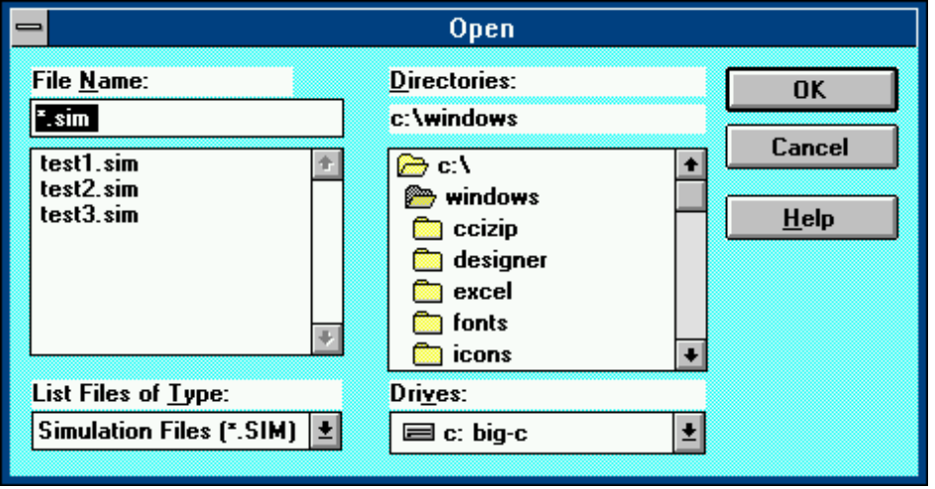

Figure 2. Sim File Open and Save

The next selection, as shown in Figure 3, shows the various colors which can be used to change the background of the Simplexus window and the model window.

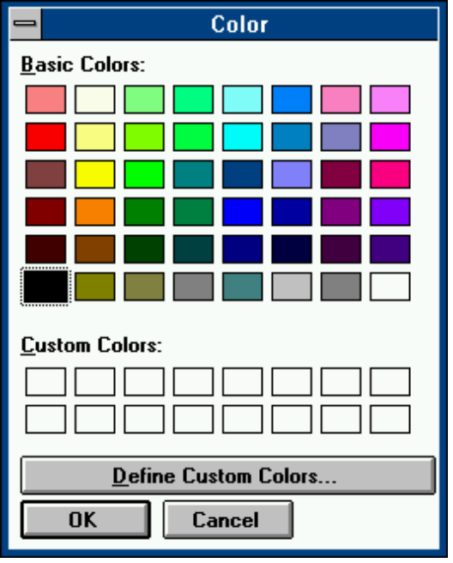

Figure 3. Background Colors

The next dialog box is provided to enable you to select fonts. These are raster fonts, not printer fonts, which will enable you to customize the look of your model display with labels. other graphics artifacts include lines, rectangles, and ellipses, and these are described later.

The print utility is used to print a buffer which contains, among outer things model configurations, process and source configurations, and resource configurations. This buffer, and its contents, will be explained in our discussion of the next two menu groupings.

Finally, the exit selection terminates Simplexus, flushes and closes all files.
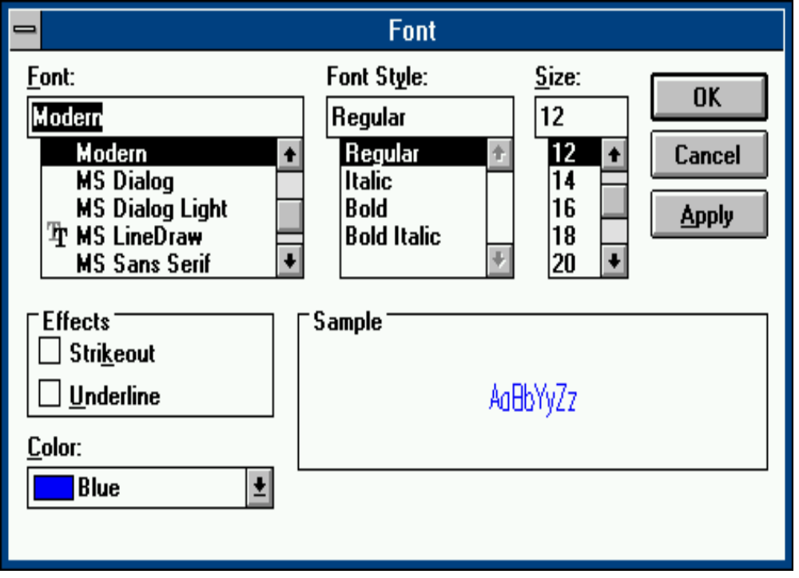

Figure 4. Fonts

Creating the Top Level Model

The next series of menus deal with creating the top-level container, a "model" container. First, using the pull down menu, select "Create Model". Once selected, position the cursor on the screen and click the LEFT button. A model icon will appear; open it with two clicks of the left button. This model window will contain all subsequent objects, including the graphical artifacts mentioned above. using the second menu selection, open the model dialog box, as shown in Figure 5. This dialog box will permit you to enter the course model parameters.

Timers
You will note that the sim timer interval and trace timer interval are defaulted to 1 second and 2 seconds respectively. Simplexus, as noted above uses several synchronous Windows 3.1 timers. One use of the timer is to gate the events into the simulation engine and then to return to the Windows event loop to display trace or other data. Otherwise, with Windows 3.1, no graphics would be possible so long as the simulation was executing. As Windows literature takes pains to point out, Windows 3.1 is a non-preemptive scheduling system wherein executing applications must voluntarily relinquish the CPU; timers are one of forcing such cooperation. This (Windows 3.1) system of synchronous timers has been extended to the Windows NT version of Simplexus , even though Windows NT supports asynchronous timers, to make it backwards compatible
. 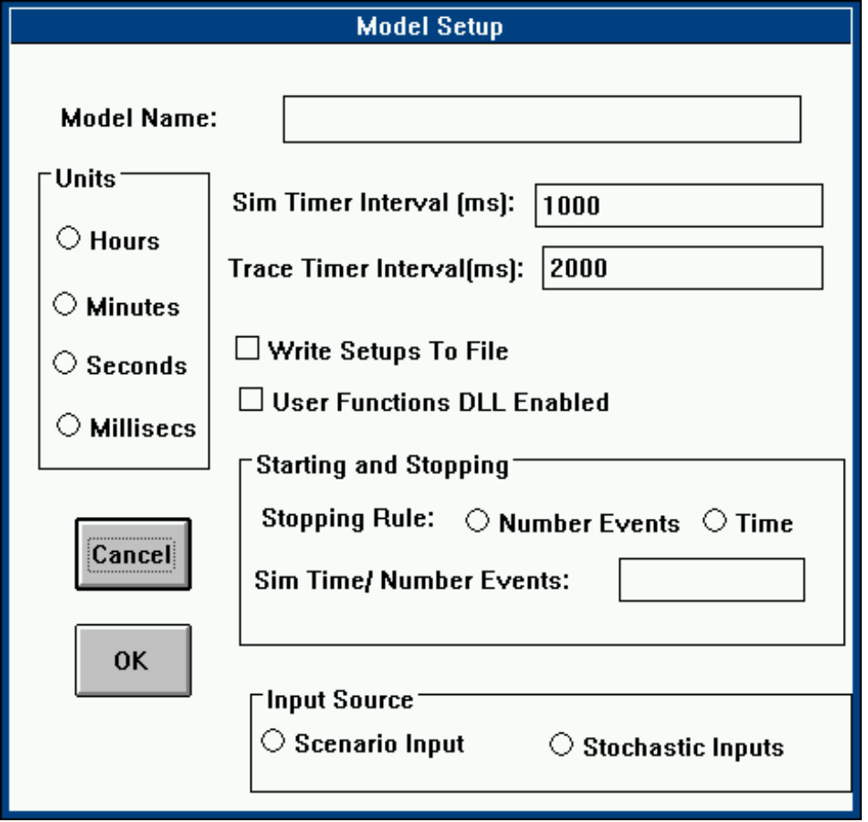

Figure 5. Model Setup

The value of the simulation timer interval determines the rate at which the simulation is executed on the screen, and the value of the trace timer determines rate at which the graphical trace points are displayed on the screen. Too rapid a rate makes the simulation unintelligible; leave the defaults unless there is a good reason to change them. The execution mode for Simplexus, turbo or normal, is described later: Simplexus has the capability to bypass timer operations and the associated graphical output, and execute the simulation as fast as the computer permits, without any graphical output except the simulation clock. You can change the default timer intervals in SIM.INI, or you may change the defaults while executing a simulation by accessing this dialog box. Again, do not change these intervals casually.

Time Units
You will also note the radio buttons for time units. You must select a time unit for your simulation. Actually, it does not really matter, since they are all discrete-valued, and are rendered as hours, minutes, etc. for ease of understanding. One could as easily have had a single unit such as simulation time units. Even so, the simulation clock is advanced in fractional parts. That is, the integer of milliseconds is cast as a floating point number an used as a mean for a pick from a probability distribution. The probability distribution returns a floating point number, and this number advances the simulation clock.

Why discrete-valued units, (cast as floats)? The answer has to do with the way data is retrieved from text boxes, which are the small data input boxes for text and numbers which you see in dialog boxes. Windows does not have the ability (that I am aware of) to read floating point numbers from these, so all numeric input for all dialog boxes is integer. This is VERY important. Thus, when you are asked to enter a percent enter 55, not 0.55. Your answer is converted to floating point values for those parameters that require floating point values. Most computer simulations will utilize milliseconds; a bank simulation may utilize minutes. As you might imagine, computer simulations which attempt to simulate any length of time using milliseconds may have some difficulty, there being 60,000 milliseconds to a minute, and 3,600,000 in one hour; for that reason, the simulation clock is dimensioned as a double precision variable. Other key variables are doubles or longs as appropriate. You may not mix time units, such as hours and minutes, in a single simulation.

Writing Setups to File
This check box will dump your setups to a file in the default directory. The file name is MODEL.DAT. Use this file to inspect or print the setups.

User Functions Enabled
Simplexus permits the user to augment and customize a simulation through the use of the dynamic link library, USERCODE.DLL. USERCODE.DLL is a link library which can be populated by users to customize their models. This customization takes several forms: first, users may develop and insert a bitmap or logo which will be displayed as the model is invoked. This logo is enabled in the SIM.INI file, and the display interval for it is specified there also. The bitmap is displayed when, for example, as stored model is retrieved, just prior to the display of the model window's icon.

Secondly, the icons representing ALL of the objects (except the Simplexus icon) are replaceable. This means, for example, that a face or figure representing a teller could replace the process icon, and a bank building could replace a workstation, and a central bank or headquarters the host node. The source code, USERCODE.C, USERCODE.DEF, and USERCODE.RC is provided for this purpose.

The most important function of the usercode, however, is to allow users to participate in the development of the simulation model at a lower level. Essentially, the code written into the function USERFUNC is used in lieu of the process intrinsic delay. That is, instead of executing or delaying 15 milliseconds, a function will be vectored to the user written code for specialized processing. One use of this would be, for example, to write code which mimics the OSI layers 2 through 7. Alternatively, the function could be used as part of a unit test jig to exercise actual software or code in the context of its support environment (sort of one step beyond the traditional stubs and drivers approach to unit test). To use the usercode function, you must select (create) an object or node of type USER from the objects menu; this menu will be described in the next section.

Stopping Rule

You must enter a stopping rule, which will be either number of events or elapsed simulation time. By number of events, we mean the number of events processed by node zero. Simulation objects or nodes are given a numeric identifier as they are created. If only one event generator or source node is used, that node should be the first, or zero-th node. Although selecting a source as the first and zero node is only a convention, it is a convention with special significance since the stopping rule is based on events received (or in this case generated) by the first node. Therefore, if you select a process, then a resource, and thirdly a source, and connect them in reverse order, your simulation will execute until the process node has processed the number of events specified in the stopping rule. Consider the following logic for stopping rules:

(1) If you have only one source node, it is not necessary to toggle that as lead -off node. Simplexus will use that node to generate traffic whether it is the zero node or a node with a higher index.

(2) If you have more than one source node, Simplexus will determine which is the lead-off node. If there are no lead off nodes, Simplexus will use the zero node if it is a source node; otherwise it will use the first node in the node array which is a source node.

(3) If there are no source nodes you will receive an error message.

(4) If you are using a scripted scenario file, Simplexus will terminate the simulation at end of file or at the achievement of the specified time or event count, whichever is first.

(5) Consider time and event count as units operating to terminate the simulation in the same way. That is, they are simply discrete units; always remember that simulation time is elapsed time from time zero. Events are counted at the starting source node. If there is only one source node, event counts are made from that node.

As noted above, enter the number of events, or sim time, as an integer.

Input Source

Events will either be generated as a stochastic process or will be read in from a scenario text file. The scenario text file is nothing more than a sequence of numbers which describe the inter arrival interval between events. As noted, the simulation ends at end of file or simulation time or number of events, whichever is soonest. Simplexus contains a rudimentary on-line scenario generator as one of the menu items. Alternatively, develop a file with any word processor, which contains the precise intervals desired. Use tools such as PV-Wave or Mathcad to display the arrival profile plot. Be certain to include sufficient events or time [units] to provide a statistically significant sample size. You can also generate a script by using several source nodes, one gating its arrivals with an exponential probability distribution function, while a second uses a constant arrival rate (representing perhaps a background load). These two loads are sent to a single process; that process records its arrivals and sends the output to a text file (see “Outputs” below). The text file can then be used to “play back” the composite arrival scenario as a single scenario, plotted, used for histograms, etc. Many experiments of this nature are possible.

Verifying Model Attributes

The final pushbutton control will allow you to view your model attributes as entered. Until nodes are entered (in the next series of menus), you will have no entries for these. You may use this rudimentary "viewer" at any time. Use of this viewer populates a print buffer (as noted above); you may use the print menu described above to print this buffer; alternatively, you may dump the setups to MODEL.DAT and print them separately, or do both. In any event, although some error checking is provided, you, as modeler, must insure that all necessary model, process, and resource parameters are correctly entered. For that reason it is important to know and study the attributes which comprise the process and resource nodes. These attributes as presented in the “Verify” window represent the fields of the data structure or record which defines simulation objects in Simplexus; although the term “process” is used frequently in the window, the fields apply to all types of nodes. This data structure is almost 700 bytes; definition of these attribute fields is provided as follows:

(1) Current Node. This is a string which labels the node you are currently working. Whereas it is not required that you provide a node with a unique name, it is highly suggested that you do so.

(2) Process Number. Each node is given an integer id as it is created. Nodes are created base zero, such that the first node is 0, second is 1, etc. This is not user-settable.

(3) Process Type. An integer describing the type; this integer is rendered to its string equivalent. Type numbers are set by Simplexus as each node is created. Not user-settable.

(4) Process Service Delay . This is the intrinsic delay. This value must be entered for source and process nodes; there are no defaults, and the simulation will not execute if there are no values here. The time units will be as specified in the model setup.

(5) Node is/is not a resource. Informational only.

(6) Distribution. Values will be node (for constant), Exponential, Normal, etc. as selected by the user. If none are selected, defaults are used.

(7) Uniform Dist Lower Bound. If the Uniform probability distribution function is selected, you must have a positive or natural value in this field ( 0 or greater). No defaults are provided.

(8) Uniform Dist Upper Bound. If the Uniform distribution is selected, this value must be a natural number and must be greater that the lower bound. No defaults are provided.

(9) Random Number Seed. Provide a value between 0 and 99 inclusive. Defaults are provided.

(10) Standard Deviations. Enter 1 or 2. This field applies to the selection of the Normal probability distribution function. Defaults are provided.

(11) Max Storage Size. For mailboxes and disks, the capacity in bytes. The disk dialog box requires that this value be entered as an integer of megabytes. No defaults are provided.

(12) Disk Access Time. For Disks. This value represents the mean rotational latency and track random seek time. Do not consider mean track-to-track seek time, as this time is both rarely given in vendor documentation, and also likely to be too conservative. No defaults are given.

(13) Transfer Rate. For Disks and LANS, describes the bandwidth of the transmission media. For LANS, these are not user settable for the different protocols selected, but are settable for disks. For LANS, the standard values can be user derated.

(14) Process/has/has not CPU. Informational only.

(15) Process Number of Successors... . This is a most important field. The number and type of resources or successor processes must map to those shown in the model window. This field describes the relationships which this object or node participates in.

The balance of the fields relate to conditional processing. These fields are entered via the “Conditions Matrix” dialog box accessed through the process dial box. Attributes are generated in source nodes and passed via event notices/records to the successor objects.

(16) Size. Events will be tested for a size attribute. The test is successful if the size attribute in the event equals this value.

(17) Type. Events will be tested for a type attribute. The test is successful if the event type attribute is equal to or greater than this value.

(18) ID. Events will be tested for a unique identifier, which is the sequence number of the event generated. The test is successful if the event unique identifier equals this value.

(19) Utilization. If the utilization of this process is greater than this value the test will be successful.

(20) Queue Size. If the queue length of this process is equal to or greater than this value the test will be successful.

(21) New Delay. If any tests (conditions) above are successful, this value will describe the new intrinsic delay for one transaction.

(22) New Successor. If any tests (conditions) above are successful, this value will describe the index of the new successor. See “Process Number” above for a description of the index. The term “New Successor” is somewhat of a misnomer: a disk, for example, must be designated as a “New Successor” if it is desired to vector data to it ONLY when a condition (described above) is met. Such a case might be, for example, to dump data to a disk when process utilization reaches 20%. See the description of the Conditions Matrix dialog box below for more details.

(23) Bytes Written. This value describes the number of bytes written. This value must be entered for any process nodes having disks, LANS, or mailboxes as successors.

(24) Bytes Read. This value describes the number of bytes read. This value must be entered entered for all process nodes having disks, LANS, or mailboxes as successors.

(25) New Msg Size. This value specifies a new mesage size, in bytes.. It can be used to transform message sizes either absolutely or as a result of a condition. It is frequently used in conjunction with repeat Factor, below.

(26) Repeat Factor. This vaslue, an integer, is used to determine the number of times a message is loaded onto a successor’s event queue. It may be used in conjunction with New Msg Size above to reprosent a packet disassembler.

Changing Model and Object Attributes

All of the dialog boxes for model and node (or object) setups can be accessed while the simulation is operating in normal (not turbo) mode. This provides a capability to alter model attributes during execution, on the fly.

Creating Nodes: Sources, Processes, Resources, Meters, and Graphics

The second item along the main menu bar, "Model Elements" is both the largest and most complex, containing as it does the bulk of Simplexus functionality. The first item, colors, is a replication of the background colors selection noted in the first main menu item, only this one is for the background of the model window.

Skipping the second item momentarily, the third item, graphics objects deals with selecting and positioning several graphics items with the model window. These include ellipses, rectangles, lines, and text. You may use these artifacts to "dress up” your simulation; they are stored along with other simulation setup parameters, when the simulation is saved in a .SIM file The intent of the text is to provide labels, the rectangles and ellipses may be used to section off areas a system into various subsystems; the lines may be used as "connectors" between the processes.

Destroy simulations graphics objects with the right mouse button as described below.

Lines
“Lines” in the generic have two identities: one the one hand, a line is a graphic artifact in the same manner as rectangles, text and the like. Lines of this type are selected from the main pulldown menu and destroyed in the same manner as rectangles, On the other hand, a line may also have an identity as a “connector”; between a process node and another process node, or between a process node and resource.

Connectors
A connector is a method of specifying the relationship between process and resource nodes. As will be shown in the following section, you, as modeler, must map the connections or relationships from your paper model onto the graphics of the simulation model. In Simplexus, this is accomplished by the use of a "connection matrix". A connection matrix simply shows the successors to your process. These successors may be other processes, or resources, since by successor we mean any recipient of a stimulus or event generated by a designated or given process. The connection matrix is established through the use of list boxes to select (and delete) successors, or alternatively, through the use of lines (or “connectors”) to link the nodes In this manner, a network of nodes is established. The two methods are described as follows.

Method 1, Graphic Connectors:

Position your mouse over the source node and give a single click with the right or middle mouse button to anchor the source of the connector. Then, position the mouse on the destination or target node’s icon and give a single click with the right or middle mouse button to anchor the connector terminus. Open the source or target node’s setup dialog box and verify that the destination node has been correctly linked with the Verify Process pushbutton. You may use this method to connect all objects on a single window (model, workstation, or host node), but you may not cross window boundaries. This is because, in Microsoft Windows, each window comprises a device context. Things are drawn and done within that device context, such that although it is theoretically possible to draw an object on a parent window which crosses into child windows and such, Simplexus does not attempt to violate the single device context Windows model. Anyway, You may draw connectors within workstations and host nodes, but not between them. To do that, method 2 is provided.

Method 2, List Box:

This is the preferred method, although it is less graphical and intuitive. Each node or object described below will provide a dialog box which will permit you to describe the object’s attributes. For source nodes and process nodes, an additional feature is the provision of a list box containing all possible nodes which may be targets or destinations for events generated by the node being characterized. All objects in the system are represented in this box. For example, if you are characterizing a process on a workstation which represents a LAN transport protocols, its target may be a similar process within another workstation: that similar process will be represented in the list box. Use the following procedure to select successors or targets. First, for source nodes, highlight the target candidate. Second, press the “Accept Entry” pushbutton. Third, invoke the process verify screen with the “Verify Process” pushbutton to determine and verify that the connection was made properly. For process nodes, the procedure is the same, except for the following: insure that the “Add” or “Delete” radio button is pressed prior to making the list box selection. So the steps are: press the add (or delete) radio button, highlight the candidate, press the Accept pushbutton, and finally, verify. Do this for each node until the matrix is established. It is recommended that the model setups checkbox contained within the source and process dialogs be checked. The output of your source and process characterization will be dumped to a disk file which can be printed and studied.

Source Nodes

The first order of business is the source node. As Figure 5 shows, the source node is our event generator, and our discussion of this object will be expansive if for no other reason that the dialog attributes will be replicated for the other nodes.

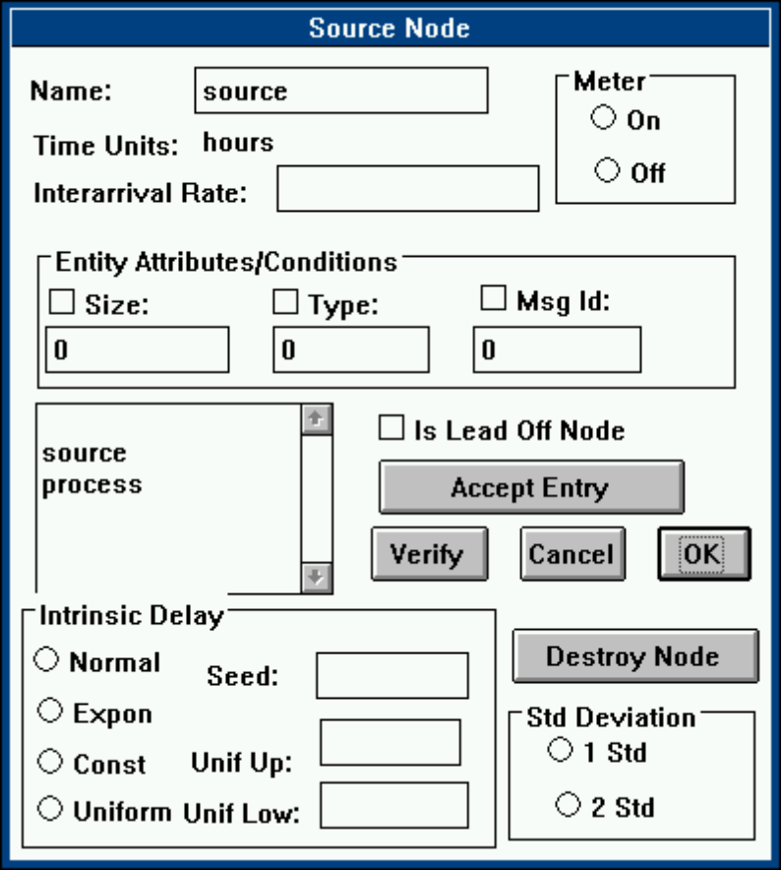

Figure 5. Source Node

Select a source node an position it on the model window; enable the dialog box with two clicks of the left button. Working from the top, select the appropriate parameters.

Name

Select a name, "Source1", for example. This will be the name displayed beneath the icon for that object.

Time Units

This is simply a static text box which displays your selection of time units made in the Model Setups in the previous menu group; used as a memory-jogger.

Meter

The operation of the meters is discussed later. Meters are plots of utilization, throughputs and the like, which appear below the object it is plotting, and provide a real-time view into the activity of the object or node. It is activated with the radio button. Selecting “Meter On” with the radio button enables the meter and creates its icon. Selecting “Meter Off” disables the meter operation only. You must destroy the icon with either the window’s system menu, or with the “Destroy Object” button in the meter dialog box. You can create multiple meters by toggling the radio buttons: each time the “Meter On” radio button is turned to the on position, a new meter is created. Each meter can then be directed to display a different run time parameter, as described below.

Inter arrival Rate

Essentially, service delay is to a process node as inter arrival rate is to a source node. By this definition, it is the delay or interval between the "spawning" of each event to a successor. you are entering a mean value as an integer.

Entity/Attributes and Lead off Node

Select attributes to be propagated along with each event generated. These attributes may be tested by process conditions; if the attributes meet the test conditions, the process may select certain results processing . This attribute/conditions/results paradigms is termed conditional processing. All events generated by a given source node have the same attributes, but you may have more than one source node. If you do have more than one source node, one of them must be the "lead off" node to start the simulation.

Successor/Target

The source node must have one or more successors to target its events. Select an object from the list box and then press "Accept Entry".

Arrivals
The purpose of this check box will be elaborated in the “Outputs” section of this User’s Guide. Essentially, checking this box will cause a file to be created in the default directory, which contains two columns; the first contains a running count of the number of events generated. The second column contains the simulation time.

Verify

All dialog boxes will have a "verify" button. This is to permit you to view the simulation setups as Simplexus sees them. You may dump this output to a printer using the print menu selection in the first group of menu items “File”, or, by using the check box, enable the dumping of these parameters to a disk file. (This dumping capability is provided only for source and process nodes in this release.)

Figure 6 Node Setup Parameters

Figure 6 shows the parameters for all node objects: sources, process, and resources. Obviously, not all fields apply to all objects. Insure that all parameters entered in the dialog boxes are reflected in the setup parameter list. For source nodes, service delay is equivalent to inter arrival rate. Event attributes are not reflected; node conditions and results are reflected, and these are reflected as object attributes, or attributes which inhere in the object or node. Display of event attributes are an omission which will be implemented in a later release of this product. Please note that the text window which displays the object attributes as shown in Figure 6 is a dump of the values of the global variables which will characterize this particular object, and not the values of intermediate variables. If these values are in error the simulation will not execute or will execute improperly.

Distributions for Intrinsic Delay

Law and Kelton, cited above, describe the uses of various probability distributions in simulation activity. These are summarized from pp. 330 - 341, Simulation Modeling and Analysis as follows:

uniform --- used as a "first" model for a quantity that is felt to be randomly distributed between a and b but about which little else is known.

exponential -- inter arrival times of "customers" to a system. You will want to use the exponential distribution in the source nodes. Also, may wish to use this distribution for service delays. Much has been written of this distribution in the literature, particularly with respect to the number of arrivals, which are said to be Poisson, or discrete-value and normally distributed , while the exponential probability distribution function refers to the frequency of the arrivals. For these reasons, exponential distributions are frequently used in queuing theory and models.

normal -- errors of various types, e.g., the impact point of a bomb; quantities that are the sum of a large number of other quantities.

constant -- this, obviously, is not a probability distribution function, but is provided as a means of entering a non deterministic parameter. Not all things in life are random.

Future releases of this product will provide binomial and lognormal distributions.

Seed

Simplexus provides the capability for up to 100 random number seeds. Simulations should utilize multiple random number seeds (or "streams") in order to preclude spurious correlations. Both Jain and Kelton/Law enumerate the dangers of using a single seed for multiple processes; read and heed. The random number generator is a Marse and Roberts linear congruential generator with a large period. Enter a number between 1 and 99.

Please keep in mind the following: assuming that the same seeds are entered for the first and subsequent runs, and all other parameters unchanged, identical results will be obtained. This is because the “streams” resulting from the random picks are totally deterministic. This can be a blessing or a curse. There are, for example, occasions where you would want identical results, such as when replicating an experiment for a customer. At other times, you would want to perform “independent replications”: by varying the random number seeds, you can obtain results which should be similar but not identical. Indeed, Jain proposes that one of the goodness tests of a simulation is that it should produce similar results with different seeds. Law proposes, however, that independent replications be performed to provide a sufficient sample size to perform measures of confidence.

Independent replications are particularly important when the number of events or “arrivals” into the simulation is insufficient to calculate confidence intervals: an unfortunate but sometimes real situation. It is best to have a sufficient sample size; for example, if your requirement is to provide that an end-to-end delay shall have a mean delay of 5 seconds with 95 percent probability and 90 percent confidence, you need at least 103 samples.

Upper/Lower Bound

For uniform distributions, enter an upper and lower bound; insure the upper bound is greater than the lower bound.

Standard Deviations

Enter one or two. The normal distribution provided is a standard normal distribution and no provision is made for varying the kurtosis of the distribution.

Workstations and Host Nodes

Select and place these objects. Open them and place your process nodes inside, as well as your CPU node. Place your disk nodes inside or out, and your LAN nodes outside. You do not have to use workstation and host nodes: they are strictly “container” artifacts with no functionality whatsoever. There are no dialog boxes for these objects.

Process Nodes

The dialog box attributes for the source node above will be repeated for each of the objects in the menu, with slight variations. For process nodes, the main difference is the inclusion of a "conditions" matrix dialog box as a nested dialog box. This dialog box provides for populating process objects or nodes with load (or environmental) conditions and processing conditions. Additionally, results may ensue from these conditions. These results, for example, may take the form of a change in intrinsic delay, or may take the form of a special result called a "message". Actually, this is result is not so much a message as a control signal or "control flow" if you will , which is overloaded onto the event which is spawned from the process. This overloading of the event notice occurs in much the same way that the source node initializes each event notice it spawns with specified attributes. The difference here is that the "control signal" or trigger is meant to cause a disk or LAN to behave in certain ways (e.g., write or read various amounts of data). Figures 7 and 8 show the process and conditions matrix dialog boxes, respectively.
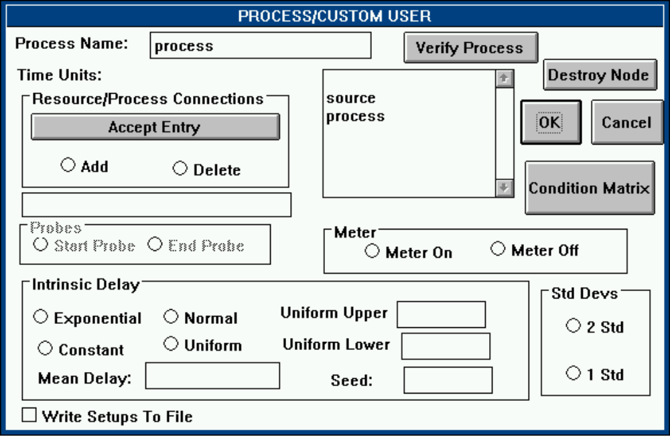
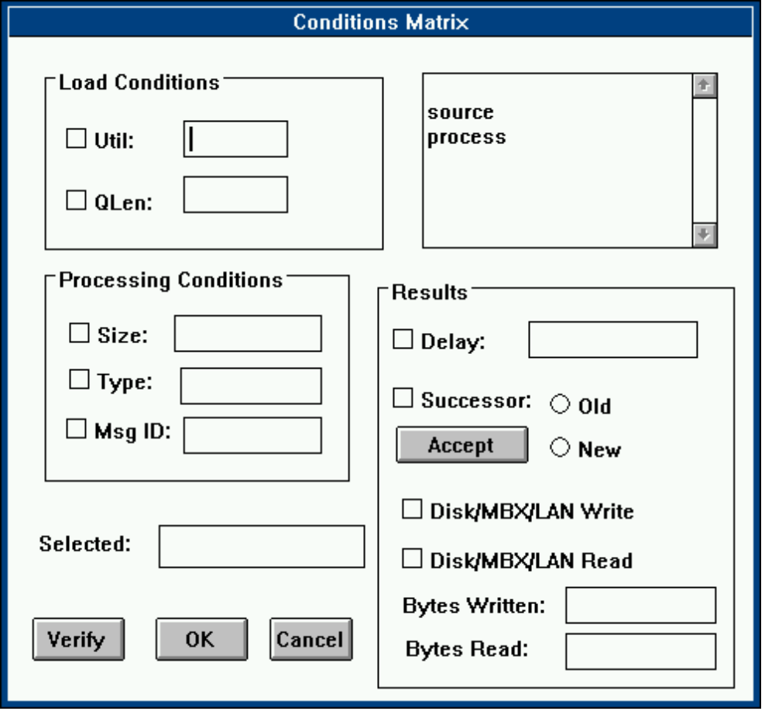

Figure 8. Conditions Matrix

Process Dialog Box
Complete the process dialog box in the same way as the source box. Use the following sequence to enter successors. (1) enable the “Add” radio button, (2) select the resource or process which is to be linked to the current process, (3) press the “Accept Entry” button to register this selection . For additional links, select the candidate from the list box, and press “Accept Entry” for each.

To delete a link, (1) enable the “Delete” radio button, (2) select the entry from the list box that you wish to delete, (3) press the “Accept Entry” button to register your selection.

If you (1) desire conditional processing or (2) have selected disks, LANs., or mailboxes as successors, you must populate the conditions matrix box , as described below.

File Outputs

For process nodes, five files may be written: utilization, queue length, number of arrivals or events, throughput, and response time. For resources, percent used [full] is provided, although these have significance only for disks, LANs and mailboxes. The six measures are described in the “outputs” section below. the files are named with the process name as prefix, followed by F1, F2, F3, F4, F5 and F6 as suffix, corresponding to utilization, number in queue, etc. as noted above. The default names for process nodes are process-0, process-1, etc. These names are one character too short for MS-DOS to open a correct filename, and the C function fopen which is used for these files will therefore fail. To insure that the files are opened, if you desire this output, simply shorten the default name to 8 characters or less, using the edit text box for the process name in the process dialog box.

Conditions Matrix

The conditions matrix dialog box servers two purposes. First, it permits the user to characterize the data to be written to a disk, mailbox, or LAN, and secondly, it permits to characterization of conditions and resulting actions for each process. There are, therefore, attributes, conditions,
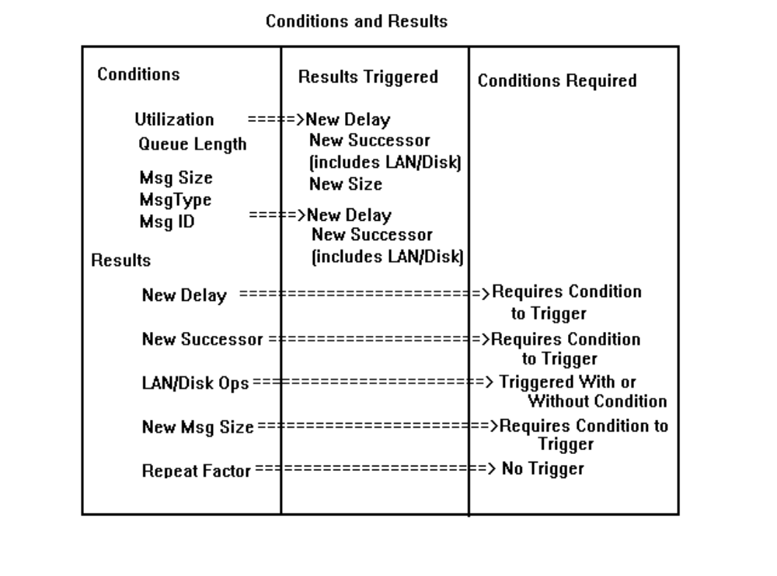

Figure 8a. Conditions and Results

and results, all of which can be used in different ways to simulate activity. Figure 8a summarizes these relationships

You will note that (1) not all conditions trigger all results, and (2) The check boxes for the Disk/LAN/MBX and associated edit boxes can be used with or without conditions. Finally, note that the edit box for the repeat factor is unconditional, that is, used without any conditions, while the edit box for the new message size must have a queue size as a condition.

If you specify a queue length of five, and as a result a new size of 5000 bytes then (assuming that the incoming messages are 200 bytes), you can approximate the activity of a packet assembler. Conversely, if you specify a queue length of zero,
and a message size of 100 bytes (vice 5000 bytes), and then specify a repeat factor of 5, you can mimic the action of a packet disassembler. Keep in mind that you can have a process with zero intrinsic delay. That is, you can have processes performing conditional processing that do not have any delay in simulation time, such that the activity of the packet assembler can be disassociated from, for example, a process representing OSI layers 4 through 7.
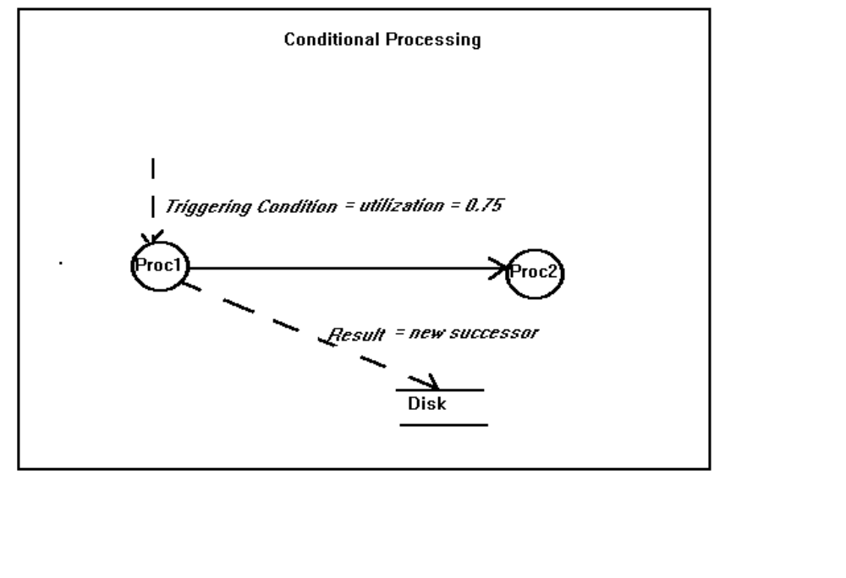
Figure 8b. Conditions and Results

Event notices, as noted above, are overloaded to act as “carriers” for attributes. Normally, these attributes are loaded by the source nodes; occasionally, in the case of disks, LANS, and mailboxes, they must be loaded at a given process. If the attribute so stated meets a test condition then a result may be enabled. This is called conditional processing. The conditions matrix dialog box provides a means of specifying the test conditions and the results which will be tested against the attributes loaded into the source boxes. Figure 8b shows the condition as a trigger which causes output to be redirected to a disk. -The conditions fall into two categories: load (or environment ) conditions and processing conditions.

Load/Environment Conditions

If the utilization or queue length of the process reaches the specified level, then results are triggered. The result may be to write data to disk, change an intrinsic delay, cause a new message size to be generated (as in a packet assembler), or spawn an event to a new (different) process or resource.

Processing Conditions

For processing conditions, a test is made of the entered value against the value entered in the “source” box for equivalence. If the test passes, results are triggered, which may be one or more of the results noted above. Note that the “Message ID” is simply an integer specifying the “nth” message generated, so it is a one-time test. The type is an integer: multiple source nodes may be set up to generate all messages (events) of a type; these messages will be mixed into the system, and this test will trap messages of a single type. The same processing occurs for messages (events) of a given size.

Results - Old and New Successors

This is the most complex of the results, and operates in one of several ways as follows:
(1) If the result is to switch a link, or output, to a successor from an “old” successor to a “new” successor, then do the following: check the “successors” check box, enable the “old” radio button and select the entry from the list box. The press the “Accept” button to register it. Next, perform the same sequence for the “new” process or resource, enabling the “new” radio button. The effect of this result is to vector an event to a “new” successor if one or more conditionds are met. Example: if you have a small-capacity disk and a large capacity disk, and you wish to vector output to the large capacity disk in lieu of the small disk, if the message received is greater than 5000 bytes, then you would use this feature. If the message is less than 5000 bytes, output continues to go the small (or “old” disk).

(2) If the result is to conditionally vector output only, then do the following: check the “successors” check box, enable the “new” radio button, select the entry from the list box, and press the “Accept” button to register it. The effect of this result is to vector events to a “new’ or contingent successor if one or more conditions are met. Example: if the queue reaches 50 or more, send 500 bytes to the disk. (This effect may be used to mimic the saturation of a receive buffer by dumping the excess to disk). Example 2: If message id 5280 is received, send a message (event) to process y.

Results - Disk/LAN/MBX Activity

With respect to mailboxes and the like, first, determine if the data to be transferred is conditional upon a successful test of an attribute. If you have a disk which is, for example, a routine or normal asynchronous successor to a process, then you you must do the following: (1) check the read or write check box as appropriate, and (2) enter the number of bytes read/written for each read/write. This value will be a mean value; Simplexus will use the exponential probability distribution function and the entered mean to determine the byte count written to disk, mailbox, etc. The event notice will “carry” these values to the disk and the disk will combine them with transfer rate, to determine its intrinsic delay. Finally, do not forget to, populate the dialog boxes for the disks, LANs and mailboxes as appropriate, after closing the conditions matrix and process dialog box.

If you have determined that you only want the disk accessed after conditions have been met, then do not set it up as a normal successor (in the process dialog box), but set it up as a conditional successor in the conditions matrix dialog box, by (1) selecting the processing or environmental conditions, and (2) selecting the disk/LAN, etc from the list box in the conditions dialog box..

Keep in mind that all simulation objects in Simplexus must be stimulated by an event to execute. Remember also, that the bytes read/written and the check boxes must be enabled regardless of whether the disk is to be written to absolutely or conditionally .

Finally, do not enter conditional successor resources which themselves are likely to be stalled. These resources include all synchronous resources, but especially the CPU, synchronous disks, and msynchronous mailboxes. Simplexus is not robust enough to reschedule these conditional resources.

Data Transformation

Large computer systems frequently employ some sort of data transformation. This is especially true as related to LAN operations, were data is manipulated from messages to datagrams to packets to frames to bytes to bits as it traverses the ISO model’s layers and is sent between systems or subsystems. Even within systems, data is frequently typecast and manipulated. A future enhancement calls for the creation of a data transformation node which, as a minimum, will provide representation of a packet assembler/disassembler. Until then, use the New Message Size and Repeat Factors to generate a workaround for the packet assembler/disassembler problem as discussed above.

Resources

The operations of the resources will now be described. Again, to recapitulate what was noted above, resources are not so much tokens which are siezed and released, as process or workcenters which are stimulated by events. Thus, messages are “sent” to the LAN, rather than the LAN being “seized”. In Simplexus, all resources are varients of synchronous or asynchronous operation (usually reads or writes), and exhibit various forms of service delay. For this discussion, the CPU will be discussed first, followed by disks, LANS, and mailboxes; these latter three have much in common and can be reviewed as a group.

Remember that each resource has a corresponding dialog box which is used to characterize the resource. For the CPU, there isn’t much to characterize; even so, you must remeber to open the CPU dialog box even if you do not intend add any characterization ( a name, for example). The reason for this is the dialogs provide significant default values to the resources when they are invoked.

Resource Scheduling

Resources are scheduled, or accessed, according to the following rules.

CPUs, Disks. The CPU is a completely synchronous resource, while disks may be either synchronous or asynchronous. There are four states and modes which determine how and when a disk or CPU is scheduled: synchronous and idle, synchronous and busy, asynchronous and idle, and asynchronous and busy.

If all resources are idle, whether synchronous or asynchronous, they are scheduled for immediate execution.

If the resources are a mix of idle synchronous and busy asynchronous, they are scheduled for immediate execution.

If all resources are asynchronous, and one or more are busy, all are scheduled. For a busy asynchronous resource, the event notice is placed on its queue. For idle resources, execution occurs immediately, without queueing.

If one or more synchronous resources are busy and not available, the availability of each is calculated. Then, the execution of the requesting process is extended to match the resource with the latest availability. This time extended is termed “Resource Wait”. At the conclusion of the resource wait the requesting process continues its execution. Meanwhile, an event notice has been placed in the queue of the busy resource, and it executes that event in FIFO fashion.

LANs. LANs are essentially always “available”, inasmuch as one or more process may have access to them concurrently, whereas other resources may be accessed by processes serially. For LANs and mailboxes, the trick is to synchronize access to them. A concept which is central tro LANs and mailboxes is that of an enabeling trigger. A process can only execute if if is triggered by an event notice, so that the reader needs to be triggered to read when data is sent to it, and then toggle a semaphore to notify the sender to send again. This relationship is shown in Figure 9. Note that the process/LAN is a one-to-one relationship in that you should have a single process write to a single LAN and trigger one or more reader processes. A reader process should read only from a single LAN. You may wish to make a lump-sum characterization of OSI layers 4 through 7 as a single “transporter” process.

For User Datagram Protocol (UDP) LANs, access is entirely asychronous, so that the LAN is never unavailable. This does not present a problem for the sender or writer, but may present a problem for the receiver if no data is on the line. In DECNet CSMA/CD situations, each node “listens” to the broadcast, but only the addressee gets it. For the rest, the data is merely a pass-through. In Simplexus, only source nodes act autonomously (without an event triggering it), so that for UDP LANs this can create an awkward situation for asynchronous readers. Essentially, therefore, you must trigger a reader to read; data remains on the line until it is read by the last reader, so for asynchronous situations, the reader is triggered by an event from the sender and it reads the data which is on the LAN. To broadcase, for example, the sender would be required to trigger each reader in sequence. If a reader is triggered out-of-sync with the no data availabile, then a trace message is posted. You can only see this message if you have trace enabled. Note that for UDP LANs, depending on the frequency and source of the reader’s trigger, it is possible to have multiple reads for each write or multiple writes for each read. Much depends on the intrinsic delay of the process doing the sending as opposed to that of the reading process, such that if the sender delays 30 milliseconds to send while the reader is stimulated every 10 milliseconds and takes 15 milliseconds to read... .

For TCP and X.25 situations, the reads and writes are synchronized with semaphores, so that a a write cannot occur without a corresponding read and so forth. Should a writer attempt a write without being write-enabled, then the writer process is deferred a random delay of less that 1 time unit and a retry attempted. If a read never occurs, then the writer is stalled and a trace message is posted. The same process occurs for reader processes.

Resource Contention

The normal situation is for contention to be characterized as a function of queueing and the delays associated therewith. This is the method used for disks and CPU. For LANs, contention is a function of its capacity utilization and not of its availability (with the notable exception of the Token Ring). Thus, for non-Token Ring LANs, as capacity utilization increases, the probability of contention increases. As the probability of a “hit” occurring increases, a pick from a binomial distribution will determine the probability of a single hit from a single try (the cumulative binomial is not used). If a hit occurs, the sending or receiving process will back off and retry after a random interval of less than 1 time unit (usually, millisecond). This generic backoff and retry is used for all LANs for all types of contention: collision, line noise, whatever.

Token Rings present a special problem, since only one process may transmit at any time. Again, Simplexus tries to mimic the essence of the round-robin token passing without replicating the technology. A token (semaphore) is passed between processes. A process may transmit if it is the next sender or transmitter. If it is not the next sender or transmitter then it is deferred for a retry until it is the next sender, at which time it is scheduled for execution. Though possibly a violation of the Token Ring spirit, readers may read any time they are triggered. For contention of Token Rings, then, it is possibly wiser to consider utilization (time busy over time) as a better measure than capacity utilization.

Finally, and most importantly, note that LANs and mailboxes exhibit no queuing (since they are, in a sense, always “available”), but that the process sending and
receiving to the can and may exhibit queues. If, for example, on a TCP LAN, process A sends to process B, where process A receives data every 10 milliseconds but takes 15 milliseconds to send it to process B. At the end to the 15 milliseconds, process A signals process B to read and process B takes 20 milliseconds to read. In any case of B, process A will start to saturate and queue.

To summarize, the scheduling of synchronous resources other than LANs and mailboxes essentially defers the requesting process until the time that the resource is “available”. As for the resource, an event is place on the resource’s event queue and worked in the same manner as for asynchronous resoruces. LANs and mailboxes present special problems, where contention is a function of capacity utilization. As capacity utilization increases, the probability of a collision or other non-receipt situatation by the receiver arises. This probability is enabled through a pick from a binomial distribution where, as the utilization increases, so increases the probability of success for a backoff and retry on a single try. Lastly, Synchronous mailbozes may exhibit tendencies for “deadly embrace”, or the case where a writer attempts to send and the reader is not (and may never be) read enabled, and vice-versa. This is the topic of the next section, Blocking.

Resource Blocking

Synchronous resources which requaire the synchronized action of a reader or writer pair may become blocked either temporarily or permanently. For temporary blocking a simulation timer is invoked, and another attempt is made to seize the resource. If a process has no successor processes which are enabled to read or write to the resource, the resource is said to be in a “deadly embrace”, i.e., the process writing to it is stalled forever. The resources which are most prone to this are connection-oriented LANs and mailboxes. Whereas Simplexus attempts to resolve this situation with a backoff and retry, and attempts to determine if a deadly embrace has occurred, the simulation itself cannot break such a deadlock. Some suggestions to prevent deadlock are as follows:

Mailboxes. Insure that the same amount of data is read out of the mailbox as is read into it, as the synchronous mailbox can never be enabled for write while it still contains data, and can never be enabled for read if it does not contain data.

Mailboxes and LANs. Provide sending and receiving processes that have constant (not stochastic) intrinsic delays. It is acceptable for the processess preceding and after these processes to have stochastic delays - any queueing will be calculated against these processes. This arrangement will provide for a very deterministic sending/ receiving pattern across the resource. Finally, insure that the sender’s delay is greater than the receiver’s. If it is not, the sender will always be busy awaiting the completion of the read. For mailboxes, remember to have only one sender and one receiver . Remember also to enter the required data in the conditions dialog box, namely, (1) enable the read/write chack box, and (2) enter the amout of data in bytes read or written. Finally, remember that all readers are triggered by the writer, so that each writer will have two successors - the resource and the process which is to read the data.

CPU

The CPU delay is completely adaptive and inherits the delay of the process executing. No capability exists for pooling, batching or ganging CPUs, which effectively forecloses representing SMP, or symmetric multiprocessing. With several CPUs shown, you can, however represent asymmetric multiprocessing by mapping a given CPU to one or more processes. Also, the operation of the CPU is completely synchronous to the requesting process: if the CPU is not available, then it’s availability is calculated from its queue length, and the requesting process is rescheduled for execution at the next available CPU time. Currently, different scheduling algorithms are not supported; future enhancements are intended to enable these dialog box selections which are shown as grayed out. Hopefully, these improvements will incorporate priority schemata as well as ageing.

Disk

For the discussion of disks, mailboxes, and LANs, please refer to Figure 9 below.
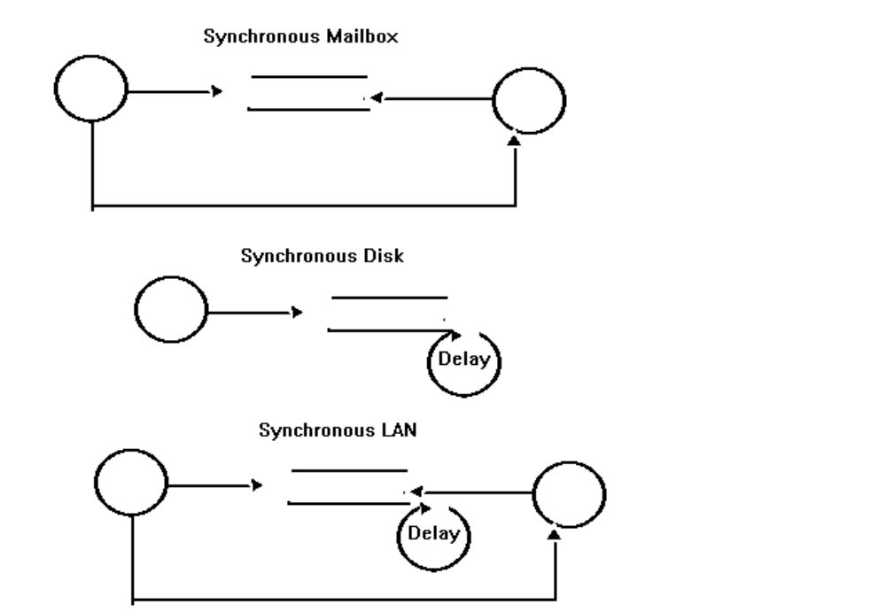

Figure 9. Synchronous Operation

The disk can operate either synchronously or asynchronously on both writes or reads. (For reads, the reading process is almost required to operate synchronously if it is to receive the data.) It is not necessary that a disk have both writer and reader processes sending to it. For asynchronous operations, events are simply queued up ath the resource and executed as they appear on the event list. For synchronous operations, the scheduler determines the simulation time associated with the event list and reschedules the sending or triggering process at that time, in the same manner as the CPU above. Service delay is a function of disk access (composed of seek and rotational latency), and transfer (number of bytes times transfer rate). The seek times are intend to be mean random seek, and not track-to-track.

An important conceptual element common to all three resources, is that process send events to it. The event can either provide data or remove data; this contrasts to the resource being sent data and then sending data to another process as that process reads. Again, the conditions dialog box provides the means whereby these reads and writes are specified.

LANs

Local Area Networks (LANs), and more generally communications are the “tarbabies” of simulation modeling. This is because that, once the commitment has been made to model them, it is difficult to abstract their functionality upward to more general levels in a clean and forthright manner. Books have been written on the subject, and several outstanding tools are marketed which deal exclusively with LANs and communications. The Simplexus objective is simply to provide a baseline functionality which can be used and included as a general representation in systems whose primary performance effects are not communications related.
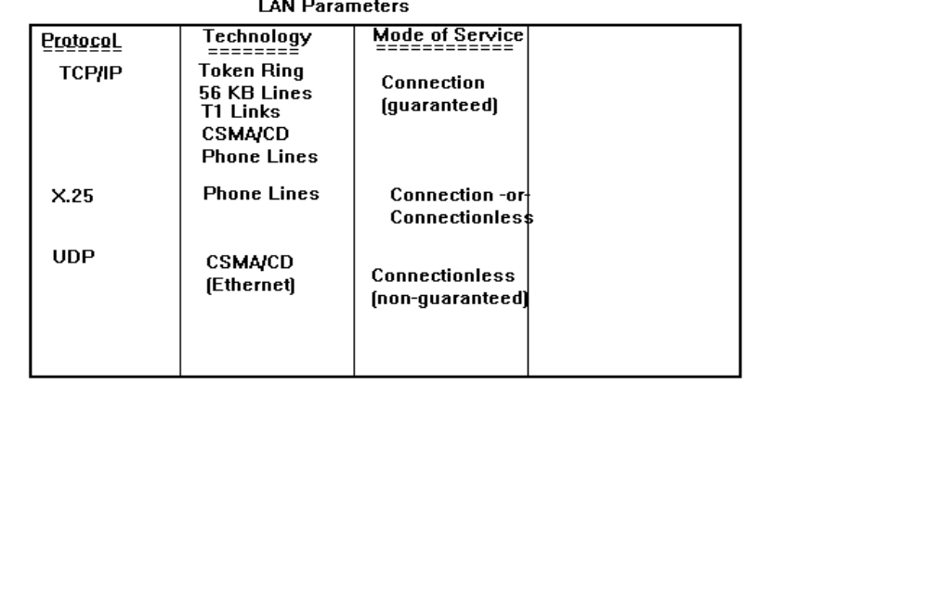

Figure 10. LAN Parameters

Consequently, the essential functionalites have been abstracted upward into somewhat generic configurations. The LAN or communications represented here is a complexus of three key parameters: protocol, technology, and mode of service, where mode of service translates roughly to synchronicity (synchronous or asynchronous access). Figure 10 summarizes these relationships. For this release, SNA is not included, so that the available protocols include TCP/IP, X.25, and UDP (User Datagram Protocol). These cover the most widely used situations and, as implemented and noted, are somewhat generic. The dialog box provides for the setup of the parameters as shown in Figure 10.

It is important to note that a LAN is read from and written to in much the same manner as a disk. That is, writes and reads must be to the LAN as a successor, and reads must be triggered. Even though, for example, UDP/Ethernet may be described as a connectionless, non-guaranteed delivery system, the reality is that a listener node must actually read something which is on the line, and so , as noted above, must be “triggered” by the sender.

Also note that, although the X.25 protocol is listed as both connection and connectionless oriented (it presumably has this capbility -see ISO Standard 8473) Simplexus implements it as a generic connection-oriented protocol using phone lines. Enter the baud rate as bits per second, such as 14400, etc.

Finally, note that transmission media are assumed to be perfect, and that contention for LAN is solely a function of the LAN capacity utilization, so that, for example UDP/Ethernet, a backoff and retry is accomplished as a function of increasing utilization, with the retry interval of less than 1 millisecond. For synchronous protocols, the stochastically generated delay and retry will simulate a NACK.

For the Token Ring service, contention will more approximate the busy/idle states of other resources and processes, where the LAN will be unavailable during the period that the token is transmitted. In other types of service, the LAN is, in a sense, always “available”. Please use Figure 10 in configuring your LAN, and do not generate protocol/technology combinations which do not make sense.

Mailboxes

Except for LANs, the mailbox interprocess communications device (IPC) is the most complex, and is inspired by the VMS model. Mailboxes are nothing more than RAM which is set assigned as a logical device, and which is allocated to one or more processes. Whereas real mailboxes can be written to and read by one or more processes, Simplexus supports only a single reader and single writer per mailbox. Mailboxes have several combinations in their form of operation: synchronous writes, asynchronous reads, synchronous reads, asynchronous writes, asynchronous writes and reads, and synchronous writes and reads. Of these, the synchronous writes and reads are the most complex, since the writer cannot write if a message is in the mailbox, and a reader cannot read if no message is in the mailbox, so that the operation must toggle back and fourth between writing a single message, read the single message, and repeat. Asynchronous writes are “load and go”, while asynchronous reads are “read and go”. If an asynchronous mailbox is full, the excess messages written to it "fall on the floor", or spill out. If a synchronous mailbox contains a message which is never read, the sender will be stalled forever. Conversely, if a mailbox reader is wwaiting on a sender to load the mailbox, and the load never occurs, the reader will be stalled forever. Obviously you do not want this to happen.

Memory

Semiconductor memory is not represented as an object. Model possible paging activity as an aggregate or lump-sum overhead on CPU and disk resources.

User Defined Process

See the discussion above relative to the USERCODE.DLL and UserFunc1. You may provide your own C code to represent an intrinsic delay, either simulated or actual code. The user defined process node is identical to the process node except for this capability to call UserFunc1 to return an intrinsic delay. Regular process nodes will never call UserFunc1, so, even though the two nodes share the same processing code, they are provided with their own icons and windows structures. This separation thus provides a means of splitting off the user defined processes from the predefined process nodes.

One of the most useful techniques is to use the USERCODE.DLL to contain a prototype code unit , which can then be driven by the simulation model. The code unit can therefore be tested in situ, or within the simulated context of the larger development system. The timing results thus obtained can then be mapped against performance requirements budgets for that particular utit to determine if the unit will meet its performance requsirements. When the aggregated timing results for an entire executable thread are lashed together, the system end-to-end timing budgets can be validated.

Another technique is to use the USERCODE.DLL to develop a specialized process node with greater definition and fidelity than the general purpose process node. Typically, when a process node “executes” it merely delays and amout of time. Simplexus attempts to add value to this delay with some conditional processing features, but even so this ‘delay’ can be considered a gross oversimplicication of the way things really happen when a process executes. Consequently, you may wish to model a process which depends on a multiplicity of variables, and the USERCODE.DLL link library is the best way to characterize this functionality. You can also use the window handle for the main window (which is passed in as a parameter) to display message boxes within your code.

You must use a 32 bit compiler to compile USERCODE.DLL; the Microsoft Visual C++ for 32 bit applications was used in for this release. You may not compile the DLL with any 16 bit compiler - the source code formats for the DLL are too dissimilar. A makefile, for use with the Microsoft 32-bit version 7.0 command line complier has been included in this distribution. If you use the Borland 4.0 compiler or the Microsoft Visual C/C++ 32-bit compiler, simply place the source code and the *.DEF file in the project file templates for these compilers.

Place your code inside of the UserFunc1 template and return a real value representing an intrinsic service delay to the calling process. Note that multiple instances of a user defined object will each call UserFunc1 and will each execute identically, unless provision is made in UserFunc1 for separating them. Black Forest Software cannot, for proprietary reasons, provide users access to the full set of global symbols for manipulating and updating values in UserFunc1, however, if more capability is required, call Black Forest Software and we will consider changing the visibility of symbols, call or return parameters on a case-by-case basis.

Meters

Figure 11 shows the setup dialog box for meters. Meters are enabled by means of
a radio button in most of the object dialog boxes. A meter may display the utilization, throughput, number of arrivals, or queue length for the node or object that it is attached or linked to. meters will display this output either in iconized or zoomed windows, in either text or plot output. The procedure for showing a meter normal or zoomed is as follows: (1) open the meter dialog by double clicking with the left mouse button. (2) press the show normal radio button
(3) re-iconize the window by pressing the OK button, (4) double click again. The window should show normal.

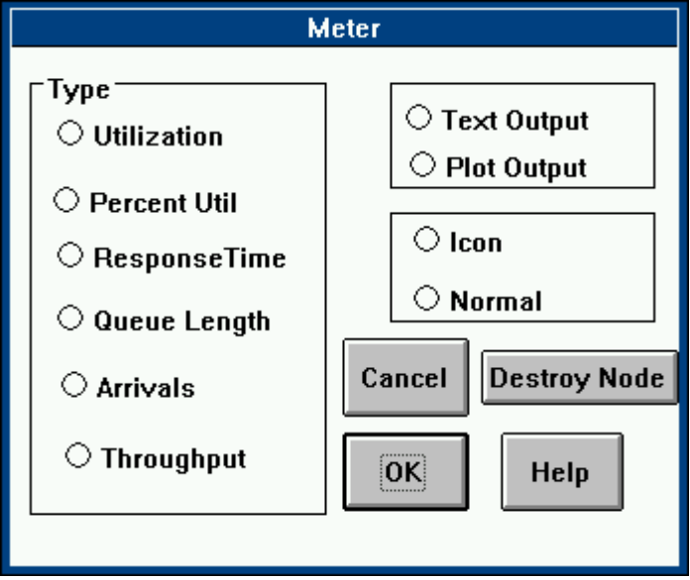
Figure 11. Meters

Destroying Simulation Objects

Method 1:
Destroy nodes by selecting Destroy Node in the Dialog box for it. Destroying a node removes its graphic, but the underlying node parameters remain, much in the same manner that deleting a file under DOS does not remove its data from the disk.

Method 2:
Use the System Menu pulldown in the upper left corner of the window to close (and hence destroy) the window and node.

Destroying Graphics Objects
All graphics objects (including text), are drawn within an imaginary rectangle called a “bounding” box. using the right or middle mouse button, select a point within the object to be destroyed with a single click. A message box will prompt you to destroy the object or cancel the action.

Removing Links or Connections Between Nodes
Using the right or middle mouse button perform the same action as above for graphics objects. Verify that the correct deletion has occurred by opening the process dialog box for either the source or destination node, and pressing the Verify Process button.

Outputs
Simplexus provides for several forms of outputs, including summary reports of results, raw data reports, bitmap captures, and trace outputs. Additionally, output can be shown, in real time by means of meters and animation.

Highlighting

As each executable node begins its processing, it is highlighted with a rectangle for the duration of its execution cycle. Note that this is not a precise measure of the execution of the node, inasmuch as the highlighting is triggered by Windows timer messages, and these messages are not accorded a high priority for processing in the Windows event queue. It is suggested that the highlighting be combined with windowed trace for a more precise rendering of the processing states of the simulation. The highlighting cannot be turned off. The following colors indicate the degree of utilization:

green - 0% - 50%
yellow - 51% - 95%
red - 96% +

Utilization for LANs is expressed in terms of bandwidth; for disks, it is interpreted as capacity used.

Trace

A single level trace is provided both as a text file and as windowed trace. Chose either or both. Note that the window trace is controlled by a timer: in order to be useful the timer interval should be greater than 1 second. This, however, makes the simulation execute very slowly. The suggested use is to use the trace to debug a simulation. For presentations, the window trace is useful for showing the progress of the simulation and for providing the audience with a view into what is happening "behind the scenes". The trace file output is dumped to TRACE.OUT. This can become a very large file very fast, so do not use the text trace for extended periods.. Also keep in mind that, although other forms of output (the *.F1 files for example) use buffered output, the text trace flushes the file buffer on each write. This is to insure that, during debug, the text file contains the very last trace statement. The implications of this is that, for large or long simulations your system’s file IO subsystem will be working very hard to write the trace file output.

Instantaneous Raw Data

These comprise the six *.F* files noted above: utilization, queue length, total events, throughputs response time, and percent full. As noted, the file produced is a text file containing two vectors: the first is the instantaneous datum, while the second is the simulation time. Numerous excellent data reduction and visualization tools are available which can be used to analyze these results off-line. These include PV-Wave, Unifit II, Mathcad, and Graftool. One might plot the metric on the X- axes against the simulation time on the Y-axes. You can also use the “arrivals” plot to produce an ex-post arrival profile for comparison against an original scenario event profile, or to generate an original profile which can derive a simulation. To do this, take the second column, “simulation time”, and extract the differences of the intervals between succeeding times. These deltas, or inter arrival times, should then be pasted to another file; call that file “SCENARIO.DAT” . Scenarios produced in this manner incarnate the activities of one or more of the process or resource nodes. The following definitions apply:

(1) Utilization. Defined as time busy over time.

(2) Number in queue. This, as noted above, is simply an instantaneous metric or “snapshot”.

(3) Arrivals. These refer an event notice for any node at the point of commencing processing, i.e., an arrival event has been posted and is starting execution. If the server is idle, it will execute; if the server is busy it (the event) will wait in the server’s queue; if the server must seize an unavailable synchronous resource, then its state [the server’s] is awaiting resource.

(4) Throughput. Defined as number of events over time. Results are expressed as number of events per time unit.

(5) Response Time. Defined as intrinsic or service delay, plus resource waiting, plus queuing delay. For example: the actual time to conduct a bank transaction includes waiting in line (queuing delay), the time at the teller’s window (intrinsic delay), and the possible time that the teller may be at the vault getting cash (resource wait).

(6) Percent Used (or full). This metric is sometimes confused with utilization above; it relates to device capacity and the percent of that which has been used or consumed. Obviously, for storage devices or Local Area Nets, when these are full disastrous consequences can result.

Reports

Both the on-line and summary reports are produced automatically, and are a superset of the six metrics above. Metrics for resource waiting have been broken out, as have other metrics for service delay and queuing. The text file is named SIM.OUT and is in the default directory.

Graphics

The plots, or meters which may be generated to show the real time progression of utilization and other parameters can be captured for rendering into word processors, slides, etc. The following procedure is recommended: (1) press the Pause/Step button in the simulation clock. (2) bring up Paintbrush or Paintshop and another graphics application, (3) Enlarge the meter using the procedure described above for zooming the meter window, (4) press control-ALT-PrintScreen to capture the image into the paste buffer (5) Paste the paste buffer (clipboard) into the application, (6) save the file into an appropriate *.BMP file.

Inputs

Normally, your simulations will be driven from stochastic processes. That is, arrivals will be generated in real time from pick from a probability distribution function. If you use the same random number seed(s), you will always get the same results.

You may wish to experiment with scripted inputs, also known as scenarios. This is simply a series of real numbers. Each number represents an inter arrival interval. You can generate such a script with any word processor, or you may generate one with the built in generator. I have attempted to provide some crude phasing, which will vary the mean after a given number of events. The modulus of that number is the period for that mean, after which the mean is toggled back to the original value. This provides, more or less, a crude square wave effect. Anyway, scenarios provide a method for accommodating spikes or instantaneous bursts in arrival traffic, as well as precise and repeatable arrival profiles. They definitely have their uses; name the scenario file SCENARIO.DAT.

Execution Mode

Simply put, you may execute the simulation slow or fast ("Turbo Mode" , which probably seems a little gratuitous). For full presentation graphics, execute slow. For serious performance engineering and large or long simulations, execute fast.

To reset the run-time simulation variables and re-initialize the simulation, select the "Reset Sim" item. Alternatively, exit Simplexus and re-load it.

The Simulation Clock

A Simulation clock is provided as a window into the elapsed simulation time in the chosen time units. You may stop the clock by pushing the “pause” button to change simulation parameters, then re-start the clock and the simulation. You may also reset certain run-time variables to remove any initial transient, or “warm up” effects. If you dump, for example, the utilization values for a given node to a text file (as described above for the *.F1, F2, F3, etc. files), then you will observe the first few values may seen erratic and non-uniform. You may wish to “trim” these away from your results as initial transient phenomena by using this reset feature. Experiment for best results. The variables reset include: simulation time, queue lengths, event count, resource wait and queue delay time.

HELP

Unfortunately, not available in Simplexus for this release, on-line hyper linked help is a major enhancement goal for the future.

Chapter 5. Technical Specifications

This chapter will provide an overview of Simplexus’ capabilities. Whereas Simplexus can model a very large number of objects, it capabilities are finite. The following limits are provided; call Black Forest Software to tailor these to your needs:

Number of Models--10
Number of Nodes (includes process and resource) -- 50
Number of host/workstation nodes -- 20
Number of meters -- 50
Number of successors per process -- 10
Number of graphics objects -- 50

You can invoke as many instances of Simplexus on a given system as it will accommodate.

Examples

A. A Simple MM1 Model

An MM1 model is a single server, single queue model and is the simplest form of model supported by Simplexus. It is also the foundation for all other models that you may want to build, and consists of one source node and one process node. Let us step through a typical process of building, executing , and examining the output for the MM1 model.

Setup.
1. Pull down the Model menu item and select Create Model.

2. Position the cursor on the screen an click the left mouse button. The model icon will appear.

3. Open (“Zoom”) the model icon by double-clicking the left button.

4. Pull down the Model Elements menu and select Object; holding the mouse button, move to the right and select Source.

5. Position the mouse in the model window and click the left button to position the source node..

6. Using the same procedure as above, select a Process node and position it to the right of the source node’s icon.

7. Position the mouse inside the source node icon and double click to open it.

8. At this point you are ready to populate the source node attributes, or “characterize” it as we say. Working from the top, enter to value 70 in the Interrarrival Rate edit box. Use the Return Key on your keyboard for these values.

9. Now, in the list box you will see the words “source” and “process”. We will establish the connection of the process node to the source node. Select (highlight) the word “process” with your left mouse button. After it is highlighted (black) press the button labeled Accept Entry. This will register your selection with Simplexus.

10. In the Intrinsic Delay group box, select the button marked Expon for “exponential”.

11. Enter the value 10 in the Seed edit box. If no value is entered, Simplexus will default to 15 for the random number seed.

12. Press the button marked Verify. A window will appear showing the characteristics for this source node. Note especially the values for “Process Service Delay”, “number of Successors”, and “Successor Name”. These are critical attributes, and should show the values you just entered.

13. Dismiss the Verify window with the system menu in the upper left corner of the window.

14. Dismiss the source node dialog box by clicking on the OK button (do not click the Destroy Node button).

15. Now open the Process icon. In the Intrinsic Delay group box, select Exponential and enter the value 30 in the edit text box. Use the Return Key on your keyboard for these values.

16. As above, click the Verify Process button to examine your entries. Dismiss the dialog box with a click on the OK button.

17. Now, return to the main menu. Under Model, select Model Setup. We will now enter the run-time parameters necessary to execute the model. In the Model Name edit box, enter the word “Test”. In the Units group box, select “milliseconds”. In the Starting and Stopping group box select “Number Events”. In the Sim Time/Number Events edit box enter the value 10 and press Return, In the Input Source group box select “Stochastic”.

12. Verify your entries as above by clicking the Verify button.

Executing the MM1

1. Returning to the main menu, select Execute Move to Execution Mode and verify that Turbo Mode Off is checked. Move to and select Go!.
2. The message box Starting Sim will appear. Dismissing the message box will generate the simulation clock. The simulation clock will step off the events and the simulation time units until the magic number (simulation time or events) has elapsed.
3. The process or node executing is highlighted.

Examining the MM1 Output

1. Return to the main menu. Under Output select Report. You will note that the utilization of the source node is 100 percent or more. This is normal: the “service delay” of the source node is unique in that it is a measure of the elapsed time between arrivals. Effectively, then, the source node is never idle, since it spawns an event at the end of its service cycle.

2. Note the utilization of the process node and its queue. Examine the other outputs (or lack of them).

3. Exit the program, open a DOS window, and verify the existence of SIM.OUT in the default Simplexus directory. Browse this file and verify that the output is the same as for the on line report.

4. Repeat the above experiment, only reverse the service delay parameters, that is, enter 30 for the interarrival rate, and 70 for the process service delay. Expect to see, in the report, a queue developed, and a utilization approaching 100% for the process.

The MM1: Final Remarks

This has been a simple, almost trivial exercise. The results could have easily been calculated with pencil and paper. But it demonstrates the basic and fundamental building block of Simplexus. Larger simulations are simply aggregations on MM1s lashed together in some fashion. The important thing is to build your model slowly, establishing a pattern which prevents you from omitting critical details (like model run-time parameters, which I frequently forget). you can experiment endlessly with the MM1: change the delay probability distribution functions, select and enter unique names for the nodes, dump setup parameters to files, experiment with meters, experiment with “connectors” (graphical connection matrices)-- all within the context of the MM1. Once you are comfortable with the MM1, and have established a “rhythm” for entering the data and populating the dialogs, then move on to the more complex forms of modeling.

B. A Simple Computer Model

Setup

Develop the MM1 model above. Add to it a CPU resource and a disk resource.
Open the process dialog box and , from the list box, highlight successively the cpu and disk to link them as successors. After each highlighr in the list box, press the Accept Entry button. Next, press the Conditions Matrix button to bring up the Conditions Matrix dialog. Check the box for Enable Disk/LAN/MBX Write. Enter the number 2000 in the box labeled Bytes Written. Close the Conditions Matrix dialog and the process dialog. Open gthe CPU dialog and give it the name CPU-1 in the text edit box, then close the CPU dialog. Now open the disk dialog. Give it the name Disk-1. Enter a capacity of 230, and transfer rate of 800 and an access time of 12. Click the Asynchronous check box, and close the dialog.

Execute the Computer Model

Execute the model and examine the results. You should see no contention for the resources. As an experiment, link another process to the source node,and then link the CPU to it. Observe the contention for the CPU as measured by the CPU utilization. Now link the disk to the second process and observe the disk utilization.
Expand the Computer Model

Once the basic computer model is constructed, add LANs or mailboxes, insuring that the two parameters (Write/Read Enable, and Bytes Written/REad) are entered in the Conditions Matrix dialog box. Insure that each writer has two successors: (1) the mailbox or LAN, and (2) the reader. Insure that the Conditions Matrix dialog is completed for the reader as well as the writer. Start with a synchronous mailbox, then an asynchronous mailbox, asynchronous LAN, and finally, a synchronous LAN. Observe the effects of different loadings on these resources.

Sources

The following references have been found to be helpful in building simulation models:

Deitel, Harvey M., An Introduction to Operating Systems, Addison-Wesley, 1984

Hansen, Per Brinch, The Architecture of Concurrent Programs, Prentice-Hall, 1977

Holt, R.C.; Lazowska,,E.D.; Graham, G.S.; and Scott, M.A., Structured Concurrent Programming with Operating Systems Applications, Addison-Wesley, 1978

Jain, Raj, The Art of Computer Systems performance Analysis, John Wiley and Sons, 1991

Law, Averill M. and Kelton, W. David, Simulation Modeling and Analysis, Second Edition, McGraw-Hill, 1992

Luconi, Fred, Asynchronous Computatational Structures, (Thesis), Massachusetts Institute of Technology, 1968

Pritsker, A. Alan B, Introduction to Simulation and SLAM II, Third Edition,John Wiley & Sons, 1986

Russell, Edward C., Building Simulation Models with Simscript II.5, CACI, Inc, 1983

Shaw, Alan C. The Logical Design of Operating Systems, Prentice-Hall, 1974

Shlaer, Sally, and Mellor, Stephen, Object Oriented Systems Analysis, Yourdon Press, 1988

Shlaer, Sally, and Mellor, Stephen, Object Lifecycles, Yourdon Press, 1988

Sloan,M.E., Computer Hardware and Organization, Scienence Research Associates, 1976

Smith, Connie U., Performance Engineering of Software Systems, Addison-Wesley, 1990

Stevens, W. Richard, Unix Network Programming, Prentice-Hall, 1990

Tannenbaum, Andrew S., Computer Networks, Prentice-Hall, 1983

Van Huss, Ronald E. Simulation and Design in an Object Oriented World , ACM Tri-Ada ‘90 Conference Proceedings, Baltimore, Md, December 1990

INDEX

—A—
and trace timer interval, 33
application program interfaces, 19
asynchronous, 16, 27, 33, 61
—B—
back off, 56
bandwidth, 21, 22, 38
binomial distribution, 56
Black Forest Software, 6, 7, 8, 9, 10, 62
BONeS, 19
Borland C++, 6
—C—
CADRE Teamwork SIM, 19
capacity utilization, 56
CISC, 19
clock, 34, 35, 67, 69
Conditions Matrix, 50
Connectors, 41
constant, 18, 23, 37, 38, 46
continuous state, 16
cost, 7, 9, 19
CPU, 11, 18, 19, 21, 22, 23, 28, 33, 39, 47, 58, 62
CSMA/CD, 56
—D—
Data Transformation, 53
deadlock, 58
deadly embrace, 57
debug a simulation, 65
DECNet, 56
delete a link, 49
design, 7, 15, 17, 18, 19, 22, 24
discrete event, 6, 9, 15, 16, 17, 19
Discrete Event Simulation and Modeling, 15
disk, 10, 16, 18, 22, 24, 27, 38, 39, 42, 44, 47, 50, 52, 53, 62, 63
Dynamic Link Library, 7
—E—
effects, 16, 17, 18, 19, 25, 69
emulation, 16, 17
Ethernet, 61
evaluation, 7
event generator, 27, 29, 36, 42
exponential, 37, 46, 53
—F—
File Outputs, 50
fonts, 31
—G—
Graphics, 25, 41, 63, 66
—H—
Highlighting, 65
HIMEM.SYS, 11
host nodes, 27, 42, 47
—I—
icons, 7, 11, 28, 35, 62
independent replications, 25, 46
Installation and Setup Problems, 13
inter arrival rate, 22, 44, 45
intrinsic delay, 24, 36, 38, 39, 47, 52, 53, 62, 66
ISO Standard 8473, 61
—J—
Jain, 15, 25, 46, 74
—K—
Kelton, 15, 45, 46, 74
kurtosis, 47
—L—
LAN, 18, 19, 21, 22, 42, 47, 50, 56
Law, 15, 25, 45, 46, 74
level of detail, 16, 19
Lines, 41
—M—
mailbox, 28, 50, 53, 61
Major Modifications and Enhancements, 8
MAKEFILE, 12
Marse and Roberts, 46
Memory, 62
Meters, 63
mimic, 16, 53
Minor Changes and Modifications, 8
MIPS, 18
modeling plan, 24
—N—
Network II.5, 19
normal, 9, 21, 34, 40, 46, 47, 63
—O—
Overview of Simulation and Simulation Models, 15
—P—
processes, 15, 16, 18, 23, 27, 28, 39, 41, 46, 58, 61, 62, 68
protocol, 60, 61
—Q—
QEMM, 11
QIOW, 16, 27
QPR, 21
queue length, 39, 50, 52, 63, 65
—R—
random number seed, 68
Raw Data, 65
Registry, 11
Removing Links, 64
reports, 65, 66
Resource Contention, 56
Resource Scheduling, 55
resources, 6, 11, 16, 19, 23, 24, 27, 28, 39, 41, 45, 50, 55, 61, 62
retry, 56, 57, 61
RISC, 19
risk mitigation, 18, 20
rotational latency, 24, 38, 59
round-robin, 57
—S—
SCENARIO.DAT, 12, 66, 68
scheduling, 18, 28, 33
Seed, 46
seek, 59
seminars, 9
SES Workbench, 19, 23
shareware, 7
sim timer interval, 33
SIM.INI, 11, 12, 35
SIM.OUT, 12, 66
Simplexus, 6, 7, 8, 9, 10, 11, 12, 13, 14, 15, 16, 18, 19, 23, 25, 27, 28, 29, 30, 31, 33, 34, 35, 36, 37, 38, 41, 42, 44, 46, 53, 61, 65, 69, 70
Simscript, 19, 23, 74
sizing, 18
SLAM, 19, 74
source node, 27, 36, 37, 41, 42, 43, 44, 47
Standard Deviations, 47
Stopping Rule, 36
successor resources, 53
synchronous, 16, 27, 28, 33, 61, 66
system behavior, 17
—T—
TCP, 56, 57, 60
throughput, 18, 50, 63
time, 7, 8, 9, 15, 18, 19, 23, 25, 27, 30, 35, 36, 37, 38, 43, 44, 50, 52, 65, 66, 67, 68, 69
Time Units, 34, 43
timers, 11, 33
timing, 18
Toke Rings, 57
trace, 7, 12, 25, 33, 34, 56, 65
TRACE.OUT, 12, 65
track-to-track, 59
Trade Secrets, 7
trade study, 19
training, 9
Training and Consultation, 9
Turbo Mode, 69, 72
—U—
UDP, 56
uniform, 46, 47, 69
upgrades, 7, 9
User Datagram Protocol, 56
User Defined Process, 62
USERCODE. DLL, 28
USERCODE.C, 11, 35
USERCODE.DEF, 11, 35
USERCODE.DLL, 11, 35, 62
USERCODE.RC, 11, 35
UserFunc1, 62
USERMAN.DOC, 11
USERMAN.PS, 11
utilization, 22, 39, 43, 50, 52, 63, 65, 66, 67, 69
—V—
validation, 24, 25
verification, 24, 25
Visual C++, 6, 62
Vitae, 12
Voice Mail System, 8
—W—
WARRANT.DOC, 11
Warranty and Disclaimer, 7, 9, 11
Win32s, 9, 10, 12, 13
Windows 3.1, 6, 9, 10, 13, 33
Windows for Workgroups, 11
Windows NT, 6, 9, 10, 13, 14, 19, 33
WINSIM.EXE, 10, 11, 13
workstations, 27, 42
Workstations and Host Nodes, 47
Writing Setups to File, 35
—X—
X.25, 56, 60, 61

