Base System Architecture
Ease on the surface requires power and speed at the core, and Chicago’s modern, 32-bit architecture meets these requirements. Freed from the limitations of MS-DOS, Chicago preemptively multi-tasks for better PC responsiveness—so users will no longer have to wait while the system copies files, for example—and also delivers increased robustness and protection for applications. Chicago also provides the foundation for a new generation of easier, more powerful multi-threaded 32-bit applications. And most importantly, Chicago delivers this power and robustness on today’s average PC platform while scaling well to take advantage of additional memory and CPU cycles.
The mission of Chicago is to deliver a complete, integrated, operating system, that offers modern 32-bit operating system technology, and includes built-in connectivity support. In addition to the high-level mission of Chicago, market requirements must be met to deliver a high performance, robust, and completely backwards-compatible operating system.
This section of the Chicago Reviewer’s Guide discusses the base architecture used by Chicago. The base architecture covers low-level system services for managing memory, accessing disk devices, and providing robust support for running applications. Chicago delivers a modern 32-bit operating system that is compatible with existing software and hardware, and delivers a platform for new applications.

Summary of Improvements over Windows 3.1
Improvements made to the base architecture of Chicago result in many benefits to users. A summary of some of the key improvements include:
- Fully integrated 32-bit protected-mode operating system, eliminating the need for a separate copy of MS-DOS
- Preemptive multitasking, and multithreading support—improving system responsiveness and smooth background processing
- 32-bit installable file systems including VFAT, CDFS, and network redirectors supporting better performance, use of long filenames, and an open architecture supporting future growth
- 32-bit device drivers available throughout the system, delivering improved performance and intelligent memory use
- Complete 32-bit kernel, including memory management, scheduler, and process management
- Improved system-wide robustness and cleanup after an application ends or crashes, delivering a more stable and reliable operating environment
- More dynamic environment configuration reducing the need for users to tweak their system
- Improved system capacity, including better system resource limits to address issues Windows 3.1 users encountered when running multiple applications

Fully-Integrated Operating System
The first thing that users of Windows 3.1 and MS-DOS will see when they turn their computer on (or perhaps won’t see) is the lack of an MS-DOS command prompt from which they would need to invoke Windows. Chicago is a tightly integrated operating system that features a preemptive multitasking kernel that boots directly into the graphical user interface, yet provides full compatibility with the MS-DOS operating system.
Many of Chicago’s components overcome limitations inherent in MS-DOS and Windows 3.1, moreover, the improvements do not come at the cost of compatibility with existing software, hardware, or computing environment.

A Preemptive Multitasking Operating System
The job of the operating system is to provide services to the applications that are running in the system and, in a multitasking environment, to provide support for allowing more than one application to run concurrently. Windows 3.1 allowed multiple applications to run concurrently in the system in a cooperative multitasking manner. The Windows 3.1 operating system required an application to check the message queue every once in a while in order to allow the operating system to relinquish control to other running applications. Applications that did not check the message queue on a frequent basis would effectively hog all of the CPU time and prevent the user from switching to another running task.
Chicago uses a preemptive multitasking mechanism for running Win32–based applications and the operating system will take control away from or give control to another running task depending on the needs of the system. This means that unlike Win16–based applications, Win32–based applications do not need to yield to other running tasks in order to multitask in a friendly manner (Win16–based applications are still cooperatively multitasked for compatibility reasons). Chicago provides a mechanism for Win32–based applications to take advantage of the preemptive multitasking nature of the operating system to facilitate concurrent application design, called multithreading. A Win32–based application running in the system is called a process in terms of the operating system. Each process consists of at least a single thread of execution that identifies the code path flow as it is run by the operating system. A thread is a unit of code that can get a time slice from the operating system to run concurrently with other units of code, and must be associated with a process. However, a Win32–based application can spawn (or initiate) multiple threads for a given process to enhance the application for the user by improving throughput, enhancing responsiveness, and aiding background processing. Due to the preemptive multitasking nature of Chicago, threads of execution will allow background code processing in a smooth manner.
For example, a word processing application (process) may implement multiple threads to enhance operation and simplify interaction with the user. The application may have a separate thread of code that responds to keys typed on the keyboard by the user to place characters in a document, while another thread is performing background operations such as spell-checking or pagination, while yet another thread is spooling a document to the printer in the background. Some Windows 3.1 applications that are available today may provide functionality similar to that just described, however because Windows 3.1 does not provide a mechanism for supporting multithreaded applications, it is up to the application vendor to implement their own threading scheme. The use of threads in Chicago facilitates application vendors to add asynchronous processing of information to their applications. Applications that use multithreading techniques in their applications will also be able to take advantage of improved processing performance available from Windows NT when using a symmetric multiprocessor (SMP) system by allowing different portions of the application code to run on different processors simultaneously (Windows NT uses a thread as the unit of code to schedule symmetrically among multiple processors).
Information about how Chicago runs MS-DOS–based applications in a preemptive manner (as Windows 3.1 does today), Win16–based applications in a cooperative manner (as Windows 3.1 does today), and Win32–based applications in a preemptive manner (as Windows NT does today), is provided later in this section.

No Need for CONFIG.SYS or AUTOEXEC.BAT
Chicago no longer needs a separate CONFIG.SYS or AUTOEXEC.BAT file as MS-DOS and Windows 3.1 require. Instead, Chicago is intelligent about the drivers and settings it needs to use and automatically will load the appropriate driver files or set the appropriate configuration settings during its boot process. If a CONFIG.SYS or AUTOEXEC.BAT file are present, the settings in these files will be used to set the global environment. For example, the default search path or the default appearance of the command prompt can be defined by using the appropriate entries in the AUTOEXEC.BAT file. While Chicago itself does not need a CONFIG.SYS or AUTOEXEC.BAT file, compatibility is maintained with existing software or environments that may require one or both of these files.

32-Bit Versus 16-Bit Components
Chicago uses a combination of 32-bit and 16-bit code in order to provide a good balance between delivering compatibility with existing applications and drivers, decreasing the size of the operating system working set, and offering improved system performance over Windows 3.1. System reliability is also improved without the cost of compatibility or increased size.
Chicago is a 32-bit preemptive multitasking operating system that implements some 16-bit code to provide compatibility with existing applications. In general, 32-bit code is provided in Chicago to maximize the performance of the system, while 16-bit code balances the requirements for reducing the size of the system and maintaining compatibility with existing applications and drivers.
Chicago’s design deploys 32-bit code wherever it significantly improves performance without sacrificing application compatibility. Existing 16-bit code is retained where it is required to maintain compatibility, or where 32-bit code would increase memory requirements without significantly improving performance. All of the I/O subsystems and device drivers in Chicago, such as networking and file systems, are fully 32-bit, as are all the memory management and scheduling components (the kernel and virtual memory manager). Figure 25 depicts the relative distribution of 32-bit versus 16-bit code present in Chicago for system-level services. As can be seen from the figure, the lowest-level services provided by the operating system kernel are provided as 32-bit code. Most of the remaining 16-bit code consists of hand-tuned assembly language, delivering performance that rivals some 32-bit code used by other operating systems available on the market today.
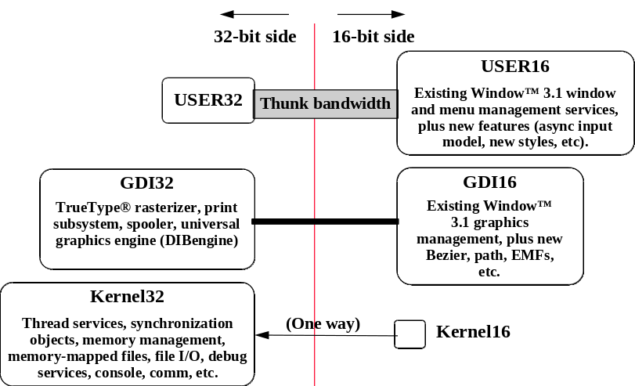
Figure 1. Relative Code Distribution in Chicago
Many functions provided by the Graphics Device Interface (GDI) have been moved to 32-bit code, including the spooler and printing subsystem, the font rasterizer, and the drawing operations performed by the graphics “DIBengine.” Much of the window management code (User) remains 16-bit to retain application compatibility.
In addition, Chicago improves upon the MS-DOS and Windows 3.1 environment by implementing many device drivers as 32-bit protected-mode code. Virtual device drivers in Chicago assume the functionality provided by many real-mode MS-DOS–based device drivers eliminating the need to load them in MS-DOS. This results in a minimal conventional memory footprint, improved performance, and improved reliability and stability of the system over MS-DOS–based device drivers.

Virtual Device Drivers—What is a VxD?
A virtual device driver (VxD) is a 32-bit, protected-mode driver that manages a system resource, such as a hardware device or installed software, so that more than one application can use the resource at the same time. To understand the improvements available in Chicago over the combination of MS-DOS and Windows 3.1, it is good to have a basic understanding of what a VxD is and the role virtual device drivers play in the Chicago environment.
The term VxD is used to refer to a general virtual device driver—the x represents the type of device driver. For example, a virtual device driver for a display device is known as a VDD, a virtual device driver for a timer device is a VTD, a virtual device driver for a printer device is a VPD, and so forth. Windows uses virtual devices to support multitasking for MS-DOS-based applications, virtualizing the different hardware components on the system to make it appear to each MS-DOS VM that it is executing on its own computer. Virtual devices work in conjunction with Windows to process interrupts and carry out I/O operations for a given application without disrupting how other applications run.
Virtual device drivers support all hardware devices for a typical computer, including the programmable interrupt controller (PIC), timer, direct-memory-access (DMA) device, disk controller, serial ports, parallel ports, keyboard device, math coprocessor, and display adapter. A virtual device driver can contain the device-specific code needed to carry out operations on the device. A virtual device driver is required for any hardware device that has settable operating modes or retains data over any period of time. In other words, if the state of the hardware device can be disrupted by switching between multiple applications, the device must have a corresponding virtual device. The virtual device keeps track of the state of the device for each application and ensures that the device is in the correct state whenever an application continues.
Although most virtual devices manage hardware, some manage only installed software, such as an MS-DOS device driver or a terminate-and-stay-resident (TSR) program. Such virtual devices often contain code that either emulates the software or ensures that the software uses data that applies only to the currently running application. ROM BIOS, MS-DOS, MS-DOS device drivers, and TSRs provide device-specific routines and operating system functions that applications use to indirectly access the hardware devices. Virtual device drivers are sometimes used to improve the performance of installed software; the 80386 and compatible microprocessors can run the 32-bit protected-mode code of a virtual device more efficiently than the 16-bit real-mode code of an MS-DOS device driver or TSR. In addition, performance is also enhanced by eliminating ring transitions that result in executing 32-bit applications that access 16-bit real-mode services—with virtual device drivers, the system can stay in protected-mode.
Chicago benefits from providing more device driver support implemented as a series of VxDs in the Windows environment, over the use of device drivers previously available as real-mode MS-DOS device drivers. Functionality that was previously supported as MS-DOS device drivers, but are now supported as VxDs in Chicago includes components such as:
- MS-DOS FAT file system
- SmartDrive
- CD-ROM file system
- Network redirector, network server, and network transport protocols
- Mouse driver
- MS-DOS SHARE.EXE TSR
- Disk device drivers including support for SCSI devices
In Chicago, VxDs provide improved performance due to a 32-bit code path and eliminating or reducing the need to mode switch between real and protected-mode, reduced conventional memory footprint by providing device driver and TSR functionality as protected-mode components that reside in extended memory, and improved system stability and reliability over using the MS-DOS device driver counterparts. Virtual device drivers can be identified by the use of a .VXD extension in Chicago, or a .386 extension as a virtual device driver from Windows 3.1.

Chicago System Layout
Figure 26 illustrates the layout of the base system architecture for Chicago. Components of the system are divided between Ring 0 and Ring 3 code, offering different levels of system protection. The Ring 3 code is protected from other running processes by protection services provided by the Intel processor architecture. The Ring 0 code consists of the low-level operating system services such as the file system, and virtual machine manager.
This figure also depicts the way that MS-DOS–, Win16–, and Win32–based applications run in the system. The following areas of this section discuss the provisions that the system makes for running these applications.
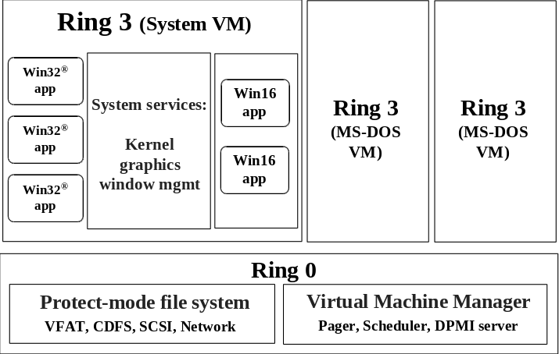
Figure 2. Chicago's Integrated Architecture for Running MS-DOS–, Win16–, and Win32–based Applications

Support for Win16–based Applications
16-bit Windows–based applications (Win16) run together within a unified address space, and are run in a cooperatively multitasking fashion as they do under Windows 3.1. Win16–based applications benefit from the preemptive multitasking of other system components including the 32-bit print and communications subsystem, and the improvements made in system robustness and protection from the Chicago system kernel.
When Win16–based application support was examined by the Chicago development team, three goals drove the architectural design based on customer needs, resource needs, and market needs: compatibility, size, and performance. Functionality such as running Win16–based applications together in the Win16 subsystem preemptively or running Win16–based applications in separate VMs was examined, however each option examined failed to meet the design goals set forth. The following discussion will provide some insight as to the architecture design of Chicago for running Win16–based applications in a fast, stable, and reliable way.

Compatibility
First and foremost, Chicago needs to run existing Win16–based applications without modification. This is extremely important to existing customers that want to take advantage of new functionality offered in Chicago such as 32-bit networking, but don’t want to have to wait until new Chicago-enabled applications are available on the market.
Chicago builds upon the Windows 3.1 platform to provide support for running existing Win16–based applications and using existing Windows–based device drivers, while providing support for the next generation of 32-bit applications and components. Chicago extends the Windows 3.1 architecture in areas that have little or no impact on compatibility, as well as enhances the architecture to deliver a faster, more powerful 32-bit operating system.

Size
While many newer computer purchases are Intel 80486-based computers with 4MB or 8MB (or more) of memory, there are still a high percentage of 80386DX-based computers with 4MB of memory in use running Windows 3.1 today. To support the needs of the market, Chicago needs to run on a base platform of an Intel 80386DX-based computer with 4MB of RAM, to provide access to the new features and functionality provided, without requiring an upgrade of existing hardware or the addition of more RAM.
To meet its design goals, the Chicago development team designed Chicago to occupy no more working set than Windows 3.1 currently does, thereby insuring that any Win16–based application running at a perceived speed on a 4MB or 8MB computer (or greater) still runs at the same (or higher) speed under Chicago and does not suffer any performance degradation. To meet the required size goals of Chicago, Win16–based applications run within a unified address space, resulting in little overhead beyond that required by Windows 3.1 to support running Windows–based applications. This allows Chicago to not only simply fit on a 4MB computer, but also to perform well. The Chicago architecture includes innovative design features such as dynamically loadable VxDs to decrease the working set of components and memory requirements used by the operating system.
Meeting the size design goal (as well as to meet the compatibility goal), precluded the development team from adopting a strategy of running Win16–based applications in a separate VM by running a separate copy of Windows 3.1 on top of the operating system (thereby paying a several megabyte “memory tax” for each application) as OS/2 does, or emulating Windows 3.1 on top of the Win32 subsystem (thereby paying a "memory tax" for running Win16–based applications) as Windows NT does.
Running Win16–based applications in separate VMs is very expensive memory wise. This would require separate GDI, USER, and KERNEL code in each VM that is created, requiring the working set to increase by as much as 2MB for each Win16–based application that is running (as is required by OS/2 for Windows). If you have a computer with 16MB or more, this may not appear to be such a big deal. However, given the existing installed base of computers it would be impossible to run Win16–based applications in their own separate VMs in 4MB at all, and very difficult to run them in 8MB with the same level of performance as customers observe and expect under Windows 3.1 today.

Performance
Users expect their existing Win16 applications to run as fast or faster than they do under Windows 3.1. Win16–based applications will benefit from the 32-bit architecture of Chicago including the increased use of 32-bit device driver components and 32-bit subsystems, as will MS-DOS–based applications.
Win16–based applications run within a unified address space and interact with the system much as they do under Windows 3.1 today. Running Win16–based applications in separate VMs requires either a mapping of Win16 system components in each address space, as Windows NT does, or providing a separate copy of each system component in each address space, as OS/2 for Windows does. The additional memory overhead required for Win16 system components in each VM to run a Win16–based application has a negative impact on system performance.
Chicago balances the issue of system protection and robustness, with the desire for better system performance and improves on the system robustness over Windows 3.1. The improvements in this area are briefly discussed below, and are described in greater detail in a separate section of this guide.

Protection
The support for running Win16–based applications provides protection of the system from other running MS-DOS–based applications or Win32–based applications. Unlike Windows 3.1, an errant Win16–based application can not easily bring down the system or other running processes on the system. While Win32–based applications benefit the most from system memory protection, the robustness improvements present in Chicago result in a more stable and reliable operating environment than Windows 3.1.
Win16–based applications run within a unified address space, and cooperatively multitask as they do under Windows 3.1. The improvements made to overall system-wide robustness greatly enhance the system’s ability to recover from an errant application, and lessens the likelihood of application errors due to improved clean up of the system. The occurrence of general protection faults (GPFs) under Windows 3.1 are most commonly caused by an application that writes over its own memory segments, rather than being caused by an application overwriting memory belonging to another application. Windows 3.1 did not recover gracefully when a Windows–based application crashed or hung. When an application was halted by the system due to a GPF, the system commonly left allocated resources in memory, causing the system to degenerate.
Due to improved protection in Chicago, an errant Win16–based application can not easily bring down either the system as a whole, or other running MS-DOS or Win32–based applications, and can at most impact other running Win16–based applications.
Other protection improvements include the use of separate message queues for each running Win32–based application. The use of a separate message queue for the Win16 address space and for each running Win32–based application provides better recovery of the system and doesn’t halt the system should a Win16–based application hang.

Robustness Improvements
System robustness is also greatly improved when running Win16–based applications over Windows 3.1. Chicago now tracks resources allocated by Win16–based applications and uses the information to clean up the system after an application exits or ends abnormally, thus freeing up unused resources for use by the rest of the system.
Robustness improvements is discussed later in a separate section of this guide.

Support for MS-DOS–based Applications
There are many improvements in Chicago for running MS-DOS–based applications over Windows 3.1. As with Windows 3.1, each MS-DOS–based application runs in its own “virtual machine” (VM). A VM takes advantage of the Intel 80386 (and higher) architecture allowing multiple 8086-compatible sessions to run on the CPU, allowing existing MS-DOS applications to run preemptively with the rest of the system. As with Windows 3.1, the use of virtual device drivers provide common regulated access to hardware resources, thereby making each application running in a virtual machine think it’s running on its own individual computer, allowing applications not designed to multitask to run concurrently with other applications.
Chicago provides a flexible environment for running MS-DOS–based applications. Unlike Windows 3.1, where users sometimes needed to exit Windows in order to run MS-DOS–based applications that were either ill-behaved or required direct access to system resources. MS-DOS–based application compatibility is improved in Chicago so almost all MS-DOS–based applications should run under Chicago.

Protection
VMs are fully protected from one another, as well as from other applications running on the system. This prevents errant MS-DOS–based applications from being able to overwrite memory occupied or used by system components or other applications. If an MS-DOS–based application attempts to access memory outside of its address space, the system will notify the user and the MS-DOS–based application will be ended.

Robustness Improvements
System robustness is also greatly improved when running MS-DOS–based applications over Windows 3.1. Robustness is discussed later in a separate section of this guide.

Improved Support for Running MS-DOS–based Applications
Chicago provides much better support for running MS-DOS–based applications within the Windows environment than Windows 3.1.
A detailed discussion of the improvements made to running MS-DOS–based applications is discussed in the section “Improved Support for Running MS-DOS–based Applications” later in this guide.

Support for Win32–based Applications
Win32–based applications can fully exploit and benefit more from the design of the Chicago architecture. In addition, each Win32–based application runs in its own fully-protected, private address space. This prevents other Win32–based applications from crashing each other, crashing other running MS-DOS–based applications, crashing running Win16–based applications, or crashing the Chicago system as a whole.
Win32–based applications feature the following benefits over Win16–based applications in Chicago or under Windows 3.1:
- Preemptive multitasking
- 32-bit Win32 APIs
- Long filename support
- Separate message queues
- Flat address space
- Memory Protection

Preemptive Multitasking
Unlike the cooperative multitasking used by Win16–based applications under Windows 3.1, 32-bit Win32–based applications are preemptively multitasked in Chicago. The operating system kernel is responsible for scheduling the time allotted for running applications in the system, and support for preemptive multitasking results in smoother concurrent processing and prevents any one application from utilizing all system resources without permitting other tasks to run.
Win32–based applications can optionally implement threads to improve the granularity at which they multitask within the system. The use of threads by an application improves the interaction with the user and result in smoother multitasking operation.

Separate Message Queues
Under Windows 3.1, the system uses the point when an application checks the system message queue as the mechanism to pass control to another task, allowing that task to run in a cooperative manner. If an application doesn’t check the message queue on a regular basis, or the application hangs and thus prevents other applications from checking the message queue, the system will keep the other tasks in the system suspended until the errant application is ended.
Each Win32–based application has its own separate message queue and is thus not affected by the behavior of other running tasks on their own message queues. If a Win16–based application hangs, or if another running Win32–based application crashes, a Win32–based application will continue to run preemptively and will still be able to receive incoming messages or event notifications.
Message queues are discussed in more detail in the “Robustness Improvements” section of this guide.

Flat Address Space
Win32–based applications benefit from improved performance and simpler construct due to being able to access memory in a linear fashion, rather being limited to the segmented memory architecture used by MS-DOS and Windows 3.1. In order to provide a means of accessing high amounts of memory using a 16-bit addressing model, the Intel CPU architecture provides support for accessing 64K chunks of memory at a time, called segments. Applications and the operating system suffer a performance penalty under this architecture due to the necessary manipulations required by the processor for mapping memory references from the segment/offset combination to the physical memory structure.
The use of a flat address space by Chicago’s 32-bit components and for Win32–based applications will allow application and device driver developers to write software without the limitations or design issues inherent with the segmented memory architecture used by MS-DOS and Windows 3.1.

Compatibility with Windows NT
Win32–based applications that exploit Win32 APIs common between Chicago and Windows NT can run without modification on either platform on Intel-based computers. The commonality of the Win32 API provides a consistent programmatic interface allowing application vendors to use a single development effort to leverage delivery of software that runs on multiple platforms. This provides scalability of applications and broadens the base of platforms available for running ISV or custom applications with minimal additional effort.
Application vendors are encouraged to develop applications either under Chicago or Windows NT, and test compatibility on both platforms.

Long Filename Support
Win32–based applications that call the file I/O functions supported by the Win32 API will benefit from the ability to support and manipulate filenames up to 255 characters, with no additional development effort. The Win32 APIs and common dialog support handles the work for manipulating long filenames, and the file system provides compatibility with MS-DOS and other systems by also maintaining the traditional 8.3 filename automatically. This eases the burden from the application developer.

Memory Protection
Each Win32–based application runs in its own private address, and is protected by the system from other applications or processes that are running in the system. Unlike running Win16–based applications under Windows 3.1, errant Win32–based applications under Chicago will only end themselves, rather than bring down the entire system if they attempt to access memory belonging to another application.
The use of separate message queues for Win32–based applications also protects to ensure that the system will continue to run if an application hangs or stops responding to messages or events.

Robustness Improvements
Win32–based applications benefit from the highest level of system robustness supported under Chicago. Resources allocated for each Win32–based application is tracked on a per-thread basis and are automatically freed when the application ends. If an application hangs, users are able to perform a local reboot operation to end the hung application without affecting other running tasks, and the system will clean up properly.
Detailed information about robustness enhancements is discussed later in a separate section of this guide.

32-Bit File System Architecture
The file system in Chicago has been re-architected from Windows 3.1 to support the characteristics and needs of the multitasking nature of the Chicago kernel. The changes present in Chicago provide many benefits to the user and results in:
• Improved ease of use
Ease of use is improved by support long filenames so users no longer need to reference files by the MS-DOS 8.3 filename structure—users can use up to 255 characters to identify their documents. Ease of use is also improved by hiding the filename extensions from users.
• Improved performance
As in Windows for Workgroups 3.11, file I/O performance is improved dramatically over Windows 3.1 by featuring 32-bit protected-mode code for reading information from and writing information to the file system, reading and writing information from/to the disk device, and intelligent 32-bit caching mechanisms—a full 32-bit code path is available from the file system to the disk device.
• Improved system stability and reliability
File system components implemented as 32-bit protected mode device drivers offer improved system stability and reliability over MS-DOS device driver counterparts due to being able to remain in protected-mode for code execution and leveraging existing driver technology first implemented in Windows NT and also available in Windows for Workgroups 3.11.

Architecture Overview
Chicago features a layered file system architecture that supports multiple file systems, and provides a protected-mode path from the application to the media device, resulting in improved file and disk I/O performance over Windows 3.1. Features of the new file system architecture include:
• Win32 API support
• Long filename support
• 32-bit FAT file system
• 32-bit CD-ROM file System
• Dynamic system cache for file and network I/O
• Open architecture for future system support
• Disk device driver compatibility with Windows NT
Figure 27 depicts the file system architecture used by Chicago.
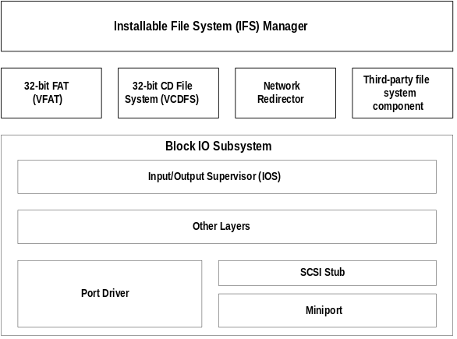
Figure 3. Chicago File System Architecture
The Chicago file system architecture is made up of the following components:
• Installable File System (IFS) Manager
The IFS Manager is responsible for arbitrating access to different file system components.
• File system drivers
The file system drivers layer includes access to file allocation table (FAT)-based disk devices, CD-ROM file systems, and redirected network device support.
• Block I/O subsystem
The block I/O subsystem is responsible for interacting with the physical disk device.
We’ll examine components of each of these layers in this section.

Installable File System Manager
Under MS-DOS and Windows 3.1, the MS-DOS Int 21h interrupt is responsible for providing access to the file system to manipulate file information on a disk device. In order to support redirected disk devices (for example, a network drive, or a CD-ROM drive), other system components such as the network redirector would hook the Int 21h function so that it could examine the file system request to determine whether it should handle the file I/O request, or let the base file system handle it. While this mechanism provided the ability to add on additional device drivers, some add-on components would be ill-behaved and would interfere with other installed drivers.
Another problem that was encountered with the MS-DOS–based file system was the difficulty in supporting the loading of multiple network redirectors to provide concurrent access to different network types. Windows for Workgroups provided support for running the Microsoft Windows Network redirector at the same time as an additional network redirector including Novell NetWare, Banyan VINES, and SUN PC-NFS, however support for running more than two network redirectors at the same time was not supported.
The key to friendly access to disk and redirected devices in Chicago is the Installable File System (IFS) Manager. The IFS manager is responsible for arbitrating access to file system devices, as well as other file system device components.
The Chicago includes support for the following file systems:
- 32-bit FAT driver (VFAT)
- 32-bit CD-ROM file system driver (CDFS), and
- 32-bit network redirector for connectivity to Microsoft Windows Network servers like Windows NT Advanced Server, along with a 32-bit network redirector to connect to Novell NetWare servers
Third-parties will use the IFS Manager APIs to provide a clean way of concurrently supporting multiple device types, adding additional disk device support and network redirector support.

32-bit File Access—Protected-mode FAT (VFAT) File System
The 32-bit VFAT driver provides a 32-bit protected-mode code path for manipulating the file system stored on a disk. It is also re-entrant and multi-threaded, providing smoother multi-tasking performance. The 32-bit file access driver is improved over that provided originally with Windows for Workgroups 3.11, and is compatible with more MS-DOS-device drivers and hard disk controllers.
Benefits of the 32-bit file access driver over MS-DOS–based driver solutions include:
• Dramatically improved performance and real-mode disk caching software
• No conventional memory used—replacement for real-mode SmartDrive
- Better multitasking when accessing information on disk—no blocking
• Dynamic cache support
Under MS-DOS and Windows 3.1, manipulation of the file allocation table (FAT) and writing or reading information to/from the disk is handled by the Int 21h MS-DOS function and is 16-bit real-mode code. Being able to manipulate the disk file system from protected-mode removes or reduces the need to transition to real-mode in order to write information to the disk through MS-DOS, which will result in a performance gain for file I/O access.
The 32-bit VFAT driver interacts with the block I/O subsystem to provide 32-bit disk access to more device types than is supported by Windows 3.1. Support is also provided for mapping to existing real-mode disk drivers that may be in use on a user’s system. The combination of the 32-bit file access and 32-bit disk access drivers result in significantly improved disk and file I/O performance.

32-Bit Cache—VCACHE
The 32-bit VFAT works in conjunction with a 32-bit protected-mode cache driver (VCACHE), and replaces and improves on the 16-bit real-mode SmartDrive disk cache software provided with MS-DOS and Windows 3.1. The VCACHE driver features more intelligent caching algorithm than SmartDrive to cache information read from or written to a disk drive, and results in improved performance for reading information from cache. Also, the VCACHE driver is responsible for managing the cache pool for the CD-ROM File System (CDFS), and the provided 32-bit network redirectors.
Another big improvement in VCACHE over SmartDrive is that the memory pool used for the cache is dynamic and is based on the amount of available free system memory. Users no longer need to statically allocate a block of memory to set aside as a disk cache, the system automatically allocates or de-allocates memory used for the cache based on system use. The performance of the system will also scale better than Windows 3.1 or Windows for Workgroups 3.11, due to the intelligent cache use.

32-Bit CDFS—Protected-mode CD-ROM File System
The 32-bit protected-mode CD-ROM file system (CDFS) implemented in Chicago provides improved CD-ROM access performance over the real-mode MSCDEX driver in Windows 3.1 and is a full 32-bit ISO 9660 CD file system. The CDFS driver replaces the 16-bit real-mode MSCDEX driver, and features 32-bit protected-mode caching of CD-ROM data. The CDFS driver cache is dynamic and shares the cache memory pool with the 32-bit VFAT driver, requiring no configuration or static allocation on the part of the user.
Benefits of the new 32-bit CDFS driver include:
• No conventional memory used—replacement for real-mode MSCDEX
• Improved performance over MS-DOS–based MSCDEX and real-mode cache
- Better multitasking when accessing CD-ROM information—no blocking
• Dynamic cache support to provide a better balance between providing memory to run applications versus memory to serve as a disk cache
If MSCDEX is specified in the user’s AUTOEXEC.BAT, the 32-bit CDFS driver will take over role played by the MSCDEX driver and communicate with the CD-ROM device. The use of MSCDEX is no longer necessary under Chicago.
Users of CD-ROM multimedia applications will benefit greatly from the new 32-bit CDFS. Their multimedia applications will run smoother and information will be read from the CD-ROM quicker providing improved performance.

Disk Device Architecture—Block I/O Subsystem
The Block I/O Subsystem in Chicago improves upon the 32-bit disk access “FastDisk” device architecture used in Windows 3.1 to improved performance for the entire file system and a broader array of device support.
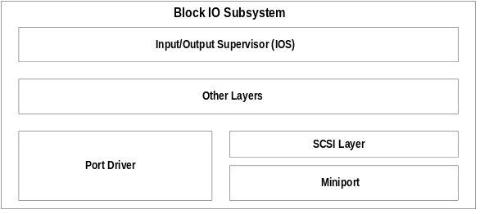
Figure 4. Architecture of Chicago Block I/O Subsystem
Components of the block I/O subsystem include the high-level I/O Supervisor (IOS) layer, which provides the interface to the block I/O subsystem to the higher layer components; the port driver, which represents a monolithic disk device driver; the SCSI layer, which provides a standard interface and driver layer to provide device-independent control code for SCSI devices; and the SCSI mini-port driver, which contains the device-dependent control code responsible for interacting with individual SCSI controllers.
The block I/O subsystem provides the following support in Chicago:
- Fully Plug and Play-enabled architecture
- Support for mini-port drivers that are binary compatible with Windows NT
- Support for Windows 3.1 fast disk drivers for backwards compatibility
- Protected-mode drivers that take over real-mode MS-DOS device drivers if it is thought to be safe to do so
- The ability to support existing MS-DOS real-mode disk device drivers for compatibility
Let’s examine the different areas that make up the block I/O subsystem. Keep in mind that the configuration of the disk device driver layers is isolated from the user, so the explanation here is provided to facilitate an understanding of the components.

I/O Supervisor
The I/O Supervisor (IOS) provides services to file systems and drivers. The IOS is responsible for the queuing of file service requests and for routing the requests to the appropriate file system driver. The IOS also provides asynchronous notification of file system events to drivers that are installed.

Port Driver
The port driver is a monolithic 32-bit protected-mode driver that communicates with a specific disk device such as a hard disk controller. This driver is Chicago-specific and resembles the 32-bit disk access (fast disk) driver used in Windows 3.1 (for example, WDCTRL for Western Digital compatible hard disk controllers). In Chicago, the driver to communicate with IDE/ESDI hard disk controllers and floppy disk controllers is implemented as a port driver. A port driver provides the same functionality as the combination of the SCSI manager and the mini-port driver.

SCSI Layer
The SCSI layer applies a 32-bit protected-mode universal driver model architecture to communicating with SCSI devices. The SCSI layer provides all the high level functionality that is common to SCSI-like devices, and then uses a mini-port driver to handle device-specific I/O calls. The SCSI Manager is also part of this system and provides the compatibility support for using Windows NT mini-port drivers.

Mini-Port Driver
The Chicago mini-port driver model simplifies the task for a hardware disk device vendor to write a device driver. Because the SCSI Stub provides the high level functionality for communicating with SCSI devices, the hardware disk device vendor only needs to create a mini-port driver that is tailored to his own disk device. The Chicago mini-port driver is 32-bit protected-mode code, and is binary compatible with Windows NT mini-port drivers, minimizing the task required by a hardware vendor to write device drivers. Binary compatibility with NT also results in a more stable and reliable device driver as the hardware vendor needs to only maintain one code base for device support, and Chicago users benefit from the preexistence of many mini-port drivers already available for Windows NT.

Support for IDE, SCSI, ESDI controllers
Through the use of either a port driver, or a mini-port driver, support for a broad array of disk devices will be available when Chicago ships including popular IDE, ESDI, and SCSI disk controllers. Keep in mind that users don’t have to decide whether to use a port driver or a mini-port driver, the driver is provided by the hardware vendor and configuration of the driver is handled by the Chicago system.

Real-Mode Mapper (RMM)
To provide compatibility with real-mode MS-DOS device drivers for which a protected-mode counterpart does not exist, the block I/O subsystem provides a mapping layer to allow the protected-mode file system to communicate with a real-mode driver as if it was a protected-mode component. The layers above and including the real-mode mapper are protected-mode code, and the real-mode mapper translates file I/O requests from protected-mode to real-mode such that the MS-DOS device driver can perform the desired operation to write or read information to or from the disk device. An example scenario where the real-mode mapper would come into play is when real-mode disk compression software is running and a protected-mode disk compression driver is not available. The net effect of this component is to ensure binary compatibility with existing MS-DOS–based disk device drivers in Chicago.

Long Filename Support
The use of long filenames in Chicago overcomes the sometimes cryptic 8.3 MS-DOS filename conventions, to allow more user friendly filenames. MS-DOS 8.3 filenames are still maintained and tracked by the system to support compatibility with existing Win16 and MS-DOS–based applications that only manipulate 8.3 filenames, but as users migrate to Win32–based applications the use of 8.3 filename conventions is hidden from the user. Long filenames can be up to 255 characters in length.
Long filenames are supported by extending the MS-DOS FAT file system and using bits and fields that were previously reserved by the operating system to add special directory entries that maintain long filename information. Extending the MS-DOS FAT layout, rather than creating a new format, allows users to install and use Chicago on existing disk formats without having to change their disk structure, or reformat their drives. This implementation provides future growth and ease of use, while still maintaining backward compatibility with existing applications.
Because Chicago simply extend the FAT structure, support for long filenames is support on diskettes as well as hard disk drives. If a long filename is used for a file on a diskette and is viewed by a user on a computer not running Chicago, the user would only see the 8.3 filename representations.
Figure 29 shows a disk directory on a Chicago computer showing long filenames and the corresponding 8.3 filename mappings.
Volume in drive C is MY HARDDISK
Volume Serial Number is 1B47-7161
Directory of C:\LONGFILE

. <DIR> 05-11-94 10:34a .
.. <DIR> 05-11-94 10:34a ..
4THQUART XLS 147 05-11-94 12:25a 4th Quarter Analysis.xls
TEXTFILE TXT 147 05-11-94 12:25a TEXTFILE.TXT
THISISMY DOC 147 05-11-94 12:25a this is my long filename.doc
1994FINA DOC 147 05-11-94 10:35a 1994 Financial Projections.doc
4 file(s) 588 bytes
2 dir(s) 48,009,216 bytes free
Figure 5. Directory with Long Filenames Visible from Command Prompt

Support for Existing Disk Management Utilities
In order for existing disk management utilities to recognize and preserve long filenames, utility vendors will need to revise their software offerings. Microsoft is working closely with utilities vendors and is documenting long filename support and its implementation as an extension to the FAT format as part of the Chicago SDK.
Existing disk management utilities that manipulate the FAT, including disk defragmenters, disk bit editors, and some tape backup software, may not recognize long filenames as used by Chicago and may destroy the long filename entries in the FAT. However, the corresponding system-defined 8.3 filename will be preserved so there is no loss of data if the long filename entry is destroyed.

File Extensions Hidden From User
File extensions are used by Chicago to associate a given file type with an application as is handled under Windows 3.1. However, file extensions are hidden from users in the Shell and Explorer to make it easier to manipulate files, and icons are used in the Chicago UI to differentiate documents associate with applications. For compatibility reasons, it is still necessary for Chicago to track filename extensions for use with existing MS-DOS and Win16–based applications. Information on the file type associations is stored in the Registry, and the associations are used to map a given file with the appropriate icon representing the document type.
In addition to hiding filename extensions in the Chicago shell and Explorer, mechanisms are available for application developers to hide filenames from users in their applications, and this is documented in the Chicago SDK. A good Chicago application will make use of these mechanisms for handling files to be consistent with the rest of the Chicago environment.

Additional File Date/Time Attributes
To further enhance the file system, Chicago maintains additional date/time attributes for files that MS-DOS does not track. Chicago will now maintain the date/time when a new file is created, the date/time when a file has been modified or changed, and the date when a file was last opened. These file attributes will be displayed when a user requests to display file properties as shown in Figure 30.
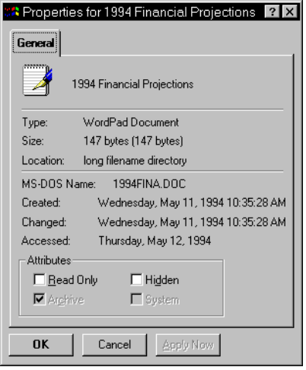
Figure 6. Properties for a File, Showing New File Attributes
Utilities can take advantage of this additional time/date information to provide enhanced backup utilities, for example, to use a better mechanism when determining whether a given file has been changed or modified by the system.

Coordinated Universal Time (UTC) Format
MS-DOS has traditionally used the local time of the computer as the time stamp for the directory entry of a file. Chicago will continue to do this for files stored on the local system, however support for using the UTC time format for accessing or creating information on network file servers. This will provide better, more universal tracking of time information as required by networks that operate across time zones.

Exclusive Volume Access For File Recover Tools
Today, disk management utilities such as disk defragmenters, sector editors, and disk compression utilities, don’t get along well with Windows 3.1. File system programs, such as CHKDSK and DEFRAG, require special (exclusive) access to the file system to minimize the disk access complexities that are present in a multi-tasking environment where disk I/O occurs. For example, if a user requests to do a disk operation that moves files or information around on the disk, if another task was accessing the information or writing information to disk at the same time, without exclusive access to the disk it would be possible that data corruption could occur. Windows 3.1 and MS-DOS do not provide a means of controlling access to the disk when other tasks may need to write information out at the same time, and it is for this reason that it is necessary today for users to exit Windows and enter MS-DOS to run disk management utilities.
The Chicago file system has been enhanced to permit exclusive access to a disk device to support the use of Windows–based disk management utilities. This is not an end-user feature, but rather is an end-user benefit. Exclusive disk access is handled through a new API mechanism as part of the file system and can be used by utilities’ vendors to write Windows–based disk management utilities. Microsoft is evangelizing this API mechanism to third-party utility vendors to facilitate moving existing MS-DOS–based utilities to Windows, as well as is using it to deliver disk management utilities as part of the Chicago product.
For example, this mechanism is being used in Chicago by the disk defragment utility delivered as part of the Beta-1 release. Unlike the combination of MS-DOS and Windows 3.1, the disk defragment utility in Chicago can be run from the Chicago shell, and can even be run in the background while you continue to work on your system.

Improved System Capacity
Chicago provides better system capacity for running MS-DOS-based and Win16-based applications than Windows 3.1. A number of internal enhancements have been made to the base system, allowing for internal system resources to not be exhausted as quickly as was possible under Windows 3.1 when running multiple Windows–based applications.
Many of the artificial limitations present in Windows 3.1 due to its architecture or internal data structures and largely due to the fact that Windows 3.1 had to run on an Intel 80286-based computer, have been greatly improved and overcome in Chicago. This will please ISVs and other developers, as well as end-users.

System Resource Limitation Improved
Many users have probably seen “Out of Memory” error messages when running multiple Windows–based applications under Windows 3.1, even though the system still reports several megabytes of available free memory. What users typically encountered was a condition where the system was not able to allocate an internal memory resource in a Windows API function call due to not enough space available in a region of memory called a heap.
Windows 3.1 maintains heaps for system components called GDI and USER. Each of the heaps is 64K in size and is used for storing GDI or memory object information allocated when an application calls a Windows API function. The amount of space available in the combination of these two heaps is identified as a percentage of system resources that are free and is shown in the Help About box in Program Manager and other Windows applications as shown in Figure 31.
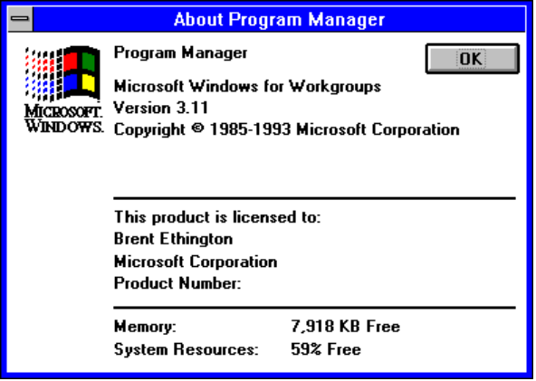
Figure 7. About Box in Program Manager In Windows 3.1 Showing Free System Resources
The percentage of free system resources displayed in the About box is calculated using an internal algorithm to represent the aggregate percentage of free memory in the GDI and USER heaps. When the free system resources percentage drops to a low number, it is quite common that the user will see an “out of memory” error message, even though the amount of free memory shown in the About box is still quite high. This error can be due to low memory in either the GDI or the USER heap (or both).
To help reduce the system resource limitation, a number of the data structures stored in the 16-bit GDI and USER heaps in Windows 3.1 have been moved out of these heaps and stored in 32-bit heaps, providing more room for the remaining data elements to be created. Users will see improvements by not encountering a decrease in system resources as rapidly as they may have seen with Windows 3.1.
All objects were not simply removed from the 16-bit GDI or USER heaps, and placed in 32-bit heaps for compatibility reasons. For example, there are some Windows–based applications that manipulate the contents of the GDI heap directly, bypassing the published API mechanisms for doing so. These application vendors to do this for perceived performance reasons. However, because they bypass the Windows API mechanisms, moving the data from the existing heap structures and placing them in 32-bit heaps would cause the existing applications to fail due to memory access violations.
Both Win16 and Win32–based applications use the same GDI and USER heaps. The impact of removing selected items from the heaps was closely examined and objects were selected based on the biggest improvement that could be achieved, while affecting the fewest number of applications. For example, the GDI heap can quickly become full due to the creation of memory-intensive region objects that are used by applications for creating complex images and by the printing subsystem for generating complex output. Regions have been removed from the 64K 16-bit GDI heap and placed into a 32-bit heap, benefiting graphic-intensive applications and providing for the creation of more smaller objects by the system. Chicago improves the system capacity for the USER heap, by moving menu and window handles to the 32-bit USER heap, raising the total limit of these data structures from 200 in Windows 3.1, to a total limit now of 32,767 menu handles and an additional 32,767 window handles per process rather than system wide.
In addition to examining information present in the GDI and USER heaps, the robustness improvements present in Chicago that facilitate cleaning up the system of unfreed resources will also help the system resource limitation problem. Chicago will clean up and de-allocate left over data structures once Chicago determines that the owner and other ended processes no longer need the resources in memory. The robustness improvements available in Chicago are discussed in the next section.

Better Memory Management
Chicago improves addressibility for accessing physical memory in the computer, as well as improves upon the swapfile implementation provided in Windows 3.1 to support virtual memory to supplement physical system memory.

Linear Memory Addressing for Win32–based Applications
To support a 16-bit operating environment, the Intel processor architecture uses a mechanism called segments to reference memory by using a 16-bit segment address, and a 16-bit offset address within the segment. A segment is 64K in size, and applications and the operating system endure a performance penalty for accessing information across segments. Chicago addresses this issue by using the 32-bit capabilities of the Intel 80386 (and above) processor architecture to support a flat, linear memory model for 32-bit operating system functionality and Win32–based applications. A linear addressing model simplifies the development process for application vendors, removes the performance penalties imposed by the segmented memory architecture, and provides access to a virtual address space that enables addressing up to 4 gigabytes (GB) of memory. Chicago uses the flat memory model internally for 32-bit components and virtual device drivers.

Compatible with the Memory Model used by Windows NT
Chicago uses the same memory model architecture used by Windows NT, providing high-end operating system functionality on the mainstream desktop. Chicago will allow full use of the 4 gigabytes (4 billion bytes of memory) of addressable memory space to support even the largest desktop application.

Improved Virtual Memory Support—Swapfile Improvements
Chicago improves on the virtual memory swapfile implementation provided in Windows 3.1 to address the problems and limitations imposed in Windows 3.1.
Under Windows 3.1, users were faced with a myriad of choices and configuration options when it came to setting up a swapfile to support virtual memory. They had to decide whether to use a temporary swapfile or a permanent swapfile, how much memory to allocate to the swapfile, and whether to use 32-bit disk access to access the swapfile or not. Users benefited from a temporary swapfile in that the swapfile did not need to be contiguous, and Windows would allocate space on the hard disk when Windows was started and free up the space when the user exited Windows. A permanent swapfile provided the best performance, however it required a contiguous block of space, had to be set up on a physical hard disk, and was statically specified by the user and not freed up when the user exited Windows.
The swapfile implementation in Chicago simplifies the configuration task for the user and combines the best of a temporary swapfile and a permanent swapfile due to improved virtual memory algorithms and access methods. The swapfile in Chicago is now dynamic, and can shrink or grow based on the operations that are performed on the system. The swapfile can also occupy a fragmented region of the hard disk, with no substantial performance penalty hit.
The user can still adjust the parameters used for defining the swapfile in Chicago, however the need to do this is reduced by intelligent use of system defaults. Figure 32 shows the new simplified swapfile configuration options, allowing the user to specify the minimum and maximum swapfile size to use.
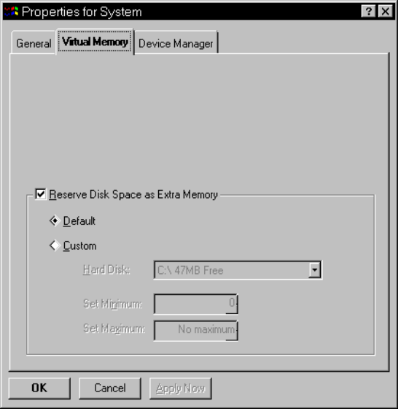
Figure 8. Virtual Memory Settings in Chicago are Simplified Over Windows 3.1

The Registry—Centralized Configuration Store
Chicago uses a mechanism called the Registry that serves as the central configuration store for user, application, and computer-specific information. The Registry solves problems associated with .INI files as used in Windows 3.1, and is a hierarchical database that stores system-wide information in a single location, making it easy to manage and support.

Problems with Windows 3.1 .INI Files
Windows 3.1 uses initialization (.INI) files to store system-specific or application-specific information on the state or configuration of the system. For example, the WIN.INI file is used to store state information about the appearance or customization of the Windows environment, the SYSTEM.INI file is used to store system-specific information on the hardware and device driver configuration of the system, and various .INI files are used to store application-specific information about the default state of an application (for example, WINFILE.INI, MSMAIL.INI, CLOCK.INI, CONTROL.INI, PROGMAN.INI, and so on).
Problems with .INI files under Windows 3.1 for configuration management include:
- Information is stored in several different locations including CONFIG.SYS, AUTOEXEC.BAT, WIN.INI, SYSTEM.INI, PROTOCOL.INI, private .INI files, and private .GRP files
- .INI files are text-based, are limited to 64K in total size, and APIs only allow for get/write operations
- information stored in .INI files is non-hierarchical and supports only two-levels of information (i.e., key names broken up by section heading)
- Many .INI files contain a myriad of switches and entries that are complicated to configure or are used only by operating system components
- .INI files provide no mechanism for storing user-specific information, thus making it difficult for multiple users to share a single computer
- Configuration information in .INI files is local to each system, and no API mechanisms are available for remotely managing configuration, thus making it difficult to manage multiple systems

Solution to Windows 3.1 .INI File Problems
To solve problems associated with .INI files under Windows 3.1, the Registry was designed with the following goals in mind:
- Simplify the support burden
- Centralize configuration information
- Provide a means to store user, application, and computer-specific information
- Provide local and remote access to configuration information
The Registry is structured as a hierarchical database of keys, where each key can contain a value, or can even contain other keys (subkeys). While similar in some ways to the Registration Database used in Windows 3.1, which served as a central repository for file associations and OLE registration information, the Registry in Chicago extends the previous structure to support keys that can have more than one value and can also support data of different types. The Registry uses a hierarchical structure to store text or binary value information to maintain all of the configuration parameters normally stored in the Windows system .INI files such as WIN.INI, SYSTEM.INI, and PROTOCOL.INI.
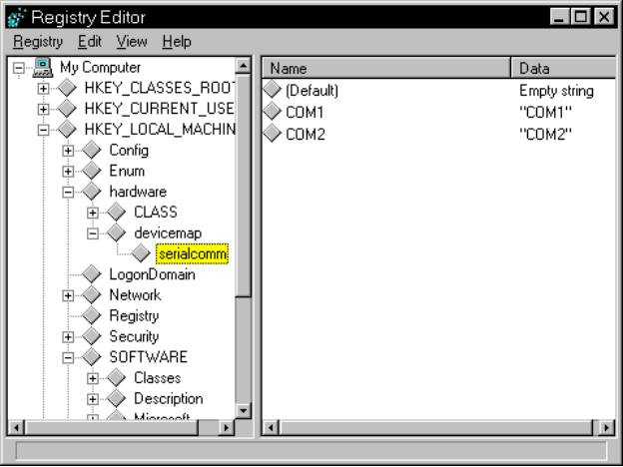
Figure 9. Hierarchy of Registry as Displayed by the Registry Editor
The Registry is made up of several .DAT files that contain system-specific information (SYSTEM.DAT) or user-specific information (USER.DAT). System-specific information such as the static reference to loading virtual device drivers will be moved as appropriate from the SYSTEM.INI file to the Registry.

System Switch Simplification
Another improvement made over Windows 3.1 and its use of ..INI files is related to system switch simplification. Windows 3.1 supports over several hundred different configuration switches that can be specified in system .INI files including the WIN.INI or SYSTEM.INI files. With intelligent enhancements made to the system, and better dynamic configuration properties, Chicago has reduced the number of entries that are normally associated with .INI files. These reductions didn’t come just by moving .INI entries to the Registry, but by examining and justifying the presence of each and every one.

.INI Files Still Exist for Compatibility Reasons
For compatibility reasons, WIN.INI and SYSTEM.INI and application-specific .INI files (as well as CONFIG.SYS and AUTOEXEC.BAT) do not go away. The Win16 APIs for manipulating .INI files will still manipulate .INI files, however Win32–based applications will be encouraged to use the Registry APIs to consolidate application-specific information.
Many existing Win16–based applications expect to find and manipulate the WIN.INI and SYSTEM.INI files to add entries or load unique device drivers, therefore SYSTEM.INI, for example, will still be examined during the Chicago boot process to check for virtual device drivers in the [386Enh] section.

Role in Plug and Play
One of the primary roles of the Registry in Chicago is to serve as a central repository for hardware-specific information for use by the Plug and Play system components. Chicago maintains information about hardware components and devices that have been identified through an enumeration process in the hierarchical structure of the Registry. When new devices are installed, the system checks the existing configuration in the Registry to determine the hardware resources (for example, IRQs, I/O addresses, DMA channels, and so on) that are not being used, so the new device can be properly configured without conflicting with a device already installed in the system.

Remote Access to Registry Information
Another advantage of the Registry for Win32–based applications is that many of the Win32 Registry APIs are remoted using the remote procedure call (RPC) mechanism in Chicago to provide access to Registry information across a network. This allows desktop management applications to be written to aid in the management and support of Windows–based computers, and allows the contents of the Registry on a given PC to be queried and over a network. With this mechanism, industry management mechanisms such as SNMP or DMI can easily be integrated into Chicago, simplifying the management and support burden of an MIS organization. See the “Chicago Networking” section later in this guide for more information on manageability and remote administration.

Better Font Support
Font support in Chicago has been enhanced to provide better integration with the Chicago Shell user interface, optimized for the 32-bit environment, and provides capabilities such as font smoothing for fonts that has not been offered previously as part of a mainstream desktop operating system.

32-bit TrueType Rasterizer
The rasterizer component for rendering and generating TrueType fonts is enhanced in Chicago. The rasterizer is written as a 32-bit component, and delivers better fidelity from the mathematical representation to the generated bitmap, as well as better performance for rendering TrueType fonts.
In addition to performance enhancements, the new 32-bit rasterizer also provides support for generating complicated glyphs (for example, Han), and results in a faster initial boot time when lots of fonts are installed in the system than Windows 3.1.

Support for Smoother Fonts
In Windows 3.1, TrueType provided a major improvement over the quality of displayed fonts over raster-based fonts provided in Windows 3.0. TrueType helped to provide smooth looking fonts that looked good from small sizes, up to big sizes. However, as the font gets larger, the ability to rasterize the font to appear smooth degrades.
Chicago provides smoother looking TrueType fonts on the screen by using a technique called antialiasing. Put simply, anti-aliasing is to TrueType, what TrueType is to raster fonts. Normally, characters are displayed on the screen using the same intensity level and may appear to be somewhat jagged when displayed in large font sizes. Font smoothing in Chicago is accomplished by using a technique that uses different intensity levels at edges and corners to produce a resulting image that appears much smoother than the unsmoothed image. Antialiasing support for fonts requires a 256 color display mode (or higher), to support different intensity levels resulting in a smooth font appearance. Font smoothing support in Chicago preserves your existing software investment by working with any TrueType font.

Robustness Improvements
Chicago improves on the robustness of Windows 3.1 to provide great support for running MS-DOS, Win16, and Win32–based applications, and provides a high level of system protection from errant applications.
Windows 3.1 provided a number of mechanisms to support a more robust and stable environment over Windows 3.0. These improvements included:
• Better resource cleanup. When a Windows or MS-DOS–based application crashed, users were able to continue running such that they could save their work.
• Local reboot. This allowed users to shut down an application that hung.
• Parameter validation for API calls. This allowed the system to catch many common application errors and fail the API call, rather than allowing bad data to be passed to an API.
While the work done in Windows 3.1 provided a more robust and stable environment than Windows 3.0, we made it even better in Chicago.

System-wide Robustness Improvements
System-wide improvements resulting in a more robust operating system environment than Windows 3.1 include:
- Better local reboot
- Virtual device driver (VxD) thread cleanup when a process ends
- Per-thread state tracking
- Virtual device driver parameter validation

Better Local Reboot
The ability for a user to end an application or a virtual machine (VM) that hangs is called a local reboot. With Windows 3.1, users were able to perform a local reboot for an application or VM that the system thought was hung by pressing the three-key Ctrl-Alt-Del combination. Users could pretty easily end errant VMs with the local reboot request, however requesting a local reboot for a Windows–based application often resulted in bringing the entire system down or not allowing the user to end the errant Windows–based process.
Chicago greatly improves upon the local reboot support by providing a means to end an MS-DOS–based application running in a VM, end a Win16–based application, or end a Win32–based application, in a manner without bringing down the entire system. The process of cleaning up the system after a local reboot is now more complete than for Windows 3.1. This process is described more fully later in this chapter.
When a user requests a local reboot, the Chicago system displays a dialog box identifying the different tasks that are running and the state that the system perceives each to be in. This level of detail affords the user much more flexibility and control over local reboot than with Windows 3.1.
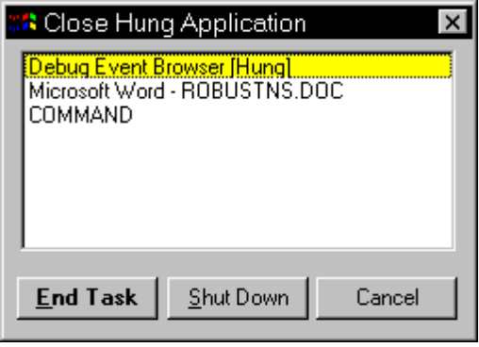
Figure 10. Local Reboot Dialog Box in Chicago
Applications are identified as “hung” when they haven’t checked the message queue for a period of time. Although an application may be performing a computationally-intensive operation, a well-behaved application will check the message queue on a more frequent basis. Just as with Windows 3.1, it is necessary for a Win16–based application to check the message queue in order to relinquish control to other tasks running.

Virtual Device Driver Thread Clean-up When a Process Ends
Local reboot support is also aided by improved VxD thread clean-up when a given process ends. With Windows 3.1, it was quite common for the system to be unable to recover if the system was running real-mode code such as BIOS routines when an application ended abnormally, or if the user requested a local reboot to end a seemingly-hung application. For example, suppose the user requested a local reboot or suppose an operation (such as a network operation in real-mode, a disk I/O, or an asynchronous application request) ended abnormally because of another application-based error. In these cases, Windows 3.1 couldn’t necessarily clean up properly to free allocated resources, and possibly couldn’t even return control to the user.
Chicago improves system clean-up by providing each system VxD the ability to track the resources it allocates on a per-thread basis. Since most computer system functionality and support is handled by VxDs in Chicago rather than by real-mode code or BIOS routines, Chicago can recover from errors or situations that, under Windows 3.1, would required the computer to be rebooted.
When Chicago ends a given thread, each VxD receives notification that the thread is ended (because the user exited the application, a local reboot was requested, or the application ended abnormally). This notification allows the VxD to safely cancel any operations it is waiting to finish. This also frees any resources that the VxD previously allocated for the thread or application. Since the system tracks an entire VM, a Win16 application, and a Win32 thread, each as a per-thread instance, the system can clean up properly at each of these levels, without affecting the integrity of the system.

Per-Thread State Tracking
Resource tracking in Chicago is much better than that provided in Windows 3.1 to aid system clean-up. In addition to tracking resources on a per-thread basis by system VxDs, resources such as memory blocks, memory handles, graphics objects, and other system items are allocated and also tracked by system components on a per-thread basis. Tracking these resources on a per-thread basis allows the system to clean up safely when a given thread ends, either normally at the user’s request, or abnormally. Resources are identified and tracked by both a thread ID, and by the major version number of Windows that is stored in the .EXE header of the application.
For a discussion of how the thread ID and the version number of Windows are used to facilitate cleanup of the system and recovery of allocated resources for Win16 and Win32–based applications, see the Win16 and Win32–based application robustness sections in this guide.

Virtual Device Driver Parameter Validation
Virtual device drivers are an integral part of the Chicago operating system and have a more important role than in Windows 3.1, as many operating system components are implemented as VxDs. To help provide for a more stable and reliable operating system, Chicago provides support for parameter validation of virtual device drivers, something that was not available for Windows 3.1. The debug version of Chicago system files provided as part of the Chicago SDK and Chicago DDK will aid VxD developers to debug their VxDs during the course of development to ensure their VxDs are stable and robust.
In addition to providing improved system-wide robustness, Chicago delivers improved robustness for running MS-DOS–based, Win16–based, and Win32–based applications, providing for a more stable and reliable environment than Windows 3.1.

Robustness for MS-DOS–based Applications
Chicago provides improved support for running MS-DOS–based applications under Chicago that were not possible with Windows 3.1. Several improvements present in Chicago provide great robustness for running MS-DOS–based applications. These improvements are described in the next two sections.

Improved Protection for Virtual Machines
Each MS-DOS–based application runs in a separate VM, and are configured by default to execute preemptively and run in the background when another application is active. Each VM is protected from other tasks running in the system, and an errant Win16– or Win32–based application can’t crash a running MS-DOS–based application, and vice versa.
Under Windows 3.1, each VM inherits the attributes and environment configuration from the global System VM. While each VM is protected from another VM preventing errant MS-DOS–based applications from accessing memory or overwriting system code thus possibly bringing the system down, the VM does not provide complete protection preventing an MS-DOS–based application from overwriting MS-DOS system code. MS-DOS–based applications have full access to all memory locations in the first megabyte of addressable memory space (i.e., the real-mode memory range).
Chicago supports a higher level of memory protection for running MS-DOS–based applications, preventing the applications from overwriting the MS-DOS system area in real-mode. Users can configure their MS-DOS–based applications to run with “general memory protection” enabled if they want the highest level of system protection. This mode is not enabled by default due to overhead required to validate memory access requests. Furthermore, parameter validation of Int 21h operations on pointers will be performed. This will increase the robustness of the system.

Better Cleanup When a Virtual Machine Ends
When a VM ends in Chicago—either normally because the exited the application or VM or requested a local reboot, or abnormally because the application ends abnormally—the system frees all resources allocated for the VM. In addition to the resources allocated and maintained by the system VxDs as previously discussed, the system tracks resources allocated for the VM by the Virtual Machine Manager, including DPMI and XMS memory that the VM requested.
In Windows 3.1, resources such as DPMI memory are not released properly when the VM is ended. Chicago frees the DPMI memory used by the VM and other resources allocated by the operating system components.

Robustness for Win16–based Applications
Chicago provides improved support for running Win16–based applications. It also provides great robust Win16 application support plus compatibility with existing Windows–based applications, while keeping the memory requirements low. The next two sections describe improvements for Win16–based applications running under Chicago.

Per-Thread State Tracking
Under Windows 3.1, when a Windows–based application ended, the resources used by the application were not released by the system. Some Windows–based applications took this into account and didn’t free certain resources as the allocated resources could then be accessed by other in-memory Windows–based applications or system components (such as DLLs). Changing the way the system behaves when a Win16 application ended—for example, by freeing up all resources allocated to the Win16 application immediately—might break an existing application.

Parameter Validation for Win16 APIs
Under Chicago, each Win16–based application runs as a separate thread in the Win16 address space to facilitate resource tracking. When a Win16 application ends, resources allocated to the Win16 application aren’t immediately released by the system but are held by the system until the system can safely free them. When the last Windows 3.x application is ended, Chicago determines that it is safe to free all resources allocated for Win16–based applications and begins cleaning the system of resources associated with Windows 3.x applications. Chicago determines that no more Win16–based applications are running by associating the Windows version number of the application with the thread ID for the running process. When no more Windows 3.x applications are running in the system, Chicago frees any remaining resources allocated by the Win16–based applications.

Robustness for Win32–based Applications
Chicago provides support for checking the validity of parameters passed to Windows APIs by Win16–based applications. Some users perceived Windows 3.0 to be unstable because the “Unrecoverable Application Errors” (UAE) were common when working with Windows–based applications. Most of this instability was in fact caused by Windows–based applications that passed invalid parameters to Windows API functions. The APIs in turn attempted to process this bad data and usually attempted to access an invalid area of memory. For example, when an application that inadvertently passed a NULL pointer to a Windows API function which tried to access memory at the address referenced, it would generate a UAE or “general protection fault.”
Chicago provides parameter validations for all Win16–based APIs and checks incoming data to API functions to ensure the data is valid. For example, functions that reference memory are checked for NULL pointers, and functions that operate on data within a range of values are checked to ensure the data is within the proper range. If invalid data is found, an appropriate error number will be returned to the application. It is then up to the application to catch the error condition and handle it accordingly.
The Chicago SDK provides debug system components to aid software developers to debug their applications. The Chicago debug components provide extensive error reporting for parameter validation to aid the developer in tracking common problems related to invalid parameters during the course of development.
While the robustness improvements for running MS-DOS–based and Win16–based applications in Chicago is better than that provided by Windows 3.1, the greatest support for robustness in Chicago is available when running Win32–based applications. Win32–based applications also benefit from preemptive multitasking, linear address space (rather than segmented), and support for a feature-rich API set.
Robustness support for Win32–based applications includes:
- A private address space for each Win32–based application to run, segregating and protecting one application from others that are running concurrently
- Win32 APIs that support parameter validation to provide for a stable and reliable environment
- Resources are tracked by threads and freed up immediately when the thread ends
- Separate message queues are used to ensure that a hung Win32–based application will not suspend the entire system

Each Win32–based Application Runs in its own Private Address Space

Parameter Validation for Win32 APIs
Each Win32–based application runs in its own private address space. This provides protection of its resources at the system level from other applications running in the system. It also prevents other applications inadvertently overwriting the memory area of a given Win32–based application, and prevents the Win32–based application from inadvertently overwriting the memory area of another application or the system as a whole.
As with parameter validation for Win16–based applications, Chicago provides parameter validation for Win32 APIs used by Win32–based applications. The Chicago SDK helps software developers debug errors resulting from attempts to pass invalid parameters to Windows APIs. For additional information about parameter validation for Win16 APIs, see the discussion of robustness for Win16–based applications presented earlier in this guide.

Per-Thread Resource Tracking

Separate Message Queues for Win32–based Applications
Resources allocated by threads in Win32–based applications are tracked by the system. Unlike thread tracking for Win16–based applications, Chicago resources are automatically deallocated when the thread ends processing. This helps to ensure that allocation system resources are freed immediately and are available for use by other running tasks.
Resources are cleaned up properly when threads either end execution on their own (for example, perhaps the developer inadvertently did not free allocated resources), or when the user requests a local reboot that ends a given Win32 application thread or process. Unlike Win16–based applications designed to run under Windows 3.1, Win32–based applications free up allocated resources immediately when the application or a separate thread ends.
The Windows environment performs tasks based on the receipt of messages sent by system components. Each message is generated based on an action or event that occurs on the system. For example, when a user presses a key on the keyboard and releases it, or moves the mouse, a message is generated by the system and passed to the active application informing it of the event that occurred. Windows–based applications call specific Windows API functions to extract event messages from message queues and perform operations on the messages (for example, accept an incoming character typed on the keyboard, or move the mouse cursor to another place on the screen).
Under Windows 3.1, a single message queue was used by the entire system. Win16–based applications cooperatively examined the queue and extracted messages destined to them. This single-queue scheme posed some problems. For example, if a Win16–based application hung and prevented other applications from checking the message queue, the message queue became full and accepted no new messages. Then other Win16–based applications were suspended until control was relinquished to them and they were able to check for event messages.
Chicago solves the problems inherent with a single message queue in Windows 3.1, by providing for separate message queues for each running Win32–based application (see Figure 35). The system takes messages from the input message queue and passes them to the message to the appropriate Win32–based application or to the Win16 Subsystem, if the message is destined for a Win16–based application. If a Win32–based application hangs and no longer accepts and processes incoming messages destined for it, the Win32–based application does not affect other Win16– and Win32–based applications currently running.
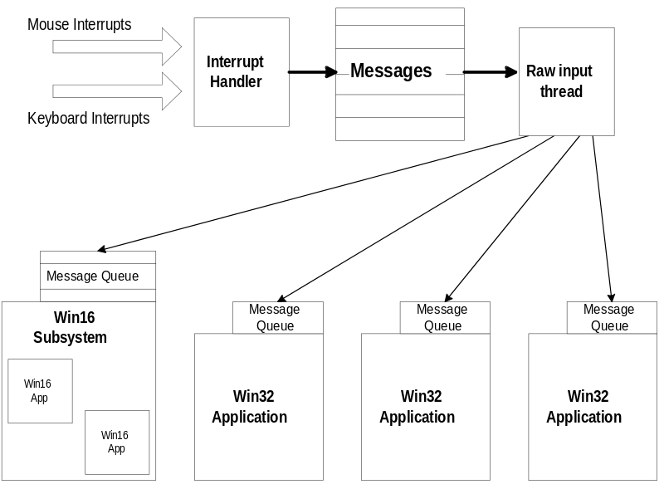
Figure 11. Win32–based Applications Use Separate Message Queues for Increased Robustness
If a Win32–based application ends or the user requests a local reboot operation on a Win32–based application, having separate message queues improves the robustness of the operating system by making it easier to clean up and to free system resources used by the application. It also provides greater reliability and recoverability if an application hangs.

Improved Local Reboot Effectiveness
Due to the robustness improvements supported in the system for Win32–based applications (including the use of a private address space, separate message queues, and resource tracking by thread), users should be able to end ill-behaved Win32–based applications in almost all cases, without affecting the integrity of the Windows system or other running applications.
When a Win32–based application is ended, resources are deallocated and cleaned up by the system as soon as the application ends. Because Win32–based applications run in their individually-allocated environment, this method is even more robust than the way Chicago is able to reallocate Win16 application resources. (See the section called “Robustness for Win16-based Applications” for more details.)

Structured Exception Handling
An exception is an event that occurs during the execution of a program, and that requires the execution of software outside the normal flow of control. Hardware exceptions can result from the execution if certain instruction sequences, such as division by zero or an attempt to access an invalid memory address. A software routine can also initiate an exception explicitly.
The Microsoft Win32 application programming interface (API) supports structured exception handling, a mechanism for handling hardware- and software-generated exceptions. Structured exception handling gives programmers complete control over the handling of exceptions. The Win32 API also supports termination handling, which enables programmers to ensure that whenever a guarded body of code is executed, a specific block of termination code is also executed. The termination code is execute regardless of how the flow of control leaves the guarded body. For example, a termination handler can guarantee that clean-up tasks are performed even if an exception or some other error occurs while the guarded body of code is being executed. Structured exception and termination handling is an integral part of the Win32 system and it enables a very robust implementation of system software.
Chicago provides structured exception and termination handling for Win32–based applications that make use of this functionality—resulting in applications that can identify and rectify error conditions that may occur outside their realm of control, providing a more robust computing environment.

Try It!
To see how the robustness improvements made in Chicago results in a more stable, and reliable environment than Windows 3.1, you’ve got to try it!


Local Reboot
To see how local reboot works in Chicago and Windows 3.1, you’ve got to try the three-finger salute. With a couple of applications running in the system, press CTRL-ALT-DEL simultaneously.
Under Windows 3.1, the system may identify the currently active application as the application that has the focus of the local reboot request, or may report back that there is no application in a hung or inactive state.
Under Chicago, the user will be presented with a list of active applications, and is given the option of terminating any currently running tasks. Applications that are no longer responding to the system are identified as being “hung” in the local reboot dialog box.

Improved Support for Running MS-DOS–based Applications
Support for MS-DOS–based applications, device drivers, and terminate-and-stay-resident programs (TSRs) does not go away in Chicago. In fact, Chicago offers better compatibility for running MS-DOS–based applications than Windows 3.1 does, including applications that are hardware-intensive, such as games.
As with Windows 3.1, Chicago provides the ability for a user to launch an MS-DOS command prompt as an MS-DOS virtual machine (VM). The functionality supported in an MS-DOS VM, is the same functionality that is available under the latest version of MS-DOS, allowing users to run the same intrinsic commands and utilities.
Chicago delivers great support for running MS-DOS–based applications, allowing even applications that would not run under Windows 3.1 to run properly. This allows MS-DOS–based applications to coexist peacefully with the rest of the Chicago environment.

Summary of Improvements over Windows 3.1
Improvements made in the system provide the following benefits for running MS-DOS–based applications in the Chicago environment:
- Zero conventional memory footprint for protected-mode components
- Improved compatibility for running MS-DOS-based applications
- Improved robustness for MS-DOS–based applications
- Better support for running MS-DOS–based games, including in a window
- Support for running existing MS-DOS–based applications without exiting Chicago or running MS-DOS externally
- Consolidated attributes for customizing properties of MS-DOS–based applications
- Toolbar availability when running an MS-DOS–based application in a window providing quick access to features and functionality to manipulate the window environment
- User-scaleable MS-DOS window through the use of TrueType fonts
- Ability to gracefully end MS-DOS–based application without exiting the application
- Ability to specify local VM environment settings on a per-application basis through the use of a separate batch file
- Support for new MS-DOS commands providing tighter integration between the MS-DOS command line and the Windows environment

Zero Conventional Footprint Components
Chicago helps to provide the maximum amount of conventional memory available for running existing MS-DOS–based applications. Some MS-DOS–based applications do not run under Windows 3.1 because by the time MS-DOS–based device drivers, MS-DOS–based TSRs, MS-DOS–based networking components, and Windows 3.1 were loaded, there was not enough conventional memory available. Chicago provides 32-bit protected-mode components that replace many of the 16-bit real-mode counterparts, providing the same functionality while improving overall system performance and using no conventional memory.
32-Bit virtual device drivers are provided to replace the 16-bit real-mode counterparts for such functions as:
Description | File(s) | Conventional Memory Saved
Microsoft Network client software | NET.EXE (full)  PROTMAN  NETBEUI  EXP16.DOS (MAC) | 95K  3K  35K  8K
Novell NetWare client software | LSL  EXP16ODI (MLID)  IPXODI.COM  NETBIOS.EXE  NETX.EXE  VLM.EXE | 5K  9K  16K  30K  48K  47K
MS-DOS extended file sharing and locking support | SHARE.EXE | 17K
Adaptec SCSI driver | ASPI4DOS.SYS | 5K
Adaptec CD-ROM driver | ASPICD.SYS | 11K
Microsoft CD-ROM Extensions | MSCDEX.EXE | 39K
SmartDrive disk caching software | SMARTDRV.EXE | 28K
Microsoft Mouse driver | MOUSE.COM | 17K
The resulting memory savings for using 32-bit protected-mode components can be quite dramatic. For example, suppose a PC was configured with the NetWare 3.x client software, using a SCSI CD-ROM drive, and with the MS-DOS support files SMARTDrive and Mouse. The resulting conventional memory savings that Chicago would offer this configuration would be over 225 KB!

Improved Compatibility
There are a number of reasons why some MS-DOS–based applications do not run properly under Windows 3.1. For example, some MS-DOS applications required lots of available free conventional memory, and thus wouldn’t run in a DOS VM due to large real-mode components, such as network drivers or device drivers. Other MS-DOS–based applications would not run under Windows 3.1 because they required direct access to the computer hardware and conflicted with Windows internals or other device drivers.
The goal of Chicago to support running MS-DOS–based applications is to be able to run existing “clean” MS-DOS–based applications that ran under Windows 3.1, as well as to support running the “bad” MS-DOS–based applications that tried to take over the hardware or required machine resources unavailable under Windows 3.1.
Many MS-DOS–based games take advantage of the assumption that they are the only application running in the system, and access and manipulate the underlying hardware directly, thus preventing them from being run in a MS-DOS VM under Windows 3.1. Games are the most notorious class of MS-DOS–based applications that don’t get along well with Windows 3.1. Some of these applications write to video memory directly, manipulate the hardware support resources such as clock timers, and take over hardware resources such as sound cards.
A number of things have been done to provide better support for running MS-DOS–based applications that interact with the hardware, including better virtualization of computer resources such as timers and sound device support. In addition, the use of 32-bit protected-mode device drivers benefits MS-DOS–based applications by providing them with more free conventional memory than was available under Windows 3.1, allowing a class of memory-intensive applications to run properly.
Different MS-DOS–based applications require varying levels of support from both the computer hardware and from the operating system. For example, there are some MS-DOS–based games that require close to 100% use of the CPU to perform properly, and there are other MS-DOS–based applications that modify interrupt addresses and other low-level hardware settings. Chicago provides several different levels of support for running MS-DOS–based applications. These levels of support take into account that different applications interact with the hardware in different ways—some behave well, whereas others expect exclusive access to the PC system and hardware. By default, MS-DOS–based applications are preemptively multitasked with other tasks running on the system and can run either full-screen or in a window. (CPU-intensive MS-DOS–based applications may not run well in a window for performance reasons, but can be run in full-screen mode to get the best response level.)

Single MS-DOS Application Mode
To provide support for the most intrusive set of MS-DOS–based applications that only work under MS-DOS and require 100% access to the system components and system resources, Chicago provides a mechanism that is the equivalent of running an MS-DOS–based application from real-mode MS-DOS—this mechanism is called Single MS-DOS application mode. While fewer MS-DOS–based applications will need to run in this mode due to improved compatibility support provided by Chicago, this mode provides an “escape hatch” mechanism for running applications that only run under MS-DOS.
To run an MS-DOS–based application in this mode, users set the Single MS-DOS Application Mode property from the Program tab on the MS-DOS property sheet for the application. In this mode, Chicago removes itself from memory (except for a small stub), and provides the MS-DOS–based application with full access to all the resources in the computer. Before a user runs an MS-DOS–based application in this mode, Chicago prompts the user as to whether running tasks can be ended. Upon user’s approval, Chicago ends all running tasks, load a real-mode copy of MS-DOS, and launch the specified application. This process is like exiting Windows 3.1, then running the specified MS-DOS–based application under MS-DOS. Once the user exits the MS-DOS–based application, Chicago restarts and returns the user to the Chicago shell.

Improved Support for Graphic-intensive MS-DOS–based Applications
Chicago improves the support for running MS-DOS–based applications in the Windows environment by providing better support for running graphic-based applications in a window, rather than requiring the application to be run in full-screen mode as with Windows 3.1. MS-DOS–based applications that use VGA graphic video modes can now be run in an MS-DOS window, whereas under Windows 3.1 the user was prevented from doing this. While Chicago is improved over Windows 3.1, the user may choose to run graphic-intensive MS-DOS–based applications in full-screen mode for the best level of performance.

Improved Memory Protection
To support a higher level of memory protection for running MS-DOS–based applications, Chicago includes a “global memory protection” attribute on the Program property sheet tab that allows the MS-DOS system area to be protected from errant MS-DOS–based applications. When the global memory protection attribute is set, the MS-DOS system area sections are read-protected so that applications can’t write into this memory area and corrupt MS-DOS support and MS-DOS–based device drivers. In addition to the system area protection, enhanced parameter validation is performed for file I/O requests issued through the MS-DOS INT 21h function, providing a higher degree of safety.
This option is not enabled by default for all MS-DOS–based applications due to the additional overhead associated with providing improved parameter and memory address checking. Users would set this flag if they are constantly encountering difficulty running a specific MS-DOS–based application.

Better Defaults for Running MS-DOS–based Applications
By default, Windows 3.1 runs MS-DOS–based applications full-screen and disabled the ability for the MS-DOS–based application to run in the background. To change this default behavior, it was necessary for users to use the PIFEDIT application and modify or create a program information file (.PIF) for the given MS-DOS–based application.
Chicago defaults to running MS-DOS–based applications in a window, and enables the background execution setting, allowing the application to continue to run when it is not the active application. The change in this default behavior provides better integration between running MS-DOS–based applications and Windows–based applications without requiring the user to change or customize the state of the system.

Consolidated Customization of MS-DOS–based Application Properties
Each MS-DOS–based application has different characteristics and mechanisms for using machine resources such as memory, video, and keyboard access. Chicago (and Windows 3.1) understand how to run Windows–based applications as requests for system services is handled through the use of the Windows API. However, MS-DOS–based applications only included minimal information about their requirements in the format of the .EXE header associated with each application. To provide additional information to the Windows environment about the requirements for running MS-DOS–based applications, a program information file (.PIF) is used to specify the configuration settings used to run MS-DOS–based applications in the Windows environment.
Under Windows 3.1, the PIF Editor application was used to create or change properties associated with running MS-DOS–based applications. Problems associated with the PIF Editor or PIF creation process included difficulty in accessing the PIF editor or PIF settings, the disassociation of PIF properties from the MS-DOS–based application for new users, the lack of a single location for storing PIF files beyond placing them all in the WINDOWS directory, and less-than-intelligent defaults for running MS-DOS–based applications.
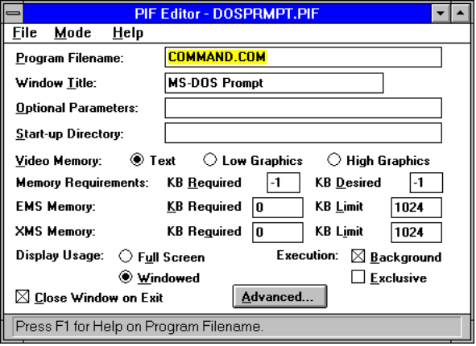
Figure 12. PIF Editor in Windows 3.1
Chicago enhances the ability to define properties for running MS-DOS–based applications by consolidating PIF files into a single location (the PIF directory where Chicago is installed), providing easy access to property information for an application (using the secondary mouse button to simply click the icon or application window), and simplifying the user interface to provide better organization of property settings (through the use of a tabbed property sheet dialog box). Through the use of property sheets, Chicago provides greater flexibility and control for running MS-DOS–based applications.
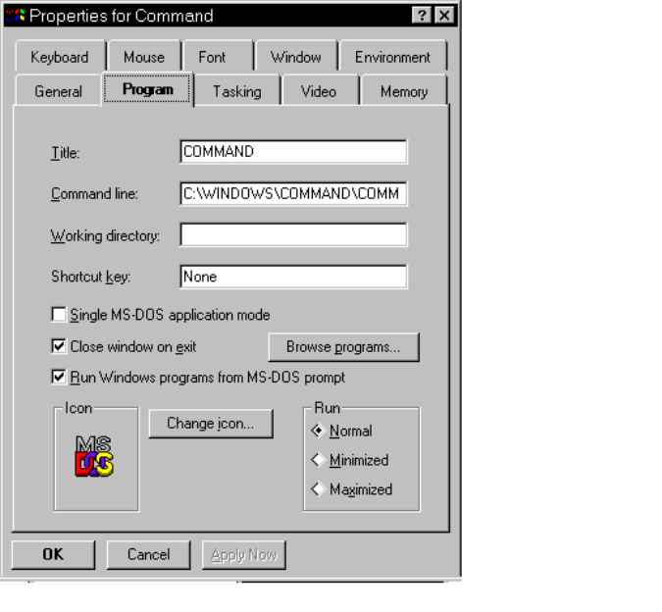
Figure 13. Property Sheet for Configuring an MS-DOS–Based Application

Toolbar in MS-DOS Window
In addition to providing compatibility enhancements in Chicago to support running MS-DOS–based applications better than under Windows 3.1, Chicago makes it even easier to use MS-DOS–based applications in the Windows environment than Windows 3.1. Many Windows–based applications implement a toolbar to provide quick access to common features and functionality of a product, Chicago extends this simplicity and power feature to making it easy to access functionality associated with an MS-DOS–based application.
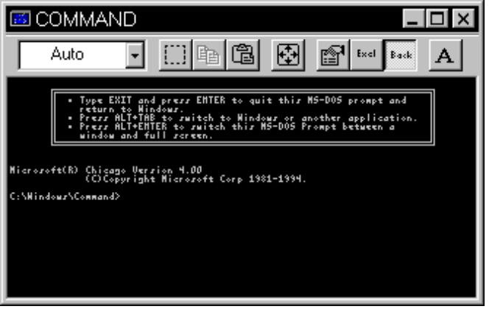
Figure 14. Toolbar in Windowed MS-DOS Box
Optionally, a user can enable the display of a toolbar in the window of a running MS-DOS–based application to provide the user with quick access to the following functionality:
- Simpler access to cut, copy, and paste operations for integrating text-based or graphics-based MS-DOS–based applications with Windows–based applications
- Easy access to switching from windowed to full-screen mode
- Quick access to property sheet information associated with the MS-DOS–based application
- Access to MS-DOS VM tasking properties such as exclusive or foreground processing attributes
- Easier access to font options for use in displaying text in a windowed MS-DOS VM

User-Scalable MS-DOS Window
Chicago supports the use of a TrueType font in a windowed MS-DOS VM, supporting the ability for a user to scale the MS-DOS window to any size. When the font size is set to “Auto,” the MS-DOS window is sized automatically to display the entire window within the user-specified area. The figure below shows the MS-DOS command prompt window being changed to a smaller size.
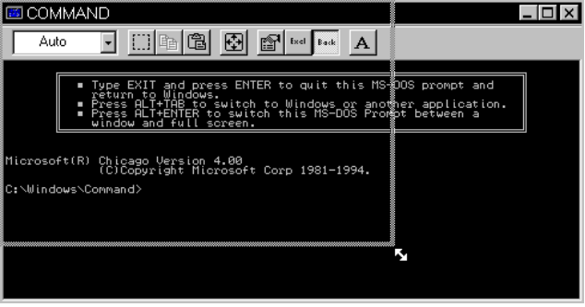
Figure 15. With TrueType Font Support, Users Can Scale an MS-DOS Window

Ending MS-DOS–based Applications Graceful
Chicago provides support for gracefully closing an MS-DOS VM through a property sheet setting available on an application-by-application basis. When enabled, the user can close an MS-DOS–based application just as a Windows–based application is closed—by clicking the close window button. If Chicago senses that the MS-DOS VM window contains a running MS-DOS–based application, Chicago prompts the user for confirmation to end the given application.
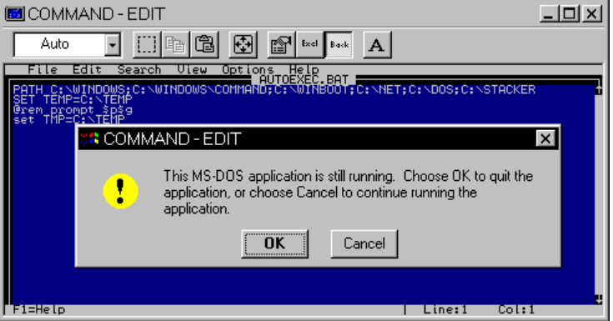
Figure 16. Warning Dialog Box Displayed When an MS-DOS—based Application is Active
In addition to simply ending an MS-DOS–based application, robustness improvements made to the Chicago system ensure that system clean up is completed properly and all allocated resources are freed. This results in memory used by the MS-DOS–based applications is deallocated properly and available for use by other applications. (Windows 3.1 didn’t properly free DPMI memory, for example.)

Local Virtual Machine Environment Settings
When Windows 3.1 starts up, it uses the MS-DOS environment as specified before Windows is started as the default state for each MS-DOS VM that is created. Any TSRs or other memory resident software that is loaded before starting Windows is replicated across all MS-DOS VMs, whether the VM needs it or not. Windows 3.1 did not provide a mechanism to allow a user to run a batch file that set the VM environment, before starting a given MS-DOS–based application. Actually, a batch file could be run by the user under Windows 3.1, but once the batch file finished processing the command statements, the MS-DOS VM was closed.
Under Chicago, a batch file can be optionally specified for a given MS-DOS–based application allowing customization of the VM on a local basis before running the MS-DOS–based application. This allows MS-DOS environment variables to be set or customized for individual MS-DOS–based applications, and for TSRs to be loaded in the local VM only. This is like having a separate AUTOEXEC.BAT for different MS-DOS–based applications. The batch file is specified on the Environment tab of the property sheet for the MS-DOS–based application.
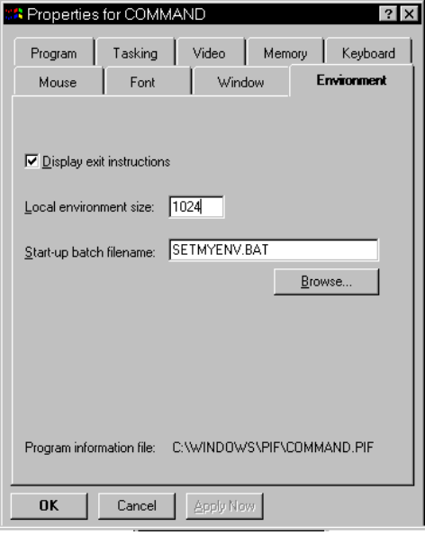
Figure 17. Property Sheet Tab for Specifying Environment Attributes

Support for UNC Pathnames to Access Network Resources
Chicago makes it even easier to access network resources from the MS-DOS command prompt by supporting the use of universal naming conventions (UNC). UNC names provide a standard naming scheme to reference network servers, and shared directories and use the following syntax: \\servername\sharename[\pathname]
The Chicago shell allows users to browse and connect to network servers without mapping a drive letter to the network resource. Chicago supports the same functionality at an MS-DOS command prompt and allows the user to:
- View the contents of shared directories on network servers from both Microsoft Network servers and Novell NetWare servers: dir \\servername\sharename[\pathname]
- Copy files from the contents of shared directories on network servers from both Microsoft Network servers and Novell NetWare servers: copy \\servername\sharename\pathname\file destination
- Run applications from shared directories on network servers for both Microsoft Network servers and Novell NetWare servers: \\servername\sharename\pathname\filename

New MS-DOS Prompt Commands
The MS-DOS command processor and utilities have been enhanced to provide better integration between MS-DOS functionality and the Windows environment. Commands that manipulate files have been extended to support long file names, and some new commands have been added to Chicago, providing access to new capabilities supported by the system.

Starting MS-DOS and Windows–based Applications
For example, the start command allows a user to start a Windows–based or MS-DOS–based application from the command prompt in one of the following ways:
start <application name> | <document name>
- Start an application by specifying the name of a document to open, and Chicago will launch the application associated with the given file type. For example, a user can type “start myfile.xls” and the application associated with the file specification will start, if there is a valid association.
- Start an MS-DOS–based application in a different MS-DOS VM instead of the current one.
- Start a Windows–based application from an MS-DOS command prompt. When the user just types the name of a Windows–based application it is essentially the same as typing “start <application>”.

Support for Long File Names
Many MS-DOS intrinsic commands and utilities have been extended to support the use of long file names. Basic examples of support for long file names includes the following commands. Many other commands have also been extended.
- The dir command has been extended to show long file names in the directory structure, along with the corresponding 8.3 filename. Also, the dir command now supports a “verbose” mode to display additional file details by typing “dir /v”.
- The copy command has been extended to allow copying or long file names to/from short or long file names. For example, typing:
“copy myfile.txt "this is my file"” will create a new file with a long file name.

Try It!
To see how Chicago improves support for running MS-DOS–based applications over Windows 3.1, you’ve got to try it!

Improved Support for Running MS-DOS–based Applications
- Try an MS-DOS–based application that is known to not run under Windows 3.1 and run it under Chicago. Does it work? (If not, report it as a bug)
- Take an MS-DOS–based application that is known to run under Windows 3.1, but doesn’t run in a window, and run it under Chicago in a window. Does it work? (If not, report it as a bug)

More Free Conventional Memory
Install Chicago on a PC with a configuration similar to one now running Windows 3.1 with MS-DOS–based device drivers and TSRs loaded. For example, use PCs with SCSI drivers, network drivers, or system support files such as SMARTDRV, MSCDEX, or SHARE.
- Type the “mem /c” command under Windows 3.1 and under Chicago. Is there a memory savings under Chicago for the same configuration?

MS-DOS–based Application Property Sheets
To see a property sheet for an MS-DOS–based application, try the following:
- Use the secondary mouse button to simply click the icon for an MS-DOS–based application, and select the Properties... item.
- Use the secondary mouse button to simply click the title bar of an active
MS-DOS–based application, and select the Properties... item.

Scalable MS-DOS Window
To demonstrate the ability to scale an MS-DOS window, open an MS-DOS VM window and set the font size to “Auto” from the Font tab on the property sheet.
Click the mouse in the scale region of the lower-right corner of the window and change the size—this functionality is more noticeable when performed at higher resolutions.

Launching Applications from the MS-DOS Command Prompt
To demonstrate the ability for launching applications under Chicago from the MS-DOS command prompt, try the start command in a variety of scenarios. From an MS-DOS command prompt, try these operations:
- Type “start /?” to see the options available.
- Type “start edit” to start the MS-DOS Edit application in another VM.
Type “start /m clock” to start the Clock Windows-based application in minimized form.

Plug and Play
Configuring PC hardware and operating systems has become a significant problem in the PC industry, resulting in customer dissatisfaction and increased support costs—all of which impacts the industry affecting PC market growth. A broad-based group of PC industry members is tackling this industry-wide problem with the development of an open and extensible framework architecture called Plug and Play. The Plug and Play specifications describe hardware and software changes to the PC and its peripherals that free the PC user from manually configuring hardware resources.
Chicago is the operating system that ties Plug and Play components together. Operating system services are implemented in Chicago to make PCs even easier to use by providing:
- Help in device detection for installing and configuring devices
- Event notification for informing other system components and applications of dynamic changes to the system state
- Tight integration among device drivers, system components, and the user interface to make the operating system easier to use, configure, and manage.
Plug and Play in Chicago not only offers functionality to make it even easier to use a Plug and Play PC, but provides benefits to configuring and managing legacy PC hardware.

The Problem With PCs Today
For a user who is not a trained technician, installing or configuring a device on a PC can be a daunting task. Most users have neither the time nor the inclination to learn about such arcane subjects as interrupt request (IRQ) lines, direct memory access (DMA) channels, small computer system interface (SCSI) termination, or monitor timings. However, if users want to add devices to their PCs or take advantage of the features of a new device, they often must address these subjects, because most existing PC systems offer no alternative. Potential PC users hear about problems that current users encounter in these areas, which reinforce their viewpoint that PCs are complex, intimidating, and difficult to use.
Although the availability of add-on devices is an advantage of the PC, the fact that the typical PC contains devices made by numerous vendors tends to compound the hardware and software configuration problem. The hardware, operating system, and applications don’t know about other PC components, and the hardware can’t tell when conflicts exist between different devices trying to share the same system resource.
The main problems associated with today’s PC hardware and operating systems can be summarized by the following three points:
- Adding devices to a PC can be a painful process.
A lack of coordination between hardware and software components leads to device conflicts when vying for valuable system resources such as IRQs, DMA addresses, and I/O addresses.
There is also no easy access to information about the configuration of a PC, leading to confusion and an increased burden on the end-user and technical support resources to solve conflicts and other device errors.
- Software has no idea what’s in the system.
Today’s operating systems only support rudimentary mechanisms for allowing applications to query the configuration of a PC. This information usually covers just basic properties of the PC including the type of CPU it has, the amount of memory configured, and possibly information about base devices such as communication ports. However, beyond basic properties, there are no consistent mechanisms to query detailed information about connected peripherals, or support for receiving system notification that may be associated with dynamic configuration of system resources (such as the addition or removal of a device on-the-fly).
- Evolution of the PC platform is stalled due to compatibility problems.
Many different bus standards exist that are used in PCs today. These include ISA, EISA, Micro Channel, PCMCIA, serial ports, parallel ports, and ECP. Creating a new bus standard or device architecture, while maintaining compatibility with the existing architectures is a difficult task. Plug and Play provides a framework on which to design and implement new PC architectures, providing a common and consistent way for devices to interact and coexist, using a bus-independent design.

Mobile Computers Demand Much Higher Flexibility
The bigger problem that the current PC architecture encounters is trying to support the higher flexibility requirements for mobile computers. Mobile computers are used in a number of environments by on-the-road users, and the technology aimed at mobile computing professionals is growing by leaps and bounds. The configuration scenario shared by mobile computer users is different from that of desktop computer users. The mobile environment is much more dynamic and demands higher flexibility from the computing platform:
- Mobile users need flexible configuration support whether in the office and on the road.
Users plug their mobile PCs into a docking station while used within the office, and run them in an undocked state while on the road. While connected to a docking station, a mobile PC may have network connectivity for accessing shared corporate resources, however once it is undocked, it’s necessary to reconfigure the PC, perhaps support network connectivity through a dial-up process rather than a local, physical connection.
- Support for hot-docking or hot-plugging of devices needs special operating system support and applications aware of changing environment.
The advent and popularity of PCMCIA also poses some dilemmas for the operating system and application programs. A main issue is how best to provide support for dynamic configuration when a device is added or removed from the system. For example, what should the operating system or application do in response to the addition of a PCMCIA card that provides access to SCSI devices, provides additional hard disk storage, or adds modem connectivity to the PC? Any of these hardware changes may affect the way software behaves on the system. Therefore, it is necessary for the operating system to support a mechanism for notification to inform the applications that their system configuration state may change and that they will need to take appropriate action. For example, suppose someone uses a word processing application to open a document on a PCMCIA hard disk drive, then decides he or she want to remove that hard disk. To gracefully handle this situation, the word processing application (which, of course, is Plug-and-Play aware) saves and closes the document before the hard disk is removed.

The Plug and Play Solution
Through automatic installation of drivers and seamless configuration, the Plug and Play architecture will turn the PC into more of an “appliance” rather than a complex, difficult to configure piece of hardware as it is today. A key benefit of Plug and Play is that it will help to create and support a dynamic platform by recognizing and enabling the transformation of the PC platform to a more mobile and dynamic environment.
The Plug and Play architecture is an open, flexible, and cost-effective framework for designing Plug and Play products. Plug and Play was jointly developed by a group of leading vendors who obtained reviews for their design proposals from hundreds of companies in the industry. Plug and Play provides a framework that works on many types of bus architectures — ISA, EISA, Micro Channel, PCMCIA, VESA local bus (VL-bus), Peripheral Component Interconnect local bus (PCI), and so on — and I/O port connections, and can be extended to future designs.
Here are three major benefits of the Plug and Play architecture:
- Support costs are reduced for end-users, MIS support organizations, and industry hardware and software vendors.
Reducing the complexities of installing and configuring devices and peripherals will have a material benefit for both users, and MIS organizations.
As many as half of all support calls currently received by operating system and device manufacturers are related to installation and configuration of devices. For businesses, reducing the high cost of supporting PCs increases the use of PCs in the workplace and focuses information systems personnel on using computer technology to solve business problems. Both Plug and Play PCs and legacy PCs store hardware and software configuration in the Registry for centralized access, so support benefits can be achieved on existing hardware.
- Plug and Play makes it easy to install and configure add-on devices with little or no user intervention.
Chicago stores all information about the hardware and resource configuration of peripheral devices (such as IRQs, I/O addresses, and memory addresses) in the Registry. On Plug and Play PCs, resource allocation is automatically arbitrated by the system and free resources are used to configure the hardware device. On legacy PCs, the information stored in the centralized Registry is used to notify the user of a potential resource conflict when configuring the peripheral. It is used also to perform device detection using the known resource information.
With a Plug and Play PC, a user can easily install or connect Plug and Play devices to the system, letting the system automatically allocate hardware resources with no user intervention. For example, by simply plugging in a CD-ROM and sound card, a desktop PC can be easily turned into a multimedia playback system. The user simply plugs in the components, turns on the PC, and “plays” a video clip.
Suppose the user wanted to install a new device on a legacy PC system. Further, suppose the new device requires an IRQ setting, and a legacy network card is already installed on the PC. Since the network card already uses IRQ 5, for example, the system tells the user that a device is already using IRQ 5 and that a different IRQ setting should be chosen. Device conflicts are a thing of the past.
- PC systems can be designed with new features.
With warm-docking capabilities, for example, a businessperson could remove a portable PC from the docking station while the PC was still running, and go to a meeting. The portable PC would automatically reconfigure to accommodate the absence of the network card and large disk drive. Another example of this is an infrared (IR)-enabled subnotebook that would automatically recognize, install, and configure an IR-enabled printer when the user walked into the printer room.

Plug and Play Support in Chicago
As set forth by the industry initiative, the Plug and Play specifications are designed to be implementation-independent, and are not tied to a specific operating system. It is up to the operating system vendor to define the level of support the system will provide for making the PC easier to use.
Chicago was designed and built from the ground up with Plug and Play support in mind, and therefore provides a very rich implementation of Plug and Play functionality throughout every component of its design. With Chicago, configuration of hardware resources is greatly simplified over legacy configuration techniques—it just works.
Plug and Play in Chicago makes PCs even easier to use and supports both existing market requirements and future PC growth to deliver the following:
- Compatibility with legacy hardware
With over 140 million MS-DOS or Windows–based PCs used throughout the world, providing compatibility with existing (or “legacy”) hardware was a given requirement. The benefit of compatibility with existing hardware ensures support for Chicago and support for new Plug and Play peripherals does not require the purchase of completely new hardware.
- Automatic installation and configuration of Plug and Play devices
This means that initial PC configuration is automatic. With Plug and Play, users no longer need to configure their system and make system-resource assignments. These assignments (including those for IRQs, I/O and DMA addresses, and memory) are handled by the BIOS and operating system, thus avoiding configuration conflicts. Installation and configuration of add-on devices and peripherals is also automatic.
- Dynamic operating environment to support mobile computing environments
This functionality brings out the real power of the Plug and Play architecture, and sets Chicago apart from other operating system implementations of Plug and Play functionality. Dynamic Plug and Play properties in Chicago include support for:
- Hot docking and undocking of mobile computers to change the state of the system dynamically
- Hot plugging and unplugging of Plug and Play devices on the fly
- “Dynaload drivers” where the operating system loads drivers for devices that are present and removes drivers from memory when the device is no longer available
- Unified messaging for mechanism for notifying other operating system components and applications about changes to the state of the system dynamically
Users of Chicago will be able to reconfigure their computer on the fly and have the changes take affect immediately, without rebooting the PC.
- Simplified device driver development by using a universal driver model
To simplify device driver development support for an IHV’s hardware device, Chicago incorporates the use of a universal driver model throughout various components in the system. Windows 3.1 supported a universal driver model for printer drivers, but Chicago provides this support for more areas including communications drivers, display adapter drivers, mouse drivers, and disk device drivers. The universal driver model ensures that it’s easy for IHVs to write peripheral drivers, thus providing for more Plug and Play devices available on the market.
- An open and extensible architecture to support new technologies
The Plug and Play implementation in Chicago must be flexible and extensible enough to support future technologies as they emerge on the market The Plug and Play Initiative will spur the creation of new and innovative technologies, and Chicago will deliver this support.
- Availability of configuration information for simplified systems management
This level of information sharing helps not only the solving of configuration problems for an end-user, but also the supportability and manageability of PCs within a corporate environment which may have hundreds or thousands of PCs. Through the use of the Registry, configuration information is easily available to the system and applications, and access to the information is made available to both locally and remotely.
Additional information about the Plug and Play capabilities in Chicago is discussed in the following sections.

Benefits of Plug and Play with Chicago
Plug and Play will be of enormous benefit to the user. No longer will the user be required to manually set jumpers and switches to redirect IRQs, DMA channels, or I/O port addresses. This will save the user’s time and will also save OEMs and IHVs the expense of supporting large numbers of user service calls related to these configurations.
Plug and Play is designed so that adding a device, either permanently or dynamically, requires nothing more than taking it out of the box and plugging it in. The PC seamlessly adjusts to the new configuration.
- Users need not concern themselves with the inner workings of Plug and Play— it just works.
The Plug and Play specifications define how the various hardware devices, software drivers, and operating system components interact. At the level where the user interacts with the PC, the PC simply works. Plug and Play reduces the time users spend on technical problems and increases their productivity and satisfaction with PCs.
- Plug and Play also benefits users who install Plug and Play devices into older, legacy PC systems.
Components using the Plug and Play architecture are able to accommodate the lack of device-reporting mechanisms in non - Plug and Play devices. Information about these devices is stored centrally in the Registry, and devices that cannot be reconfigured by the software receive first priority when resources are allocated.
- Plug and Play makes it easier to manage and support PC configurations.
This is because many procedures that were once done manually—such as setting IRQ lines, figuring out what the right jumper settings are, and installing the correct device drivers—are now performed by the Plug and Play PC system. Problems that users used to encounter with non - Plug and Play PC systems generated a tremendous support burden. Customer frustration with the configuration process reduced demand for add-on and upgrade products. For businesses, the high cost of supporting PCs inhibited increased use of PCs in the workplace and diverted information systems personnel from focusing on using computer technology to solve business problems.

