WINDOWS 95 and DOMARK GAMES

Thank you for buying DOMARK products. With the introduction of Microsoft’s new operating WINDOWS 95, the promise of hassle free gaming is close to realization. While many games will play properly in Windows 95, there are some that will not. This guide is designed to aid you in playing our games with WINDOWS 95 as your operating system.

PLEASE NOTE: The following instructions are NOT guaranteed to work. We have successfully tested them on limited basis, and as systems vary - YOU Will ACCEPT ANY RISK INVOLVED IN ATTEMPTING TO MODIFY YOUR COMPUTER’S SYSTEM FILES TO PLAY OUR GAMES.

If you have any problems or concerns regarding these instructions, please contact Microsoft technical support at 206-635-7500. You can also reach them by
Internet Access = Ftp.microsoft.com/peropsys/win_news

Please keep in mind that unless a company states that a game is compatible or designed to run in Windows 95, they are not responsible to get it to run under this operating system.
____________________________________________________________________________________

BEFORE YOU START !

1- RUN the Windows 95 programs “SCANDISK” and “DEFRAG” to optimize your hard drive

2- RUN any Virus checking programs to verify no contamination

3- WE HIGHLY RECOMMEND THAT YOU:
a- get a copy of the latest drivers for your computer hardware (e.g. mouse,
soundcard, videocard...) please check your hardware manuals
b- make sure you have made a Windows 95 startup disk
________________________________________________________________________________
Helpful articles

These excellent articles provide information on optimizing Windows 95 for game use.

PC MAGAZINE - The Windows 95 Upgrade Clinic by Don Wilmott (pgs. 269- 328) -Sept.12 1995 issue
PC GAMER - EASY DOS IT (Gaming in Win 95) by Charles Brannon (pgs.60-63) September Issue
MULTIMEDIA WORLD - Uncovering the Secrets of Windows 1995 by Michael Desmond (pgs. 85-102) Sept. 95 issue

TITLE: Formula One (F1)

TESTING RESULTS: game WILL RUN through Windows 95

COMMENTS: Formula One may start with an error message that you need 582k to run the game. You can try to run the game under this situation, if you experience problems try running the game in MS-DOS mode

RECOMMENDED SETUP:

1. Use Explorer to locate the F1 icon (in F1 directory)
2. Highlight this icon and then RIGHT CLICK
3. Select PROPERTIES
4. Go to the PROGRAM section and there:
- check CLOSE ON EXIT
- click on ADVANCED and choose
“PREVENT MSDOS BASED PROGRAMS FROM DETECTING
WINDOWS”
5. Then go to the WINDOWS and select FULL SCREEN
6. Finally, go to MISC. and adjust IDLE SENSITIVITY to LOW

Flight Sim. ToolKit (FST)

TESTING RESULTS: game WILL RUN through Windows 95

COMMENTS: FST is designed to run through windows and should run better under windows 95. Please read the FST readme.txt file for additional setup information.

RECOMMENDED SETUP: Our advice is to RE-INSTALL the game through Windows 95 and not rely on the WINDOWS 3.x installation. NOTE: there is a README.TXT in the game directory that contains valuable game information - please read this document
-----------------------------------------------------------------------------------------------------------------------------

Special Note to owners of SUPER SPACE INVADERS and SHADOWLANDS:

Our testing showed that both games WILL RUN in Windows 95. However, to obtain optimal performance you will need to go to the PROPERTIES section of each game. Once there, click the PROGRAM option, then click on the Advanced button. Then click on the choice - PREVENT MS DOS PROGRAMS FROM DETECTING WINDOWS. For added safety, click on the SCREEN option and select FULL SCREEN. Again, if any problems should occur, run the games from MS DOS mode.

SVGA HARRIER/AV8B HARRIER ASSAULT

TESTING RESULTS: Game WILL NOT run in Windows 95

COMMENTS: This game is not able to run under Windows 95. To run this game properly you will need to run the game through MSDOS MODE.

RECOMMENDED SETUP:
1. Use Windows Explorer to locate the game directory labeled either HARRIER or AV8B.
Once you locate the Directory expand the directory and locate the start
command labeled either HARRIER, AV8B or HARFLY.

2. Highlight this executable and then RIGHT CLICK. Now choose the PROPERTIES
selection. Once opened, go to the PROGRAM section.

3. In the PROGRAM section: Click on close on exit and then click on the ADVANCED
button

4. Once in ADVANCED SECTION, click on MS-DOS MODE Click off the WARN BEFORE
ENTERING MS-DOS MODE

5. Now you will need to specify a DOS configuration for the game. The easiest method of
retrieving and inserting the lines from your Config.Sys and Autoexec.Bat is to use the
Windows 95 utility - WORDPAD.

6. WORDPAD is usually located in either you START MENU or you can find it by using
Explorer. You will want to open this program while you are still in the Properties section
Thus both will be opened at the same time.

7. With Wordpad, you want to OPEN your CONFIG.SYS file and select the lines that you
need for the game. You will need the CDROM drivers lines only if you have the CD
game version. You DO NOT need the EMM386 driver, it is better to not include
this driver. You will want to keep your FILES, BUFFERS, and DOS HIGH, UMB lines. To
add these lines to the system settings for the game, use the COPY AND PASTE
technique to insert these lines into the Custom Config.Sys in the Advanced Program
Settings.

8. When you are finished with the Config.Sys in WordPad, close the file and then open the
Autoexec.bat. Cut and Paste the Mouse, PATH, any SET lines, and any soundcard lines,
into the Custom Autoexec.bat in Advanced program settings. When done, click on
OK to save your work and exit the Properties section.

9. To start the game - DOUBLE CLICK ON THE EXECUTABLE FILE THAT YOU CHANGED.

TANK COMMANDER

TESTING RESULTS: game WILL NOT run through Windows 95

COMMENTS: Tank Commander will need a custom configuration to run properly in MS DOS mode. If you cannot get enough Conventional Memory to run the game, you can disable your mouse.

RECOMMENDED SETUP:
1. Use Windows Explorer to locate the game directory labeled TANKGAME. Once you
locate the Directory expand the directory and locate the start command labeled
TC.BAT (or TC)

2. Highlight this executable and then RIGHT CLICK. Now choose the
PROPERTIES selection. Once opened go to the PROGRAM section.

3. In the PROGRAM section: Click ON close on exit and then click on the ADVANCED
button

4. Once in ADVANCED SECTION, click on MS-DOS MODE
Click OFF the WARN BEFORE ENTERING MS-DOS MODE

5. Now you will need to specify a DOS configuration for
the game. The easiest method of retrieving and inserting
the lines from your Config.Sys and Autoexec.Bat is to
use the Windows 95 utility - WORDPAD.

6. WORDPAD is usually located in either you START MENU or you can find it by using
Explorer. You will want to open this program while you have the Properties section
for the game open. Thus both will be opened at the same time.

7. With Wordpad, you want to OPEN your CONFIG.SYS file and select the lines that you
need for the game. You will need the CDROM drivers lines. You need the HIMEM and
EMM386 (set to RAM) managers. You will want to keep your FILES (put to 30), BUFFERS
(put to 20), and DOS HIGH, UMB lines. To add these lines to the system settings
for the game, use the COPY AND PASTE technique to insert these lines into the
Custom Config.Sys in the Advanced Program Settings.

8. When you are done with the Config.Sys in WordPad. Close the file and then open the
Autoexec.bat file. Copy and Paste the Mouse, PATH, MSCDEX (CD driver) and any
soundcard lines, into the Custom Autoexec.bat in Advanced program settings. When
done with the custom system files in Properties, click on OK to save your work and exit
the properties section.

9. To start the game - DOUBLE CLICK ON THE EXECUTABLE FILE YOU.

ORION CONSPIRACY

TESTING RESULTS: game WILL NOT run through Windows 95

COMMENTS: Orion Conspiracy will need a custom configuration to run properly in MS DOS mode. If you cannot get enough conventional memory to run the game, you can disable your mouse. You can also disable the game’s music. (Do this in the Setup)

RECOMMENDED SETUP:
1. Use Windows Explorer to locate the game directory labeled ORION. Once you locate
the Directory expand the directory and locate the start command labeled ORION.BAT.

2. Highlight this executable and then RIGHT CLICK. Now choose the PROPERTIES selection.
Once opened go to the PROGRAM section.

3. In the PROGRAM section: Click ON close on exit and then click on the ADVANCED
button

4. Once in ADVANCED SECTION, click on MS-DOS MODE Click OFF the WARN BEFORE
ENTERING MS-DOS MODE

5. Now you will need to specify a DOS configuration for the game. The easiest method of
retrieving and inserting the lines from your Config.Sys and Autoexec.Bat is to
use the Windows 95 utility - WORDPAD.

6. WORDPAD is usually located in either START MENU (in Accessories)
or you can find it by using Explorer. You will want to
open this program while you have the Properties section
for the game open. Thus both will be opened at the same time.

7. With Wordpad, you want to OPEN your CONFIG.SYS file and select the lines that you
need for the game. You will need the CDROM drivers lines. You need the HIMEM and
EMM386 (set to NOEMS) managers. You will want to keep FILES (set at 40), BUFFERS
(set at 30), and DOS HIGH, UMB lines. To add these lines to the system settings for the
game, use the COPY AND PASTE technique to insert these lines into the Custom
Config.Sys in the Advanced Program Settings.

8. When you are done with the Config.Sys in WordPad. Close the file and then open the
Autoexec.bat file. Copy and Paste the Mouse, PATH, MSCDEX (CD driver) and any
soundcard lines, into the Custom Autoexec.bat in Advanced program settings. When
done with the custom system files in Properties, click on OK to save
your work and exit the properties section.

9. To start the game - DOUBLE CLICK ON THE EXECUTABLE FILE YOU CHANGED.
*** (run with ORION /V420 if low on Conventional mem.)
Lords of Midnight

TESTING RESULTS: game MAY run through Windows 95

COMMENTS: Lords of Midnight was able to start and run under Windows 95, however, once into the game it locked-up. We tried several settings in Properties to no avail. The game will run in MS-DOS MODE. NOTE: the SETSOUND program sets up the game sounds (mainly MIDI music). You can skip the Intro. sequence by using MIDNIGHT to run the game. If you have a lockup in MS-DOS MODE - try to running the game without the EMM386 driver.

RECOMMENDED SETUP:
1. Use Windows Explorer to locate the game directory labeled ORION. Once you locate
the Directory expand the directory and locate the start command labeled ORION.BAT.

2. Highlight this executable and then RIGHT CLICK. Now choose the
PROPERTIES selection. Once opened, go to the PROGRAM section.

3. In the PROGRAM section: Click ON close on exit and then Click
on the ADVANCED button

4. Once in ADVANCED SECTION, click on MS-DOS MODE
Click OFF the WARN BEFORE ENTERING MS-DOS MODE

5. Now you will need to specify a DOS configuration for the game.
The easiest method of retrieving and inserting the lines from your
Config.Sys and Autoexec.Bat is with the Win95 utility WORDPAD.

6. WORDPAD is usually located in either START MENU (in Accessories) or you can find it by
using Explorer. You will want to open this program while you have the Properties
section for the game open. Thus both will be opened at the same time.

7. With Wordpad, you want to OPEN your CONFIG.SYS file and select
the lines that you need for the game. You will need the CDROM drivers lines. You
need the HIMEM and EMM386 (set to RAM) managers. You will want to keep your FILES
(set to 30), BUFFERS(set to 30), and DOS HIGH, UMB lines. To add these lines to the
system settings for the game, use the COPY AND PASTE technique to insert these lines
into the Custom Config.Sys in the Advanced Program Settings.

8. When you are done with the Config.Sys in WordPad. Close the file and then open the
Autoexec.bat file. Copy and Paste the Mouse, PATH, MSCDEX (CD driver) and any
soundcard lines, into the Custom Autoexec.bat in Advanced program settings. When
done with the custom system files in Properties, click on OK to save your work and exit
the Properties section.

9. To start the game - DOUBLE CLICK ON THE EXECUTABLE FILE YOU CHANGED.
===== These are sample files =====

CONFIG.SYS
DEVICEHIGH /L:2,29168 =C:\SCSI\ASPI2DOS.SYS /D /Z - SCSI CDROM driver
DEVICEHIGH=C:\SCSI\ASPICD.SYS /D:ASPICD0 - SCSI CDROM driver
DEVICE=C:\WINDOWS\Himem.sys - XMS memory manager
DEVICE=C:\WINDOWS\EMM386.EXE RAM HIGHSCAN I=B000-B7FF - EMS memory manager
DEVICE=C:\SB16\DRV\CTSB16.SYS /UNIT=0 /BLASTER=A:220 I:5 D:1 H:5
BUFFERS=40 - opened data buffer allowance
FILES=40 - opened files allowance
DOS=HIGH, UMB - loads DOS high and into upper memory blocks
LASTDRIVE=Z
FCBS=4,0
STACKS=0,0

AUTOEXEC.BAT
@ECHO OFF
rem C:\WINDOWS\COMMAND\MSCDEX.EXE /D:ASPICD0 /M:12 - Dos’s CD-ROM prog.
rem LH /L:0;4,26112 /S C:\MOUSE\mouse.exe - mouse
SET SOUND=C:\SB16 - sound card directory
SET BLASTER=A220 I5 D1 H5 P330 T6 - environmental sound card variable
SET MIDI=SYNTH:1 MAP:E
C:\SB16\DIAGNOSE /S - tests the sound card’s functions
C:\SB16\SB16SET /P /Q - sets the sound card’s volumes
rem C:\dos\smartdrv.exe 2048 /x /q /r
PATH=C:\DOS;C:\windows;c:\qemm;c:\mouse - enables quick access to commands
PROMPT $p$g
SET TEMP=C:\DOS - TEMP directory
SET LMOUSE=C:\MOUSE
c:\
__________________________________________________________________________________
Above are samples of a Config.sys and Autoexec.bat file. These files should be in your root directory. Backups or variations of these files may be found by looking for the .BAK or .DOS extension in either your root directory or the Windows directory.

You will still need these files for older programs that do not run properly under Windows 95. However, in many cases you may find that when you boot into DOS you now have lower conventional memory. To reclaim your conventional, you have several options:
- Run Memmaker (use the Custom setting for better results)
- REM out any un-neccessary drivers (such as Power.exe or Ansi.sys)
- Purchase a third party memory manager (such as QEMM)

You may also find that you may not have access to you mouse or CD-ROM. Upon installation, the Windows 95 system remarks (REMS)out these lines (like in the above example). To allow these lines to load, remove the REM that prefaces these lines. The lines above that are bolded are generally needed to run a basic DOS system.

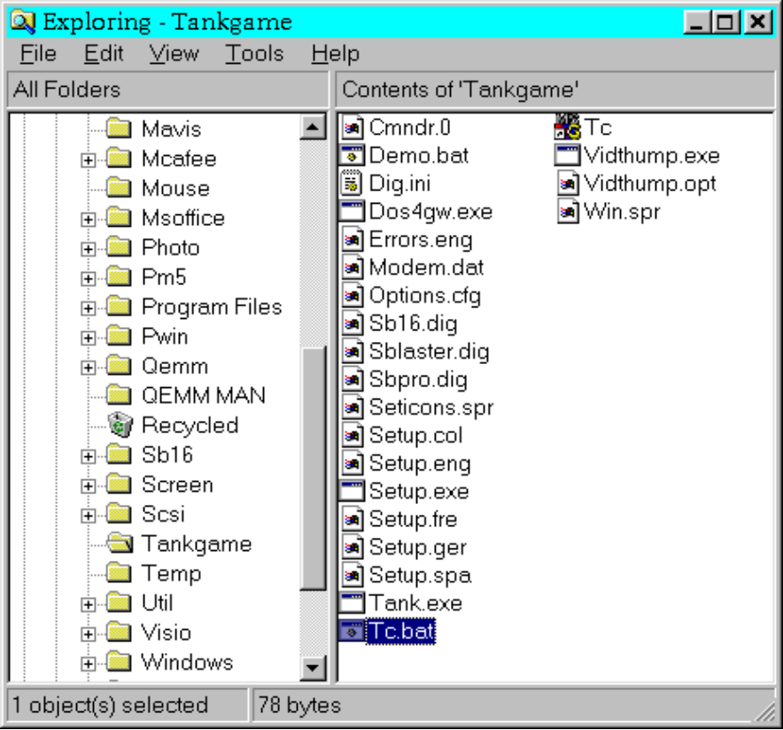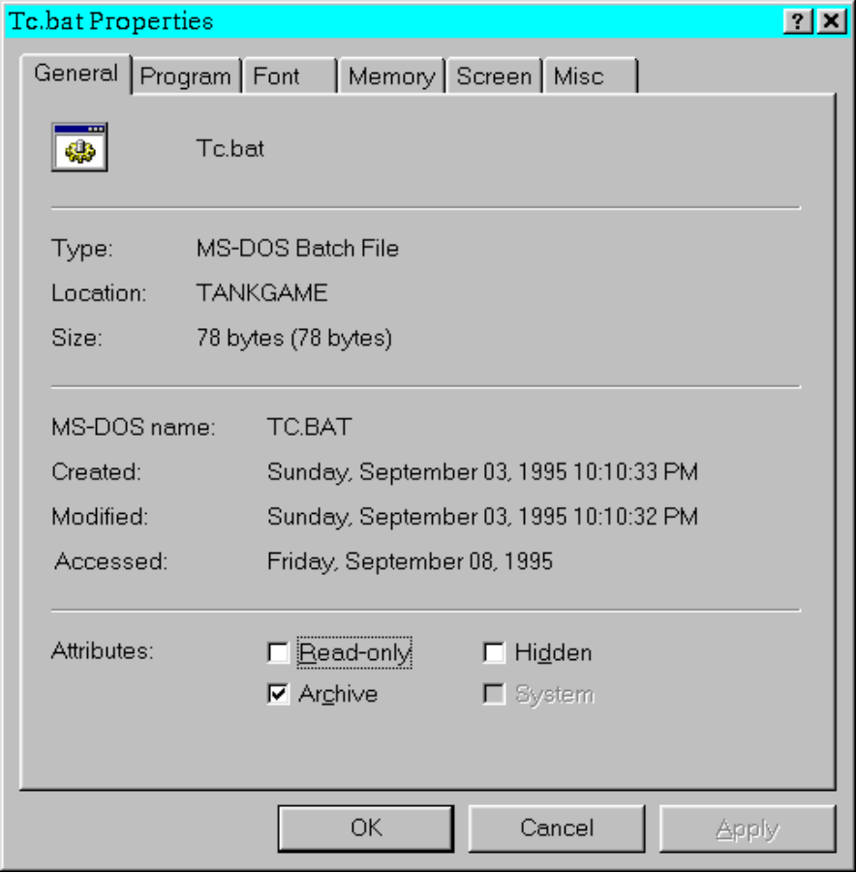
In the above Example, the game folder was After the executable was highlighted, a RIGHT CLICK brought up
opened with the use of EXPLORER. Once in the menu and the last choice “PROPERTIES” was selected.
the folder, the game executable (run command)
‘TC.BAT’ was highlighted with a LEFT click.

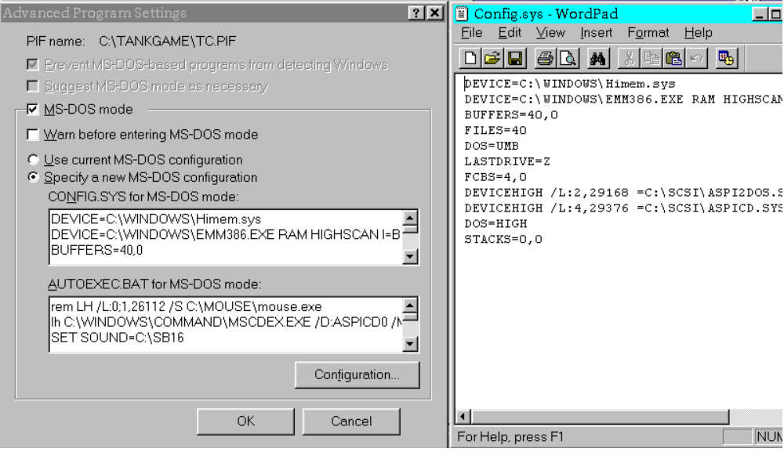

The next step is to select the ‘PROGRAM’ option. Then click on the ‘ADVANCED’
button. You are then given the screen on the left. The right screen is WordPad.
It is best to open these screens together and place them as pictured above.
Now you can open your Config.Sys and Autoexec.Bat files and simply COPY and
PASTE in the lines you need to run a game.

WWII

TESTING RESULTS: Game WILL NOT run in Windows 95

COMMENTS: This game is not able to run under Windows 95. To run this game properly you will need to run the game through MSDOS MODE. The safest video choice is to run in HIRES VESA (change in the DISPLAY section of the Main Menu)

RECOMMENDED SETUP:
1. Use Windows Explorer to locate the game directory labeled WWII. Once you locate
the Directory expand the directory and locate the executable labeled WWII.BAT.

2. Highlight this executable and then RIGHT CLICK. Now choose the PROPERTIES
selection. Once opened, go to the PROGRAM section.

3. In the PROGRAM section: Click on close on exit and then click on the ADVANCED
button

4. Once in ADVANCED SECTION, click on MS-DOS MODE Click off the WARN BEFORE
ENTERING MS-DOS MODE

5. Now you will need to specify a DOS configuration for the game. The easiest method of
retrieving and inserting the lines from your Config.Sys and Autoexec.Bat is to use the
Windows 95 utility - WORDPAD.

6. WORDPAD is usually located in either you START MENU or you can find it by using
Explorer. You will want to open this program while you are still in the Properties section
Thus both will be opened at the same time.

7. With Wordpad, you want to OPEN your CONFIG.SYS file and select the lines that you
need for the game. You will need the CDROM drivers lines only if you have the CD
game version. You will want to keep your FILES, BUFFERS, and DOS HIGH, UMB lines. To
add these lines to the system settings for the game, use the COPY AND PASTE
technique to insert these lines into the Custom Config.Sys in the Advanced Program
Settings.

8. When you are finished with the Config.Sys in WordPad, close the file and then open the
Autoexec.bat. Cut and Paste the Mouse, PATH, any SET lines, and any soundcard lines,
into the Custom Autoexec.bat in Advanced program settings. When done, click on
OK to save your work and exit the Properties section.

9. To start the game - DOUBLE CLICK ON THE EXECUTABLE FILE THAT YOU CHANGED.
(note: click on ESC to access menu while in plane cockpit)
EWA/95

