WINDIS VERSION 1.0
USER MANUAL

INTRODUCTION
This is Version 1.0 of WinDis the Internet news and mail manager application. It has been developed in C++ by Ewan Kirk as a public domain program. Its further development is being undertaken by a band of volunteers who have been inspired by the original program to take a hand in improving the application.

WinDis basic functionality is:

- NNTP News Client – downloads news for reading with an off-line reader.
- SMTP Mail Client – downloads waiting mail for an off-line e-mailer.
- SMTP Mail Server – uploads mail as individual e-mail, or to a news group.
- Finger Client – fingers servers as appropriate.
- Time Client – gets server time.

Co-ordination of the development and testing is currently being achieved using the demon.ip.winsock news group. It is anticipated that two special news groups will be created, one to provide help and identify bugs and requested enhancements, and a developers’ group to co-ordinate the development work.

This is a first attempt to start a comprehensive user manual for WinDis, you will find it sketchy in places. It is by no means complete and in the spirit of the application development itself you are invited to supply additional material where you think it is necessary. So if you find something missing, don’t whinge, find out how to do it by yourself and then write it up. Easy isn’t it <|:-)

In the Word for Windows document the text will appear in Times Roman. Where a file name or directory is shown it will be shown in Arial, thus: windis.exe. Where data entries are inserted or deleted they will be shown between inverted commas, thus: “e.g. yourhost”. Those of course using the ASCII version will not have this advantage, sorry :-(

ACKNOWLEDGEMENTS
The following brave souls have contributed to the development and testing of WinDis. This is an ever increasing list so please if you have helped and you don’t see your name e-mail john@humana.demon.co.uk.

Ewan Kirk – originator
Jeremy Sonander
David Hodgson
Colin Spensley

QUICK INSTALLATION
First of all advice for those who are starting to use windows Internet applications for the first time. You should install your winsock TCP/IP stack as instructed. There are two specific pieces of advice for Trumpet Winsock users. First is to make sure to put all the Trumpet files in the same directory and ensure that directory path is declared in your autoexec.bat file. The files you should expect to find in this directory are:

tcpman.exe
winsock.dll
hosts
services
protocol
login.cmd
bye.cmd
setup.cmd
trumpwsk.ini

Unless these files are all in the same directory you will probably get problems when running WinDis.

Second is that you should use SLIP, not PPP as your protocol. Make sure your setup specifies internal SLIP and not internal PPP. There appear to be some bugs in the Trumpet PPP implementation which cause WinDis to behave oddly especially when the PPP dial script fails. Of course, this could be a bug in WinDis but it doesn't happen with any other Winsock implementation. If you do use PPP you will probably get all the services, but at an overall reduced speed as you will find you have a very spiky throughput (check it out using TCPmeter).

When you downloaded your copy of windis.zip you should have unzipped it into a suitable directory as advised in readme.1st. If you have used DIS previously and your Internet directory is named demon you may wish to put windis.exe into there, or create a sub-directory windis if you wish. In all you will find the following files in WinDis directory on Demon:

windis.exe The executable
wdissrc1.zip The WinDis Source
readme.1st Initial help file
wdisdoc6.zip The WinDis Documentation in Word for Windows 6 format
wdistxt.zip The WinDis Documentation in ASCII text format

Having done this create an icon in a suitable windows group in the approved fashion and fire up WinDis.

If this is the first time you use Version 1.0 you will get a welcome with an “OK” and a “Cancel” button. This window is self-explanatory. Simply click on OK and you will be taken to the next screen. Clicking on “Cancel” at this point will take you gracefully out of the setup procedure. The next window you will see is the configuration window.
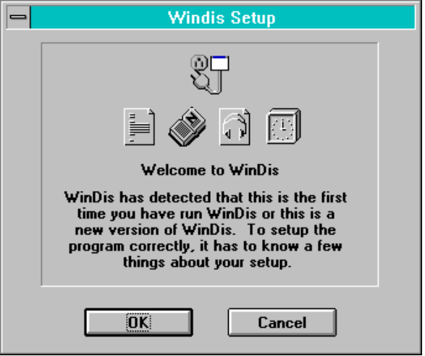

Setting the correct data in the fields is very simple and when complete a windis.ini file containing default settings is created in your windows directory.

The first fields are contained in the “TCP/IP Setup” area. In the first field labelled “Your host” you should delete “e.g. yourhost” and insert your host name. For example, mine would be “humana.demon.co.uk”. The remaining fields are even easier if you are a Demon user. In the remaining fields within “TCP/IP Setup” simply delete “e.g.” and the space after. This will leave you with valid Demon defaults for Mail Gateway, News Server and Time Server.
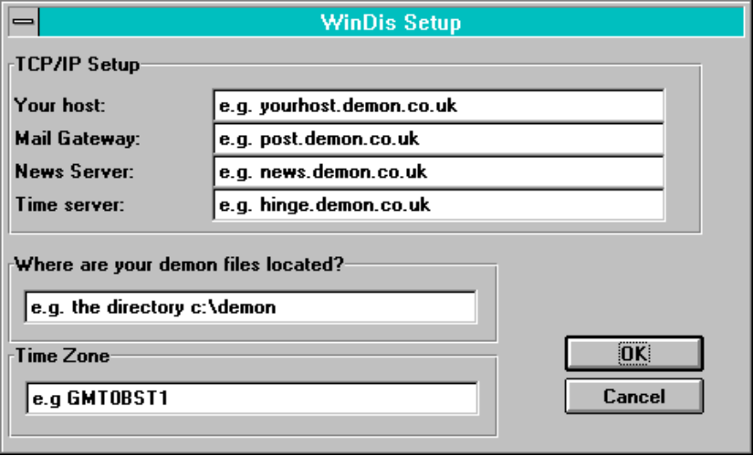
If you use a provider other than Demon you will have to insert the appropriate addresses in the remaining fields.

In the next field, contained in the “Where are your files located?” area, once again delete “e.g. the directory” and the following space if c:\demon is your WinDis directory, otherwise enter the full WinDis directory here.

In the “Time Zone” field leave the value shown. After that just click on OK and WinDis will fire up. The first window you will see will be the normal WinDis user interface.

Shortly afterwards, if the Time Client is set to kick-in automatically, you will see the Time Client window superimposed on the main window.
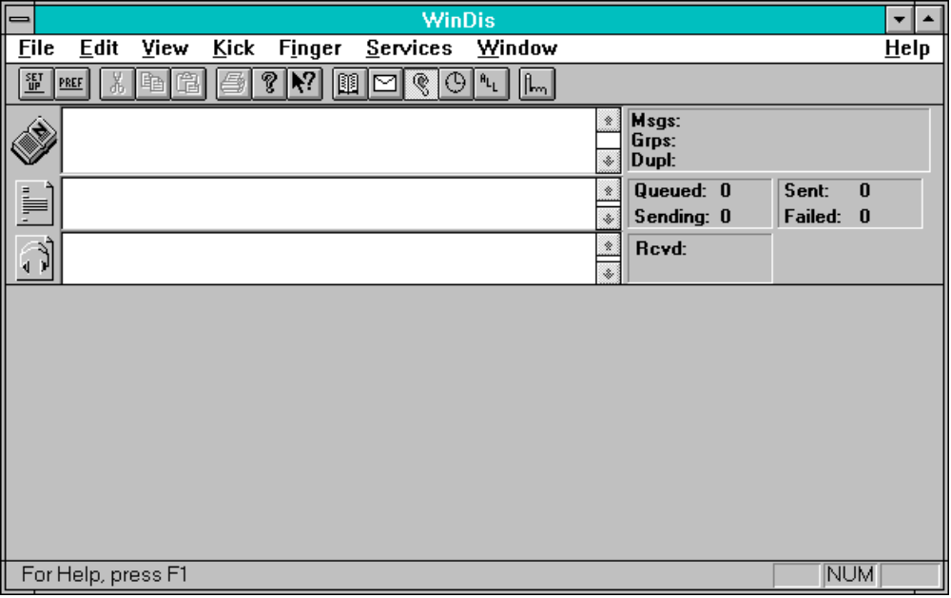

Once time has been established with Demon the “Cancel” button changes to an “OK” button which you should click, when the window will disappear. Equally if you are not interested in Demon time you can click the Cancel button immediately and later configure WinDis not to kick the time server on start-up.
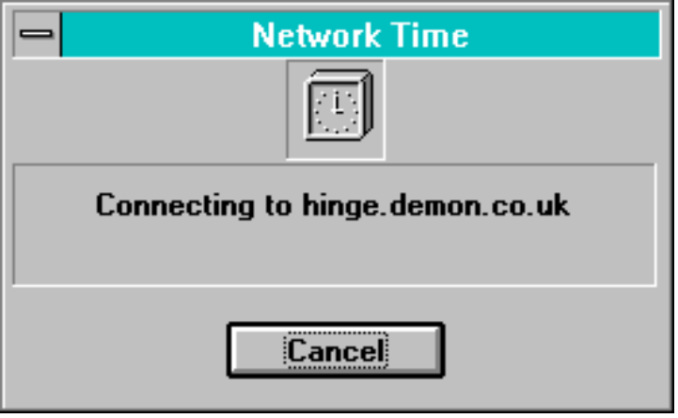

After all this is complete you can kick the news server and mail server in three ways, either by clicking the icons to the left of each window, or by clicking the appropriate button on the tool bar, or if you really want to do it the long way by using the “Kick” drop-down menu. The default setup is for the Mail Client to be enabled on start-up, if it is not kick that for good measure. Feeling really lazy? then you can kick all windows by clicking on the “All” button; second from the right.

If you have got a good connection to your service supplier and his machines are not groaning under the weight of processing a zillion .gif files things will start to happen. Sit back and watch.

The purpose of the buttons on the toolbar are pretty clear. You can either play with them on-line or off. I have not found any problem with doing so off-line. Briefly their use is as follows from left to right:

- Setup – takes you to setup window
- Pref – takes you to preferences window

- Cut – not implemented
- Copy – not implemented
- Paste – not implemented

- Print – not implemented
- Help – not implemented
- Context Sensitive Help – not implemented

- Kick News
- Kick Mail
- Kick Mail Listener
- Kick Time
- Kick All

- Invoke Finger – allows you to finger up to eight sites

As you can see although the basic program is complete there are a fair number of frills to be added. If you feel you would like to contribute in any way, either as a developer, code checker or pre-release tester please indicate in the WinDis news group. You will be added to the growing list of WinDis “Husky Helpers”.

CONFIGURATION
Setup

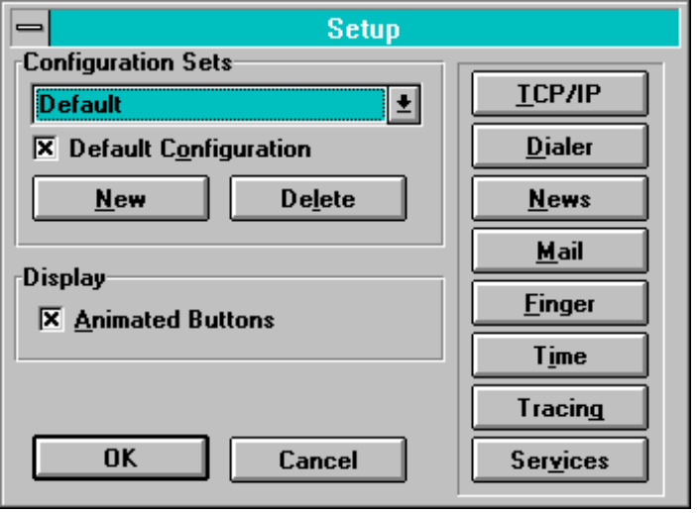

Once you have WinDis running satisfactorily you may wish to configure the program to your tastes. The two main ways of doing this are “Setup” and “Preferences” reached via the first two buttons on the toolbar or by using the “File” drop-down menu selection.

When you select “Setup” you will see the Setup window.

In Setup you will find three main areas one of which is a vertical set of buttons. In the first area “Configuration Sets” you can name a variety of configurations for, perhaps different Internet providers, or if you run WinDis on a laptop different points of presence (POPs). The use of “New” and “Delete” buttons are pretty self explanatory as is the “Default Configuration” check box.

You can override the default config set by specifying the name on the command line. So different ProgMan icons can start different configs. See section “Using the Trumpet Winsock for more information.

In the second area, “Display” you will find a check box labelled “Animated Buttons”. If you check this you will see icons showing that the process is in operation rather like a brewing up nuclear pile. They are pretty and do not slow the application, so select the box.

The purpose of the vertical line of buttons is as follows:

- OK – accept all changes and exit Setup.
- Cancel – abort changes and exit Setup.
- TCP/IP – allows you to change your host name if necessary.
- Dialer – see Section, “Using the Trumpet Winsock for setting up.
- News – allows you to select a news server (for Demon news or betanews).
- Mail – allows you to select a the mail server.
- Finger –you can pre-configure up to eight finger sites and declare a default
- Time – allows you to select a time server.
- Tracing – allows you to specify the level detail tracing should run at (suggest 2) and don’t forget to make a directory for the tracing logs to live in.
- Services – allows you to set preferences for “Expire” and “Unbatch”.

More information will be added to this section in time. Any offers?

Preferences

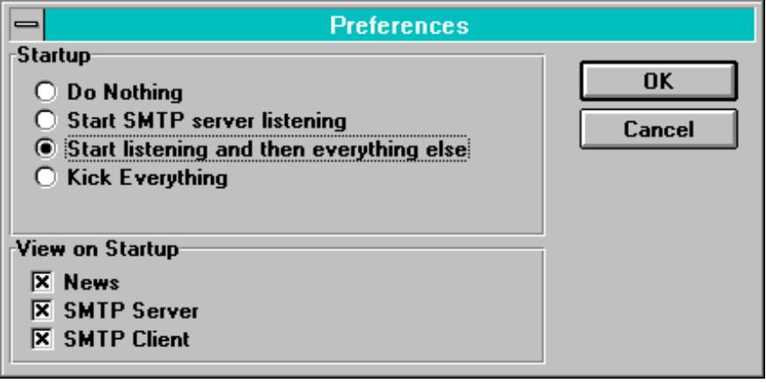
When you click on the second button in the toolbar labelled “Pref” the “Preference” window will open up.

In the first you can select what you want “kicked” on startup. Play around with the different preferences options. I favour the “Start listening and then everything else” with a “Demand loaded” Trumpet Winsock. This can be automated as explained in the instructions in “Using the Trumpet Winsock” section.

In the second box there are a series of check boxes. These enable or disable the main communications windows. It would be normal to have all three windows enabled. Once again there is an “OK” and a “Cancel” button to exit the window. The same effects can be achieved by ticking or unticking the items under the “View” menu item with the addition of selecting or deselecting the “Toolbar” and “Status Bar”. Views selected in this way will not however be saved for future operations.

USING THE TRUMPET WINSOCK
Trumpet Winsock is one of the most popular Winsock implementations. WinDis has some features to make running WinDis with Trumpet more easy when using a dialup line.

In the WinDis Preferences menu, setup WinDis to do nothing on startup. You should also set Trumpet Winsock to “Automatically Login in and Logout on Demand”. This is in the “Dialer|Options” menu item in Trumpet.

Now copy the following script into your Winsock directory and call it login.cmd. The script, as provided by Ewan is as follows:

# begin script
# trace on
# initialize modem
# setup our modem commands
display "Loading setup strings"\n

$Dialer = "Dialer"
$Filename = "windis.ini"
%ok = [load $DialString1 $Dialer $Filename]
%ok = [load $DialString2 $Dialer $Filename]
%ok = [load $DialString3 $Dialer $Filename]
%ok = [load $DialString4 $Dialer $Filename]
%ok = [load $DialString5 $Dialer $Filename]
%ok = [load $DialString6 $Dialer $Filename]
%ok = [load %DialInt1 $Dialer $Filename]
%ok = [load %DialInt2 $Dialer $Filename]
%ok = [load %DialInt3 $Dialer $Filename]

display "Dialing "$DialString1\n
$number = $DialString2
$modemset = $DialString3
%maxattempts = %DialInt1

set dtr off
sleep 1
set dtr on

output "atz"$modemset\13

if ! [input 10 OK\n]
display "Modem is not responding"\n
abort
end

%attempts = 0

repeat
%attempts = %attempts + 1
# set dtr off
# sleep 1
# set dtr on
outputecho 10 "atdt"$number%attempts\13
%test = [read 40 $result]

##############################################################
# I put the following test in because my modem outputs a cr/lf
# before the status message would otherwise get lost and
# the rest of the script would then get out of sync. It may not
# be necessary for your modem.
##############################################################

if $result =""
%test = [read 40 $result]
end
display "$result is .. "$result\n
until $result = "CARRIER 14400" | %attempts = %maxattempts

##############################################################
# test to see what modem responds with first and change
# "CARRIER 14440" if necessary.
##############################################################
wait 30 dcd

if %attempts<%maxattempts
input 30 ogin:
output <YOUR LOGIN NAME>\r
input 30 sword:
output <YOUR PASSWORD>\r
input 30 otocol:
output SLIP\r
input 50 HELLO
display \n"Connected..."
else
display "Number of attempts exceeded, aborting"\n
set dtr off
sleep 1
set dtr on
output "ath"\r
input 10 "OK"
abort
end
# end script

Make sure you change <YOUR PASSWORD> and <YOUR LOGIN NAME> to the right
things for your host.

What this does is load a set of strings from the windis.ini file. These strings can be setup in WinDis by going to the setup screen and choosing "Dialer". There are a maximum of six strings and three integers (numbers) which can be passed from WinDis into this login script. My strings look like this.

DialString1 = "Calling London"
DialString2 = "01813434848"
DialString3 = "0"
DialInt1 = 20

So what I have is the first string as a message to be printed, the second as the telephone number and the last is my modem setup string. Don’t type in the quotes. It is very important to enter the right values for your setup. DialInt1 is the number of retries that the dialer script should do. Note that this is one of these clever scripts which appends a number to the phone number to get around redial limits and blacklists in a modem.

The bye.cmd script should just be the usual:

#begin script
sleep 1
output +++
sleep 1
input 10 OK\n
output ath0\r
input 10 OK\n
#end script

OK, now you can give it a try.

Start up WinDis. It should appear and just sit there. Now click on the Listener Icon (or the "ear" in the button bar or the menu item “Kick|SMTP Server”). TCPMAN should appear and start to dial. Maximise TCPMAN and check that the sequence of commands is what you expect.

Once the SLIP is established, the little headphone icon should appear in the listener box and you can then kick mail and news manually.

If this appears to work correctly a couple of times, you can set WinDis to automatically kick the SMTP listener on startup. The best choice is the "Start SMTP Listening and then when listening is established, “Kick everything" option (found in the Preferences dialog).

Set this option and then exit WinDis. Trumpet should exit after a short while if you’ve got the inactivity timeout set on Trumpet. Now restart WinDis. Trumpet should kick automatically and log you in. Once the connection is set up, news and mail will get kicked automatically.

Finally, if you, like me, dial in to different places depending on your location, you can use the different setup sets feature of WinDis to make this quite slick.

I dial in from home and from work. I live in Cambridge so I use the Cambridge POP. I have a setup set called "Cambridge" which has (as the dialer strings):

DialString1 = "Calling Cambridge from Home"
DialString2 = "576010"
DialString3 = "0"
DialInt1 = 10

and one called "Default" which has the dialer strings as:
DialString1 = "Calling London from Work"
DialString2 = "01813434848"
DialString3 = "0"
DialInt1 = 20

I have two program manager icons for WinDis. One where the command line is c:\demon\windis.exe Cambridge and one where it's c:\demon\windis.exe Default. This makes it easy for me to just click on the icon I want depending on whether my portable is connecting from London or Cambridge.

Remember, if you use separate setup sets, if you don't start WinDis first then trumpet will use what ever the **last** setup set used was.

CONTACTING THE USER GROUP
You can currently contact the WinDis User Group in the “demon.ip.winsock” news group. In time two new groups should be established to provide exclusive net time for WinDis. For the moment we can all make things easier for ourselves by following a heading convention. I suggest that we use the following convention for heading postings:

- Windis – Help for the obvious, a brief problem description to follow.
- Windis – Bug to report a bug when you are convinced it is. Full information please.
- Windis – Suggestion for a suggested enhancement to the program, again please be as comprehensive in your posting as possible.

Please keep as much information to the news group rather than using e-mail as this will ensure everybody stays up-to-date with developments. It will also give you the greatest opportunity for getting an answer to your question and not unfairly load individuals with excessive e-mail.

Everyone will try to help you if you get into trouble, but the best piece of advice is to ensure your winsock stack is working first. Most WinDis problems result from an improperly configured winsock. There are a number of documents in Demon /pub/doc/ibmpc to help you.

KNOWN BUGS
There is a known bug in WinDis program. Users will need to run the DOS “Expire” program every now and then. There is a bug in the Newswin, Newsbase, Windis expire code and the \demon\spool\news\history is not truncated as it should be. This is on the FIX list.

