Action Manager
User’s Guide

An easy-to-use manual to

help you get the most from

your Scanner

All trademarks or brand names mentioned within this publication are property of their respective owners.

© 1995. All rights reserved. No portion of this document may be reproduced.

About This Manual & Action Manager
This User’s Guide provides instructions and illustrations to help you operate your scanner software. Note: It is recommended that you install the scanner and its related hardware first before setting up the software and Action Manager (see Scanner User’s Guide).

The Action Manager software included with your scanner (Chapter I) works with your computer’s fax/modem and fax software, Windows Print Manager™, OCR program, and Windows image editing application. When faxing documents, your fax software’s send window pops-up allowing you to enter the appropriate information: such as fax phone number and a cover page.
When you are not faxing documents, you can make copies using Action Manager’s Copy Utility. Action Manager interfaces with the Print Manager allowing you to use virtually any Windows-supported printer for generating copies.
The Action Manager also interfaces with your OCR program allowing you to read text documents into your computer system. All you do is choose your word processor, and your documents are automatically entered into it.
Lastly, the Scan & Save utility interfaces with your Windows image editing application allowing you to save images directly to PaintBrush, or other imaging programs.

Table of contents
About This Manual & Action Manager
Conventions of this Manual
A Note About Icons
Action Manager Features
Chapter I. Action Manager
Action Manager
Action Creator
Copy Utility
Fax Utility
OCR Action
Scan & Save Utility
Chapter II. Operating Action Manager
Filing Actions in Action Manager
Clearing Actions
Touch-Free Scanning
ScanFX and Action Manager

Appendix A: Glossary
Appendix B: Customer Service and Warranty

Conventions of this Manual
- Bold — First use of an important term in a chapter.
- All caps — Represent commands.
- Note — special information about the current subject.

A Note About Icons
This manual uses the following icons to point out information that deserves special attention.

Attention
Pay Special Attention. Instructions that will ease installation and prevent mistakes.


Note
Note. Special information about the current subject.

Action Manager Features
- Action Manager
- Action Creator
- Copy Utility
- Fax Utility
- OCR Action
- Scan & Save Utility
- Line art scanning
- Gray scale scanning
- Black and White scanning
- Color scanning (color scanner required)
- HP-compatible application driver
- TWAIN compliance

Chapter I. Action Manager

Action Manager
To give you quick and easy access to faxing, copying, OCR and scanning — we provide you with a unique software interface called Action Manager that appears whenever you insert a document into your scanner (Figure 1).
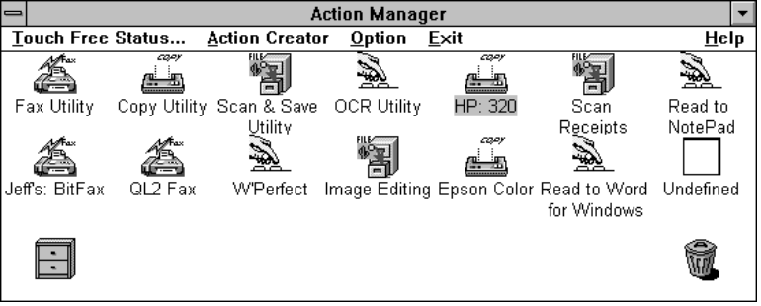
Figure 1.
Figure 1 shows 14 icons representing Actions that you can define. A filing cabinet for storing unused Actions and a trash can for deleting them. There are three menu choices for customizing the functionality of Action Manager: Option, Action Creator and Touch-Free Action Status for defining a default Action.
To enter Action Manager, using your mouse, DOUBLE-CLICK on the Action Manager icon within your Scanner Utility Program Group.
The HELP option describes important functional aspects of Action Manager. Please take time to read the descriptions to better familiarize yourself with how to operate it.
Attention

Action Creator
Action Creator is where you generate and modify an Action (Copy, Fax, OCR or Scan & Save), Figure 2.
To enter Action Creator, click on an UNDEFINED Action by using your right mouse button from within Action Manager, or choose the Action Creator drop down menu located on Action Manager’s main menu bar.

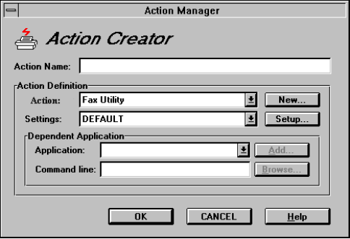
Figure 2.
The following describes how to setup your Copy, Fax, OCR and Scan & Save Actions.

Copy Utility
The Copy Utility interfaces with the Windows Print Manager and is compatible with most Windows-supported printers (Figure 3). The following describes how to set up Action Manager to perform a Copy:

- Using your right mouse button, choose an available UNDEFINED Action from within Action Manager.
- 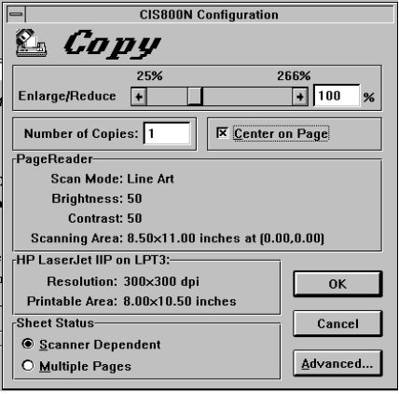
Figure 3.
- Inside Action Creator, type in a brief description as the Action Name.
- Under Action Definition and from Action, choose Copy UTILITY.
- Within Setting, choose the setting that you want to perform: B/W is for making black and white copies, Gray is for making grayscale copies, and Halftone is for making copies that simulate grayscale.
- Choose setup.
- From ADVANCED, choose your printer.
- After picking the proper printer, choose OK to exit.
- Choose OK from Action Creator to reenter Action Manager.
- Enter a document into your scanner.
- To run the Copy Utility, double-click on its icon.

Fax Utility
Action Manager pops-up allowing you to choose the Fax Utility. For example, if you use BitFax to fax documents, the BitFax send screen pops-up so you can enter the appropriate information before sending a fax: cover sheet, attachments and phone number. Please perform the following to setup your Fax Utility.
- Using the right mouse button, choose an available UNDEFINED Action from within Action Manager.
- Within Action, choose Fax.
- Within Setting, choose either Text, Picture or TextPic (both text and picture) depending on what you intend to fax.
- Choose Setup.
- From Advanced, choose your fax software from the fax driver field.
- Choose OK.
- Choose OK to reenter Action Creator.
- Enter a brief description as the Action Name.
- Click OK to reenter Action Manager.
- Enter a document into your scanner and double-click on your Fax Action to send a fax.

OCR Action
The OCR Setup allows you to set up your scanner to read text documents directly into your word processor. To setup an OCR Action, please perform the following:
- Using the right mouse button, choose an available UNDEFINED Action from within Action Manager, or choose the Action Creator drop down menu located on Action Manager’s main menubar.
- Enter an Action Name.
- Within Action, choose the appropriate OCR Application. For example, if Recognita Plus is your OCR application, choose Recognita Plus.
- Within Setting, choose the setting that corresponds to your word processor. For example, if Word for Windows is where you want your OCR documents saved, then choose Setting WINWORD.
- Under Dependent Application, choose the appropriate Application Name (the name of your word processor).
- Enter the drive, directory and executable file in the Command Line field. Note: The Command Line is the directory and executable file of the Application. If the executable file resides in a different directory other than what is given, please choose Browse and locate the directory that contains the proper command. For example, Word for Windows normally exists in: C:\WINWORD\WINWORD.EXE. The directory is WINWORD and the executable file is WINWORD.EXE.
- Choose OK.
- You are now ready to perform Touch-Free OCR.
- To run your OCR action, double-click on its icon.

If you are using a word processor or application for performing OCR that is not presently within Action Creator, choose ADD to create an Application Name and Command Line. Enter the Command Line after Parameters, or browse by choosing the file type, directory and drive to locate the proper Command Line. Choose SETUP within Action Creator to define a setting (see your OCR manual for further details).
Note

Scan & Save Utility
Scan & Save reduces the time it takes to launch an application when you want to scan information. This concept is ideal for creating a database of invoices, receipts or checks. After you insert a document into the scanner, a screen pops-up so you can designate the proper directory and file prefix (Figure 4). Also, after a document scans, it automatically appears in your Windows image editing program for easy and quick access. To set up your Scan & Save application, perform the following steps:
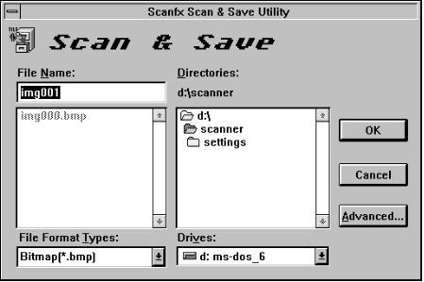
Figure 4.
- Using the right mouse button, choose an available UNDEFINED Action from Action Manager.
- From Action Creator, enter a brief description as the Action Name.
- Within Action, choose Scan & Save.
- Within Setting, choose the appropriate Setting: either B/W, Gray or Halftone.
- Under Dependent Application, choose the program where you want to scan & save your documents. Note: the default is Windows Paint Brush.
- Choose SETUP to define the scanning area, the resolution, and brightness and contrast.
- When finished, choose OK to reenter Action Creator.
- Choose OK to reenter Action Manager
- Enter a photo or picture into your scanner and double-click on the Scan & Save icon to run.

Chapter II. Operating Action Manager

Filing Actions in Action Manager
The Filing cabinet located at the bottom left of Action Manager is for storing unused actions. To enter an action into the Filing cabinet, choose it with your left mouse button and drag it to the Filing cabinet and drop. To view the contents of the Filing cabinet, click on the Filing cabinet. Note: To run a filed action, you must drag it back to an UNDEFINED icon inside Action Manager.

Clearing Actions
To clear an action, choose an action with your left mouse button and drag it to the trash can and drop. Note: Once you drop an action into the trash can, it deletes from the Action Manager and your hard disk.

Touch-Free Scanning
After setting up an Action, enter Action Manager and perform the following steps.
- Enter the Touch-Free Action Status screen located on the Action Manager menu bar (Figure 5).

Figure 5.
- 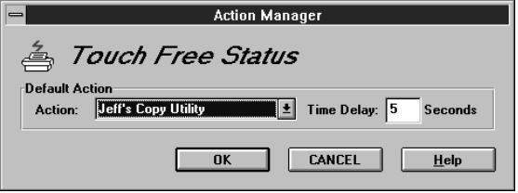
- Choose which Default Action you wish to perform. For example, if you want to perform copying, choose the appropriate COPY Action.
- Next, choose the Time Delay. The Time Delay is the amount of time before the Default Action begins to scan.
- Choose OK.
- Minimize Action Manager by clicking on the downward arrow located at the upper-right of Action Manager, or by clicking once on another open program with your mouse. By choosing a different program, Action Manager moves to the background without you having to minimize it. Note: Closing Action Manager will disconnect it from the scanner!

Action Manager pops-up whenever you insert a document into the scanner giving you a chance to either run another Action or halt the Delay Time countdown. To run another Action, double-click on that Action, to halt an Action, single-click on any Action within Action Manager.
Attention

About Paper Aware
Paper Aware contains 2 boxes: Disable and Enable. To not have Action Manager pop-up after you insert a document into your scanner, please perform the following:
- Open the application you don’t want Action Manager to pop-up in and minimize it.
- Within Action Manager, enter the Options menu and choose PAPER AWARE.
- Using the arrow keys between the DISABLE and ENABLE boxes, move the application from the ENABLE box to the DISABLE box.
- Choose OK when done.

ScanFX and Action Manager
This section describes how to operate Action Manager with ScanFX. If you do not own a ScanFX, please skip this section.
Attention
The ScanFX interfaces with Action Manager allowing you to link actions with ScanFX’s 14 softkeys, Figure 6.
The first option, KEYPAD DRIVEN (see Figure 7), allows you to link Action Manager’s definable icons with ScanFX’s 14 softkeys. For example, if you have the first icon in Action Manager defined to perform faxing, by choosing ScanFX’s softkey marked 01, you will launch Action Manager’s Fax Utility.
01 |  | 02 |  |  | 03 |  |  |  | 04 |  |  | 05 |  |  | 06 |  |  | 07
08 |  |  |  | 09 |  |  | 10 |  |  | 11 |  |  | 12 |  |  | 13 |  |  | 14
Figure 6.
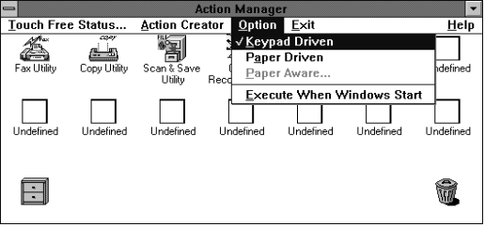
Figure 7
If you want to access ScanFX’s fax speed dialing
capabilities, you must first switch from KEYPAD DRIVEN to the PAPER DRIVEN option (Figure 7). After doing so, you can utilize ScanFX’s speed dialing features. Note: Before being able to speed dial, you must first configure ScanFX’s softkeys to perform speed dialing (see ScanFX User’s Guide for details).

Appendix A: Glossary

Glossary

Action
A process that involves either faxing, copying or scanning.

Application
A software program that lets users perform a task or set of tasks.

Brightness
A setting to determine the brightness of light projected by the scanner onto the page being scanned. This lightens or darkens the resulting image. Brightening a page that has tightly spaced characters can improve the recognition.

Compression
Removing redundant data from a file in a way that the original file can later be completely reconstructed. The resulting compressed file requires less disk space than the original.

Crop
A method of eliminating an undesirable region of a document or picture.

Dialog Box
In Microsoft Windows, a window that interacts with the user.

Dither
A method of varying patterns of dots (a dithered pattern ) to simulate a grayscale. In a dither pattern, areas which are black will have as many dots as possible. Lighter areas will have fewer dots.

DPI (Dots Per Inch) see Resolution.

Drop Down List Box
Clicking on the menu opens a list screen that drops down from the selected item, allowing you to select from a list of items.

Driver
Enables a computer to communicate with special hardware devices (such as a scanner).

Extension
The period and characters that succeed a filename. For example: TIFF, BMP and PCX are common image file extensions.

File Type
A format used to define a file.

Grayscale
An image stored with 8 bits per pixel (256 shades of gray) that can be displayed or printed in shades of gray. Grayscale images require more disk space than a black & white image.

Halftone
An image made up of variable-sized black dots spaced to simulate different gray tones of the original image.

Icon
A visual representation of an object. In Microsoft Windows, each application program is represented by an icon.

Inverse
Inverse reverses the colors of an image; black pixels for example, will change to white and white pixels will change to black.

Line Art
An image composed of lines that are black and white, and do not contain continuous tones.

Mode
The method used to scan, either Line-Art, Grayscale or Halftone.

OCR (Optical Character Recognition)
A technology in which binary images of character shapes are analyzed and identified as characters and output to editable text.

Prescan
A process that enables you to zone (choose a portion of a document), and preview a document or picture before scanning.

Resolution
The degree of detail in dots per inch (dpi); the higher the resolution, the more information will be scanned from the page image. Higher resolution images also require more disk space for storage.

Setting File
A file that contains Action settings, including type quality, image source, printer type, fax settings and resolution.

TWAIN
An image and scanner interface standard used for scanner and image program development.

Zone
A rectangular boundary that surrounds an area of text or an image. Zones can be defined by performing a prescan and then setting the area you wish to recognize.

Appendix B: Customer Service and Warranty
If you encounter any problems with your scanner, please review the installation instructions and troubleshooting suggestions contained in this guide.
For further assistance, contact your local retailer or our customer hoteline located on the back of this guide. One of our customer support representatives will be happy to assist you between the hours of 8:30 a.m. to 5:30 p.m. Monday through Friday. To avoid delays, please have the following information available before calling:
- Product name and model number.
- A detailed description of the problem.
- This manual.
- Your computers manufacturer and its model number.
- Your current operating system and BIOS (optional).
- Other interface cards in your system (including I/O address settings and IRQ settings).
- Name of software package(s), version or release number and manufacturer of the software.
Attention
We are continuously enhancing the performance of our products drivers. To check for the latest device driver that relates to your scanner, call our 24-hour BBS. Set your modem to 8-data bits, 1-stop bit, no parity and terminal emulation as VT100 or ANSI. The file you seek is compressed using PKZIP, decompress it onto a floppy disk and then install it onto your computer system.

Statement of Limited Warranty

This Statement of Limited Warranty applies only to the options you originally purchase for your use, and not for resale, from a Plustek or Plustek authorized reseller.

The warranty period for this product is one year from the date of Original Purchase as shown on your receipt, and includes all parts and labor. You should keep the receipt as it establishes Proof of Original purchase. You will need it to obtain warranty service.

If you transfer this product to another user, warranty service is available to that user for the remainder of the warranty period. You should give your proof of purchase and this statement to that user.

Plustek warrants that this machine will be in good working order and will conform to its functional descriptions in the documentation provided. During this product’s warranty period, carry-in exchange will be performed by the retailer from whom the product was purchased upon provision of proof of purchase. Replacement parts assume the remaining warranty of the parts they replace.

Before presenting this product for warranty service, you must remove all programs, data and removable storage media. Products returned without guides and software will be replaced without guides and software.

This Limited Warranty service does not provide for carry-in exchange when the problem results from accident, disaster, vandalism, misuse, abuse, unsuitable environment, program modification, another machine or non-Plustek modification for this product.
If this product is an optional feature, this Limited Warranty applies only when the feature is used in a machine for which it was designed.

If you have any questions about your Limited Warranty, contact the approved retailer from whom you bought the product, or our customer hotline located on the back cover of this guide.

THIS LIMITED WARRANTY REPLACES ALL OTHER WARRANTIES, EXPRESS OR IMPLIED, INCLUDING, BUT NOT LIMITED TO, THE IMPLIED WARRANTIES OF MERCHANTABLITY AND FITNESS FOR A PARTICULAR PURPOSE. HOWEVER, SOME LAWS DO NOT ALLOW THE EXCLUSION OF IMPLIED WARRANTIES. IF THESE LAWS APPLY, THEN ALL EXPRESS AND IMPLIED WARRANTIES ARE LIMITED IN DURATION TO THE WARRANTY PERIOD. NO OTHER WARRANTIES APPLY AFTER THAT PERIOD.

Some jurisdictions do not allow limitations on how long an implied warranty lasts, so the above limitation may not apply.

Under no circumstances is Plustek liable for any of the following:

- Third-party claims against you for losses or damages.
- Loss of, or damage to, your records or data; or
- Economic consequential damages (including lost profits or savings) or incidental damages, even if Plustek is informed of their possibility.

Some jurisdictions do not allow the exclusion or limitations of incidental or consequential damages, so the above limitation or exclusion may not apply to you.

This Limited Warranty gives you specific legal rights, and you may also have other rights that vary from jurisdiction to jurisdiction.
Plustek Inc. USA, 1362 Bordeaux Dr., Sunnyvale Ca, 94089. (408) 745-7111. BBS: (408) 745-7561 CompuServe: 75022,3451

Plustek, Inc. Germany, Brodermannsweg 17, 22453 Hamburg, Germany. 49-40-5110446.

Plustek, Inc. Taiwan, 5/F, 242 Chung Hsiao E. Road, SEC. 5, Taipei, Taiwan, R.O.C. 886-2-7204101

